Consumer Perception Survey: MHSIP

May 2018 Administration
Adults and Seniors
Jonathan Rich, Ph.D.
January 16, 2018

The Mental Health Statistical Improvement Program (MHSIP) was offered to all clients attending mental health services at a County or contract adult program during the week of May 14-18, 2018. There were 713 records returned – 629 adult surveys and 84 older adult surveys. Records were discarded if the program number was missing, was not a valid number or if the program was part of Children and Youth Behavioral Health. Only cases with an age from 18-120 were retained. This left 556 cases.

Sample description:

N: 556
Gender (n = 536): F 56.0%, M 43.8%, O 0.2%
Age (n = 556): Mean: 39.1 years, s = 13.8, range = 18 to 116.
Form Language (n = 556): English, 84.2% Spanish, 15.1%, Vietnamese, 0.7%
County/Contract (n = 556): County 55.4%, Contract 44.6%

Figure 1. Function Area (n = 556)
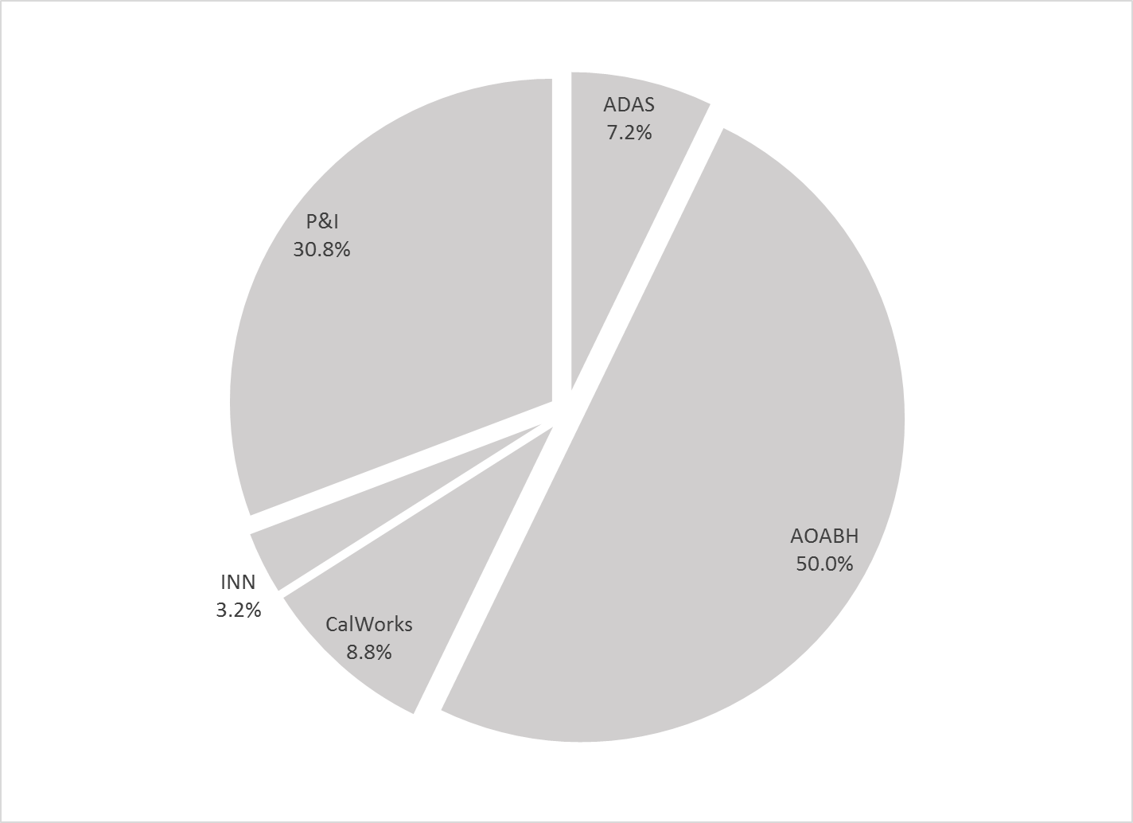

Figure 2. Race/Ethnicity (n = 531)
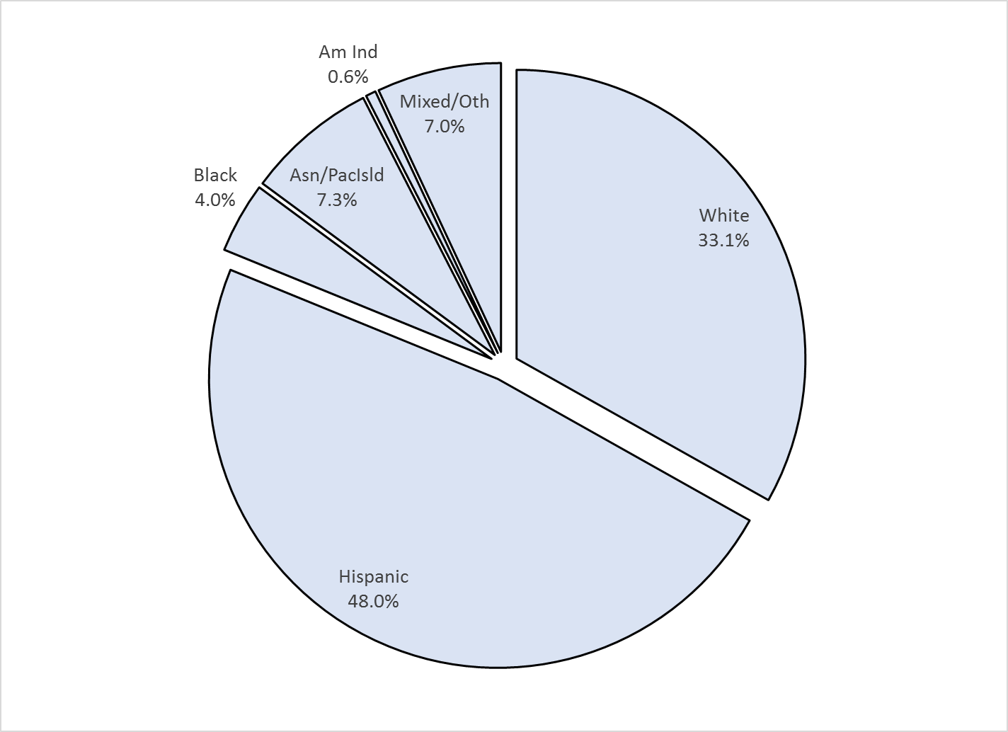

Survey respondents describe their race and ethnicity by selecting as many of the following categories as applicable: Hispanic, American Indian, Asian, Black, Pacific Islander, White, Other Race, and Unknown Race. These selections were reduced to six categories as follows. If either Asian, Pacific Island, or both are selected, that is considered a single category, “Asian/Pacific Islander.” If only one category is selected, then the participant is assigned to that category. If more than one category is selected, or if “Other Race” or “Unknown Race” is selected, the participant is classified as “Mixed/Other.” If Hispanic is selected, the client is classified as “Hispanic,” regardless of the other selections.

MHSIP Scale Scores:

Consistent with past results, responses to service satisfaction items average between “Agree” (4) and “Strongly Agree” (5). Response to items that reflect personal functioning are lower, just at the “Agree” level (4). Endorsement of service satisfaction items at or above 90%; at least three fourths of respondents endorsed personal functioning items (Figures 3 and 4).

Figure 3. Mean Scores: MHSIP Service Satisfaction
(Scale is 1-"strongly disagree" to 5-"strongly agree")

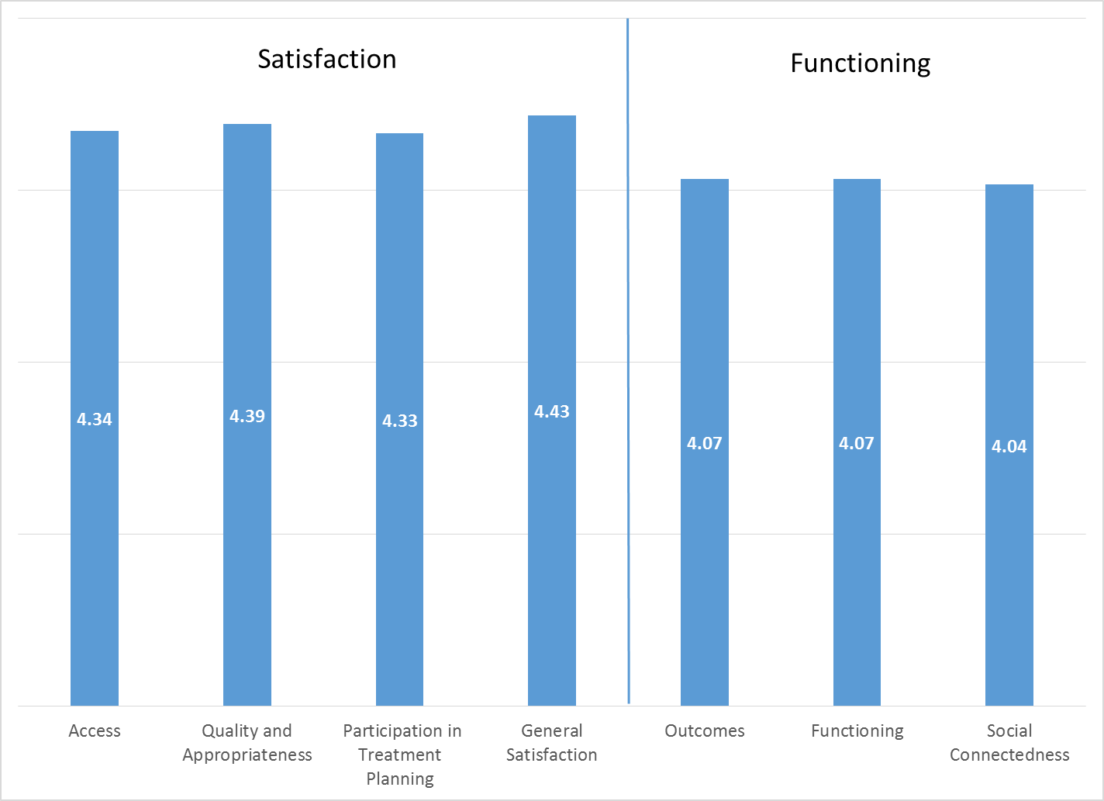

Figure 4. Percent with scores at or above 3.5, "Agree" and "Strongly Agree"
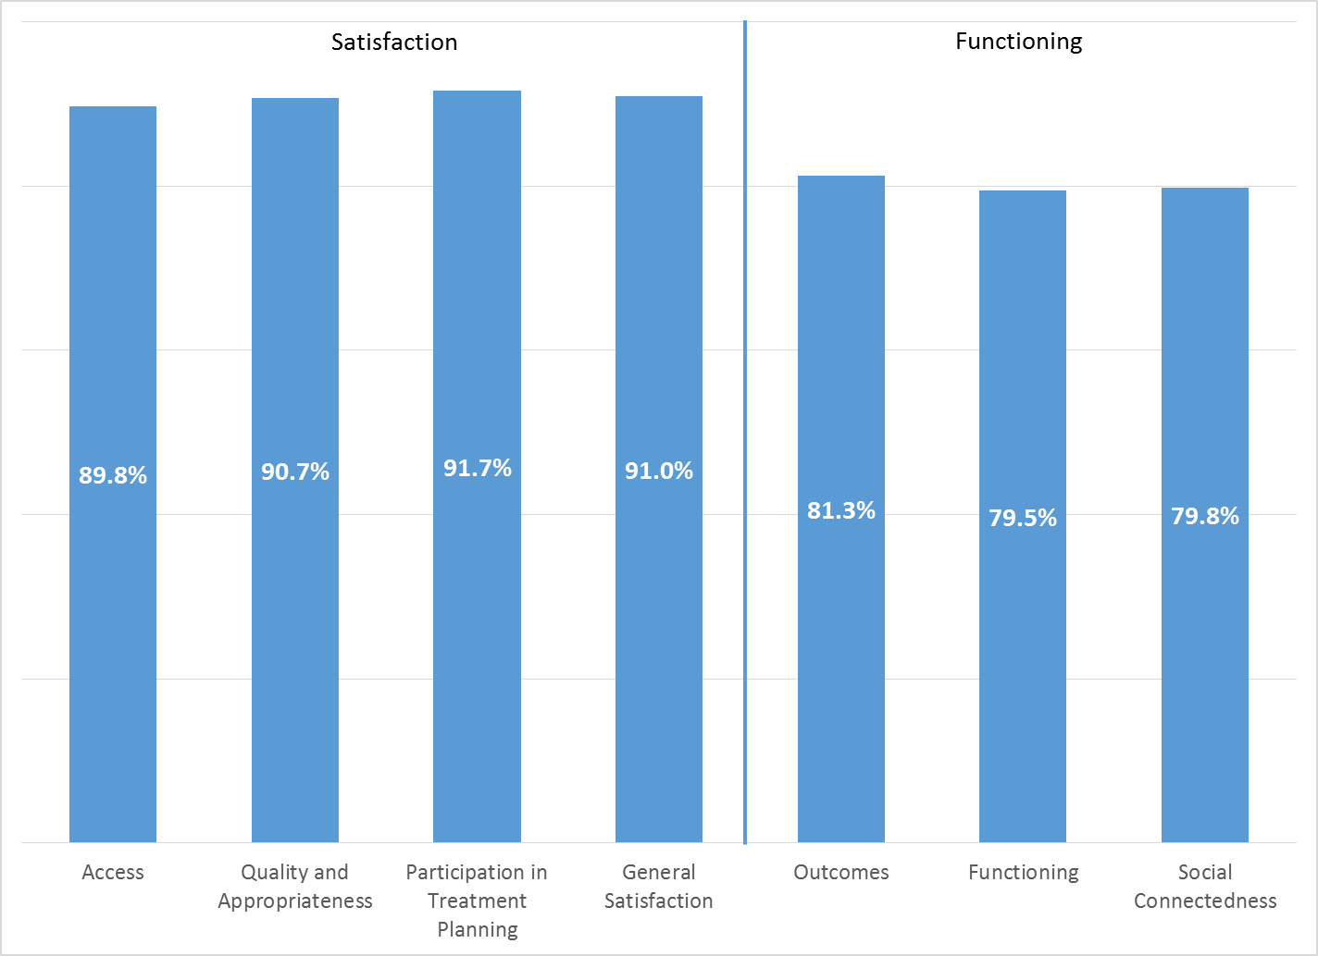

Factors affecting MHSIP scores

None of the MHSIP scores differed by ethnicity (see Figure 5). Clients in County programs generally gave higher ratings than those in contract programs (see Figure 6). MHSIP scores on the Outcomes (r = .092, p < .05) and Functioning (r = .143, p < .01) scales showed a mild relationship amount of time in the program (Figure 7).
Figure 5. MHSIP scores by race/ethnicity
(No significant differences by race/ethnicity)
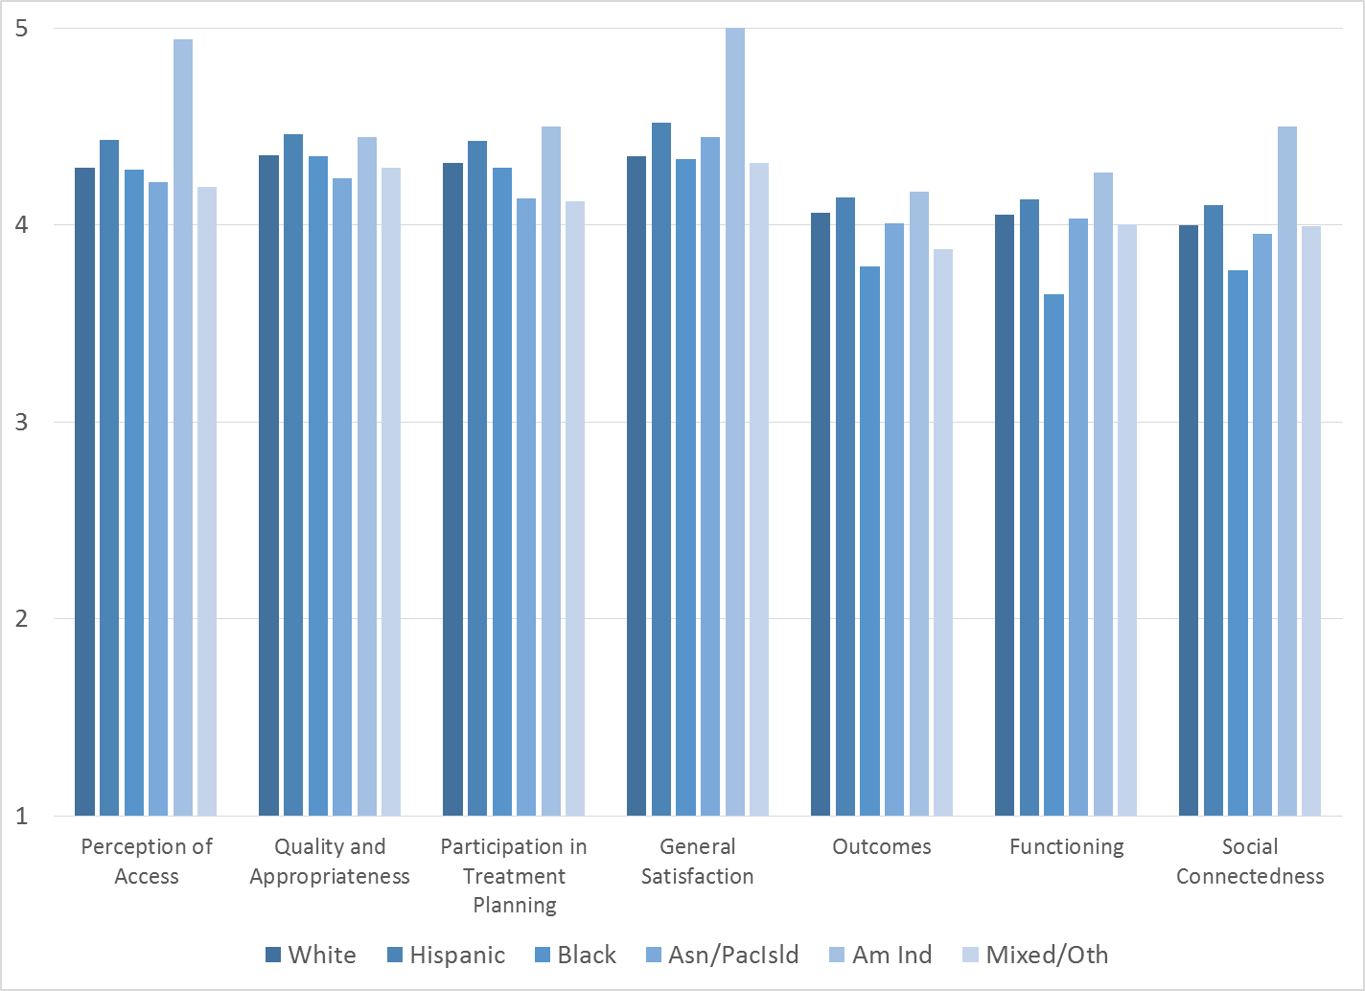

Figure 6. MHSIP scores, County vs contract clinics
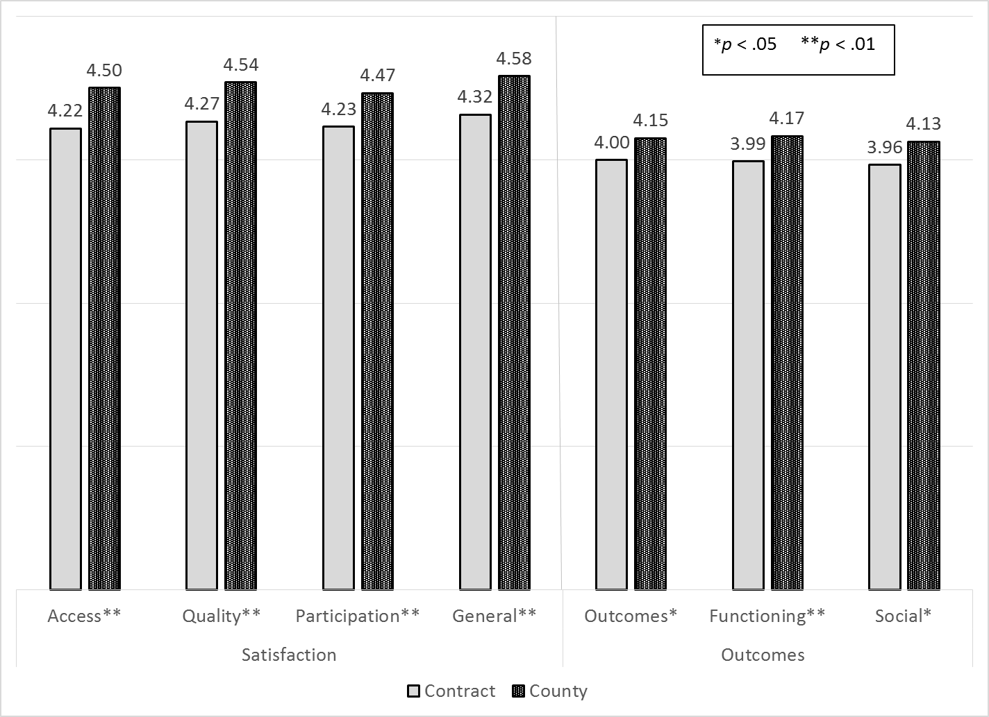

Figure 7. Outcomes and Functioning by time in service
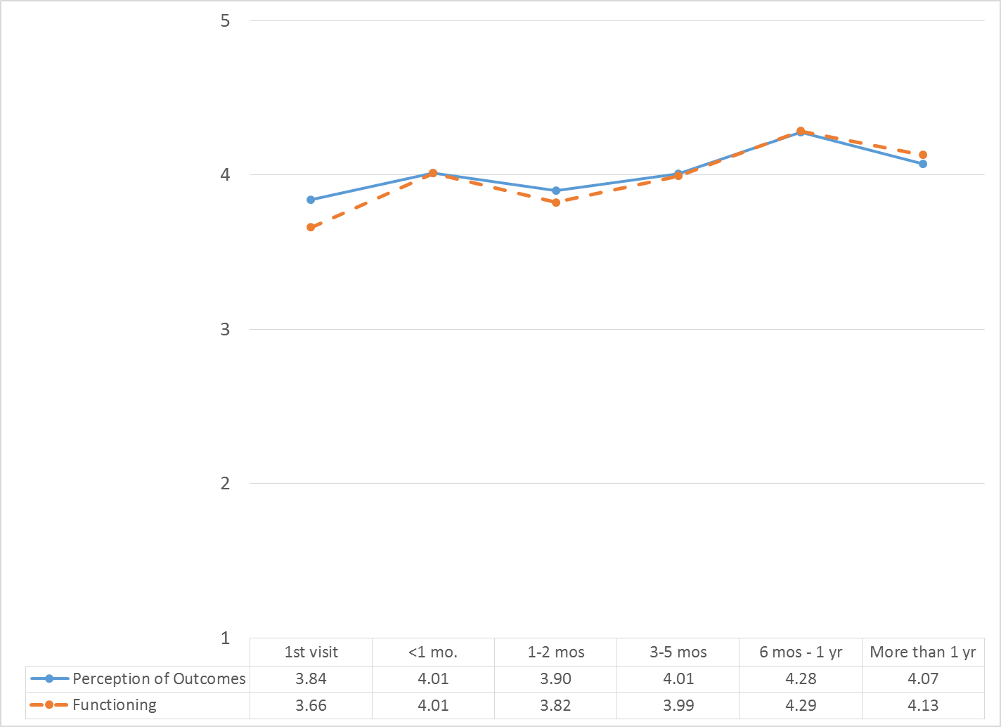

MHSIP scores differed by form language most of the MHSIP scales. Consumers who responded to the English-language survey reported slightly worse satisfaction and functioning than Spanish-speaking clients (Figure 8).

Figure 8. MHSIP scores by form language
(**p < .01 *p < .05)

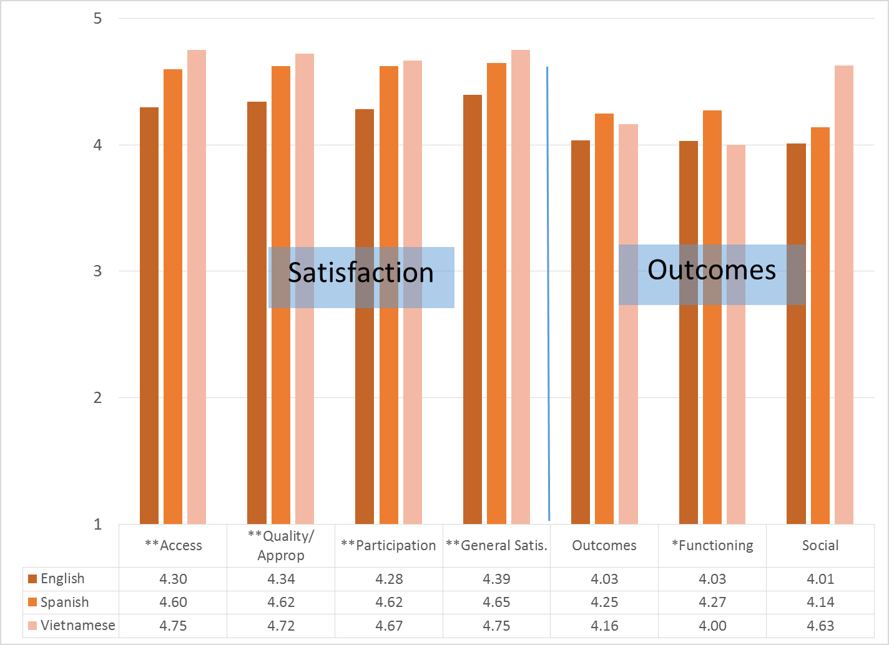

As seen in Figure 9, women’s ratings of satisfaction measures were slightly higher than men’s. There was only one other-gendered individual who was not included in this figure.
Figure 9. MHSIP differences by gender (*p < .001)
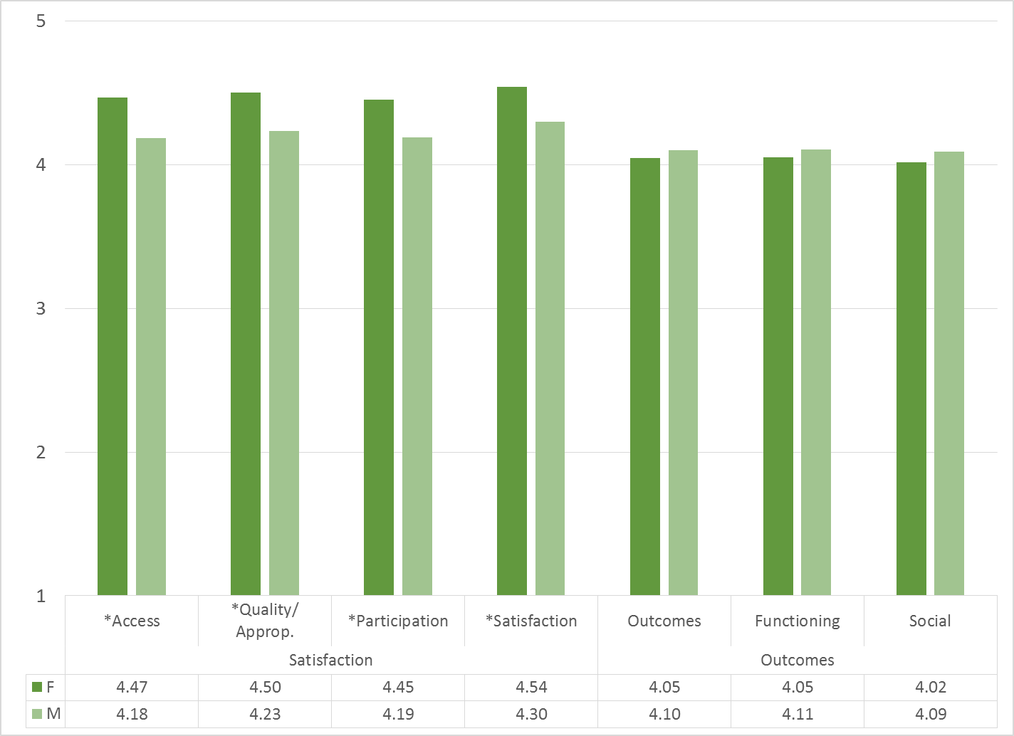

As reflected by Figure 10, all MHSIP scales differed by function area. Clients in the CalWorks, Innovations, and Prevention & Intervention programs tended to give the highest satisfaction ratings. Clients in Substance Use Disorder programs and Prevention & Intervention tended to rate their own functioning highest.

Figure 10. MHSIP differences by function area
(***p < .001, **p < .01, *p < .05)
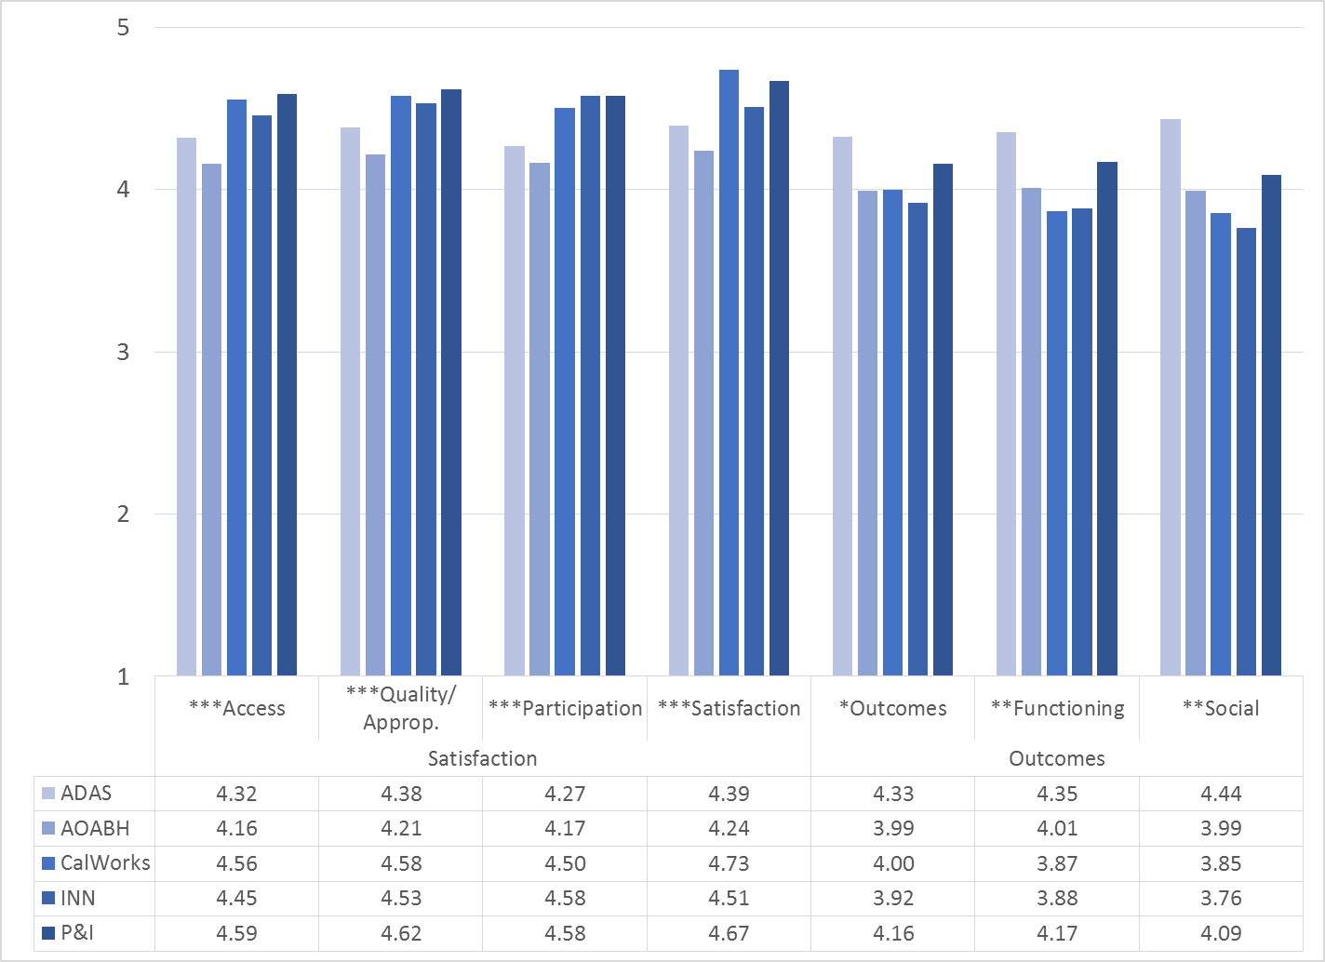

There was a significant negative correlation of the MHSIP scales with age, indicating that ratings of satisfaction and outcomes are lower among older participants (see Figure 11).

Figure 11. Social Connectedness by age group
(***p < .001, **p < .01, *p < .05)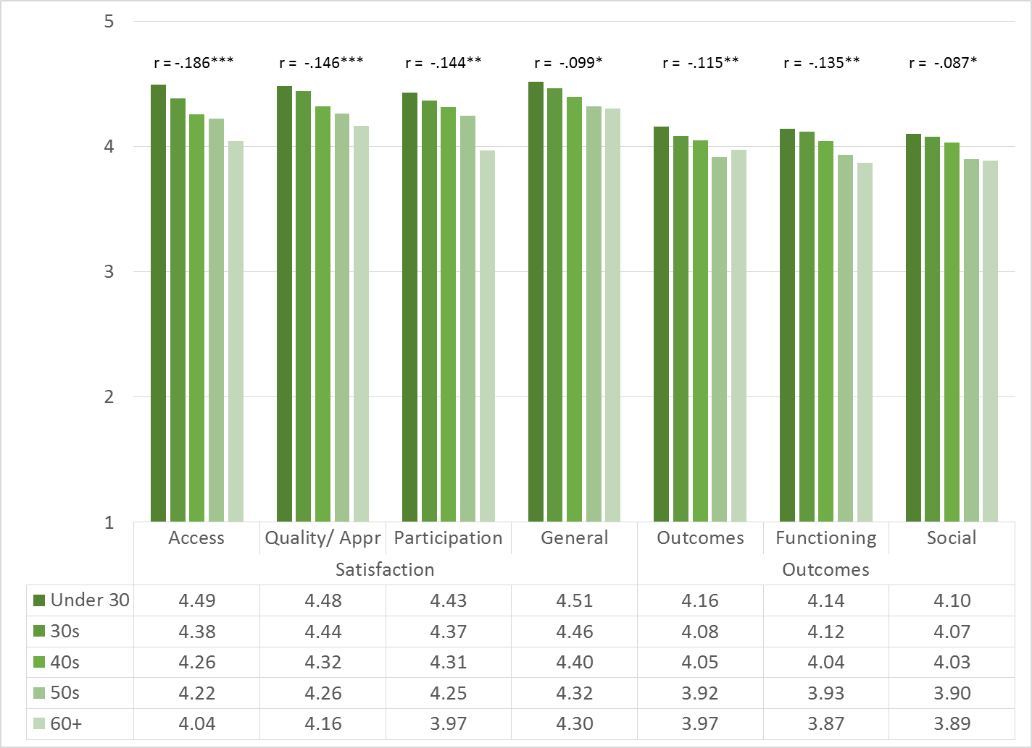

Table 1. MHSIP results by program

Program | Acc | Qual | Partic | Gen | Outc | Func | Social | N
Assisted Outpatient Treatment FSP | 4.81 | 4.87 | 5.00 | 4.72 | 4.04 | 4.13 | 3.35 | 6
ADAS AOD Anaheim Clinic | 4.00 | 4.25 | 4.07 | 4.21 | 4.02 | 4.03 | 4.18 | 8
ADAS AOD Westminster | 5.00 | 5.00 | 5.00 | 5.00 | 5.00 | 5.00 | 5.00 | 1
Anaheim N. DUI Cout | 3.42 | 3.56 | 3.75 | 4.00 | 3.63 | 3.90 | 3.63 | 2
AOABH Anaheim I | 4.11 | 4.11 | 3.71 | 3.71 | 3.52 | 3.79 | 3.82 | 7
AOABH Anaheim II | 4.75 | 4.75 | 4.75 | 4.75 | 4.34 | 4.50 | 4.50 | 4
AOABH Anaheim PACT | 4.67 | 4.00 | 4.00 | 5.00 | 3.50 | 4.20 | 2.50 | 1
AOABH Anaheim TAY PACT | 4.00 | 4.00 | 4.00 | 4.00 | 4.00 | 4.00 | 3.75 | 1
AOABH CalWORKs: Westminster | 4.50 | 4.42 | 4.30 | 4.71 | 4.17 | 3.26 | 3.82 | 7
AOABH College Community Services Anaheim | 4.33 | 4.21 | 4.17 | 4.48 | 3.93 | 3.83 | 3.93 | 8
AOABH Costa Mesa PACT | 4.13 | 4.11 | 4.13 | 4.33 | 3.97 | 3.70 | 3.63 | 4
AOABH FSP Opportunity Knocks | 4.58 | 4.47 | 4.32 | 4.82 | 4.47 | 4.50 | 4.41 | 17
AOABH FSP Steps Telecare | 4.34 | 4.34 | 4.44 | 4.39 | 4.22 | 4.29 | 4.34 | 55
AOABH FSP WIT Telecare | 3.81 | 3.90 | 3.77 | 3.81 | 3.95 | 3.95 | 4.05 | 63
AOABH Fullerton PACT I | 4.72 | 4.56 | 4.33 | 4.67 | 3.96 | 4.07 | 4.00 | 3
AOABH Fullerton PACT II | 4.09 | 4.37 | 4.10 | 4.47 | 4.06 | 3.90 | 4.05 | 12
AOABH SUD/Perinatal Outpatient: Westminster | 4.72 | 4.85 | 5.00 | 5.00 | 4.71 | 4.53 | 4.75 | 3
AOABH Westminster Clinic | 5.00 | 5.00 | 5.00 | 5.00 |  |  |  | 1
Behavioral Health Services for Independent Living-College Community Services | 4.17 | 4.56 | 5.00 | 4.67 | 3.14 | 3.20 | 3.75 | 1
Behavioral Health Services for Military Families Child Guidance Center | 4.62 | 4.44 | 4.42 | 5.00 | 3.83 | 3.92 | 3.95 | 6
BHS Outreach & Engagement | 4.44 | 4.72 | 4.63 | 4.75 | 4.92 | 4.50 | 4.33 | 4
CCS CalWORKS Anaheim | 4.67 | 4.67 | 4.64 | 4.79 | 4.02 | 3.97 | 4.03 | 27
CCS CalWORKs Santa Ana | 4.38 | 4.45 | 4.31 | 4.64 | 3.90 | 3.97 | 3.54 | 15
Community Counseling and Supportive Services | 4.54 | 4.57 | 4.52 | 4.58 | 4.07 | 4.03 | 3.93 | 65
Harbor Drug Court | 4.51 | 4.50 | 4.42 | 4.45 | 4.48 | 4.53 | 4.63 | 20
North Drug Court | 4.20 | 4.18 | 4.00 | 4.20 | 4.18 | 4.20 | 4.20 | 5
North Recovery Center | 4.79 | 4.71 | 4.67 | 5.00 | 3.71 | 3.87 | 4.00 | 4
OC Accept | 4.42 | 4.38 | 4.17 | 4.63 | 3.90 | 4.02 | 3.95 | 10
Orange County Center for Resiliency, Education & Wellness(OC CREW) | 4.71 | 4.73 | 4.71 | 4.79 | 4.69 | 4.85 | 4.75 | 8
Orange County Parent Wellness Program (OCPWP) | 4.72 | 4.75 | 4.73 | 4.82 | 4.17 | 4.20 | 4.18 | 54
Step Forward Onsite Engagement in Collaboratiive Court -Mariposa | 4.37 | 4.57 | 4.71 | 4.31 | 3.95 | 3.87 | 3.69 | 12
Stress Free Families | 4.49 | 4.48 | 4.53 | 4.56 | 4.20 | 4.21 | 4.15 | 26
Telecare and Orange (TAO South) | 4.14 | 4.28 | 4.24 | 4.34 | 3.91 | 3.93 | 3.83 | 66
Telecare and Orange (TAO) | 3.94 | 3.93 | 3.96 | 3.91 | 3.58 | 3.55 | 3.42 | 24
West DUI Court | 3.50 | 3.56 | 3.00 | 4.00 | 3.63 | 3.80 | 3.75 | 1
Total | 4.34 | 4.39 | 4.33 | 4.43 | 4.07 | 4.07 | 4.04

Yellow highlight = higher than overall average (+3 std. errors)
Grey highlight = lower than overall average (-3 std. errors)

