Consumer Perception Survey: MHSIP

November 2016 Administration
Adults and Seniors
Jonathan Rich, Ph.D.
July 28, 2016

The Mental Health Statistical Improvement Program (MHSIP) was offered to all clients attending mental health services at a County or contract adult program during the week of November16-20, 2016. There were 995 records returned (973 adults; 22 older adults). Records were discarded if program number was missing or was not a valid number, leaving 771 cases. Cases were then removed if the program was part of Children and Youth Behavioral Health, leaving 740 cases. Only cases with an age from 18-120 were retained. This left 659 cases.

Results

Sample description:

N: 659
Gender (n = 641): F 59.4%, M 40.1%, O 0.5%
Age (n = 659): Mean: 38.0 years, s = 12.2, range = 18 to 95.
Form Language (n = 659): English, 80.1% Spanish, 17.6%, Vietnamese, 2.3%
County/Contract (n = 659): County 64.6% vs. Contract 35.4%

Figure 1. Service Area (n = 659)
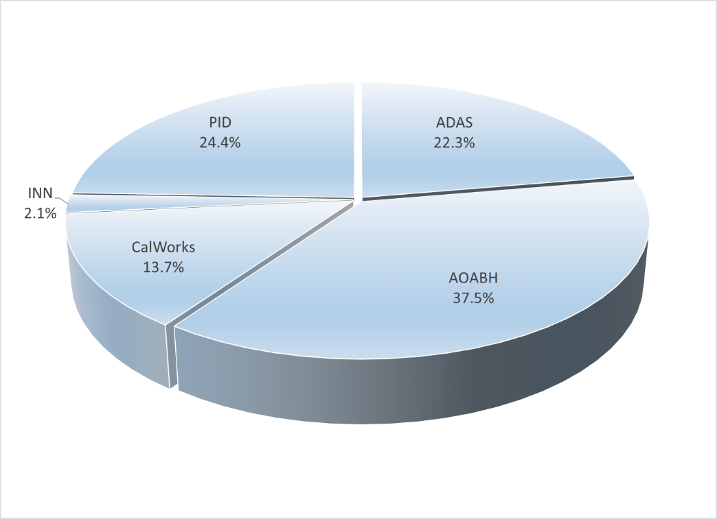

Figure 2. Race/Ethnicity (n = 633)
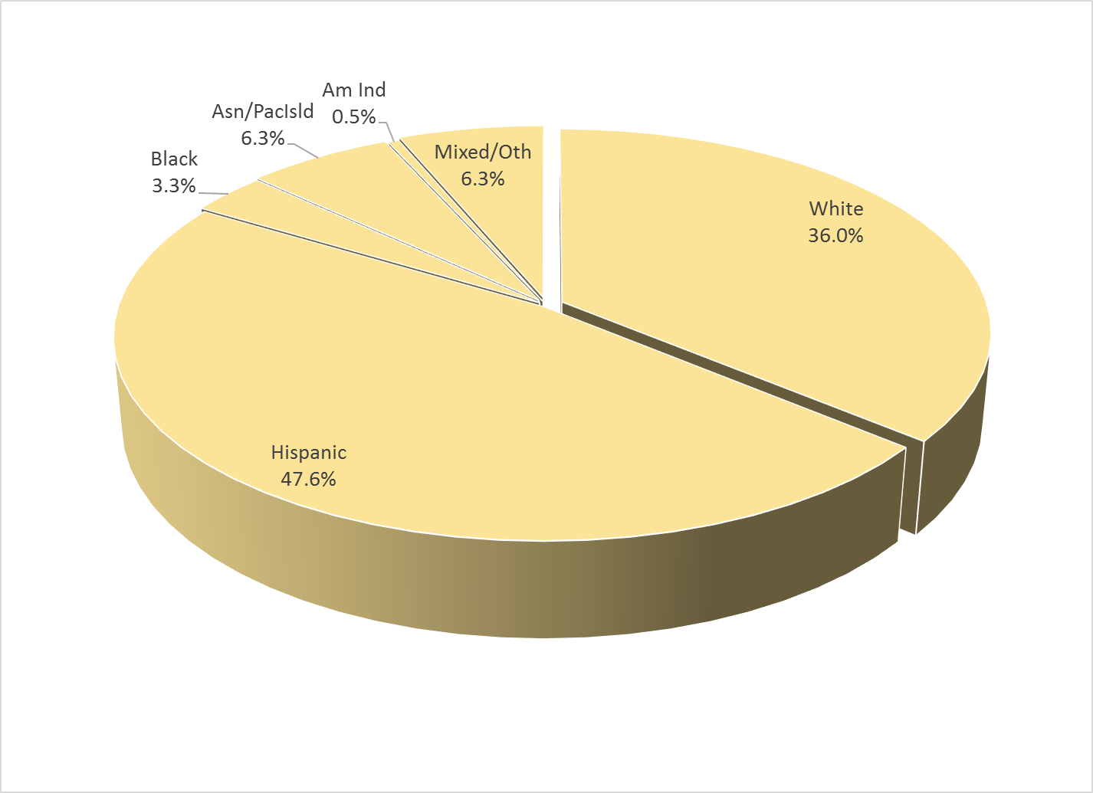

Survey respondents describe their race and ethnicity by selecting as many of the following categories as applicable: Hispanic, American Indian, Asian, Black, Pacific Islander, White, Other Race, and Unknown Race. These selections were reduced to six categories as follows. If either Asian, Pacific Island, or both are selected, that is considered a single category, “Asian/Pacific Islander.” If only one category is selected, then the participant is assigned to that category. If more than one category is selected, or if “Other Race” or “Unknown Race” is selected, the participant is classified as “Mixed/Other.” If Hispanic is selected, the client is classified as “Hispanic,” regardless of the other selections.

MHSIP Scale Scores:

Consistent with past results, responses to service satisfaction items average between “Agree” (4) and “Strongly Agree” (5). Response to items that reflect personal functioning are lower, just at the “Agree” level (4.0). Endorsement of service satisfaction items was near 90%; about three fourths of respondents endorsed personal functioning items.

Figure 3. Mean Scores: MHSIP Service Satisfaction
(Scale is 1-"strongly disagree" to 5-"strongly agree")

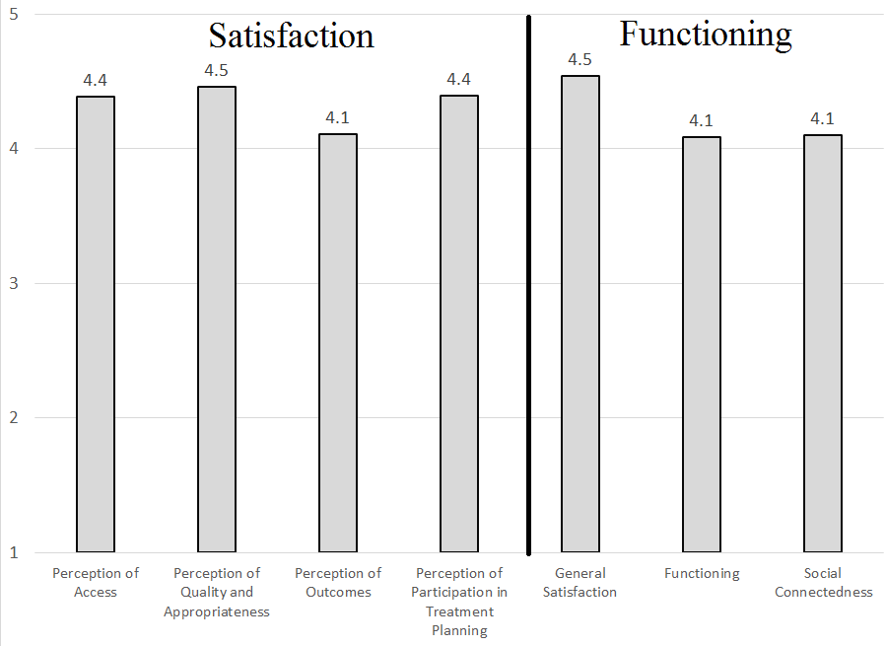

Figure 4. Percent with scores at or above 3.5, "Agree" and "Strongly Agree"
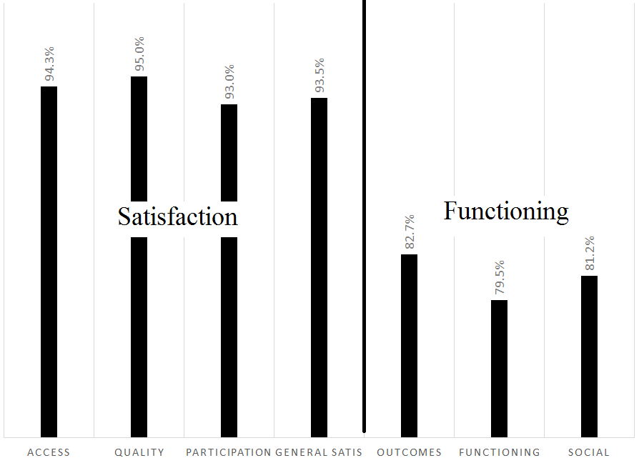

Factors affecting MHSIP scores

The MHSIP mean scores did not differ significantly by race/ethnicity (see Figure 5), whether a program was County vs. contract, or by age.

Figure 5. MHSIP scores by race/ethnicity
(Note: Race/ethnicity differences are non-significant on all scales, p > .01)
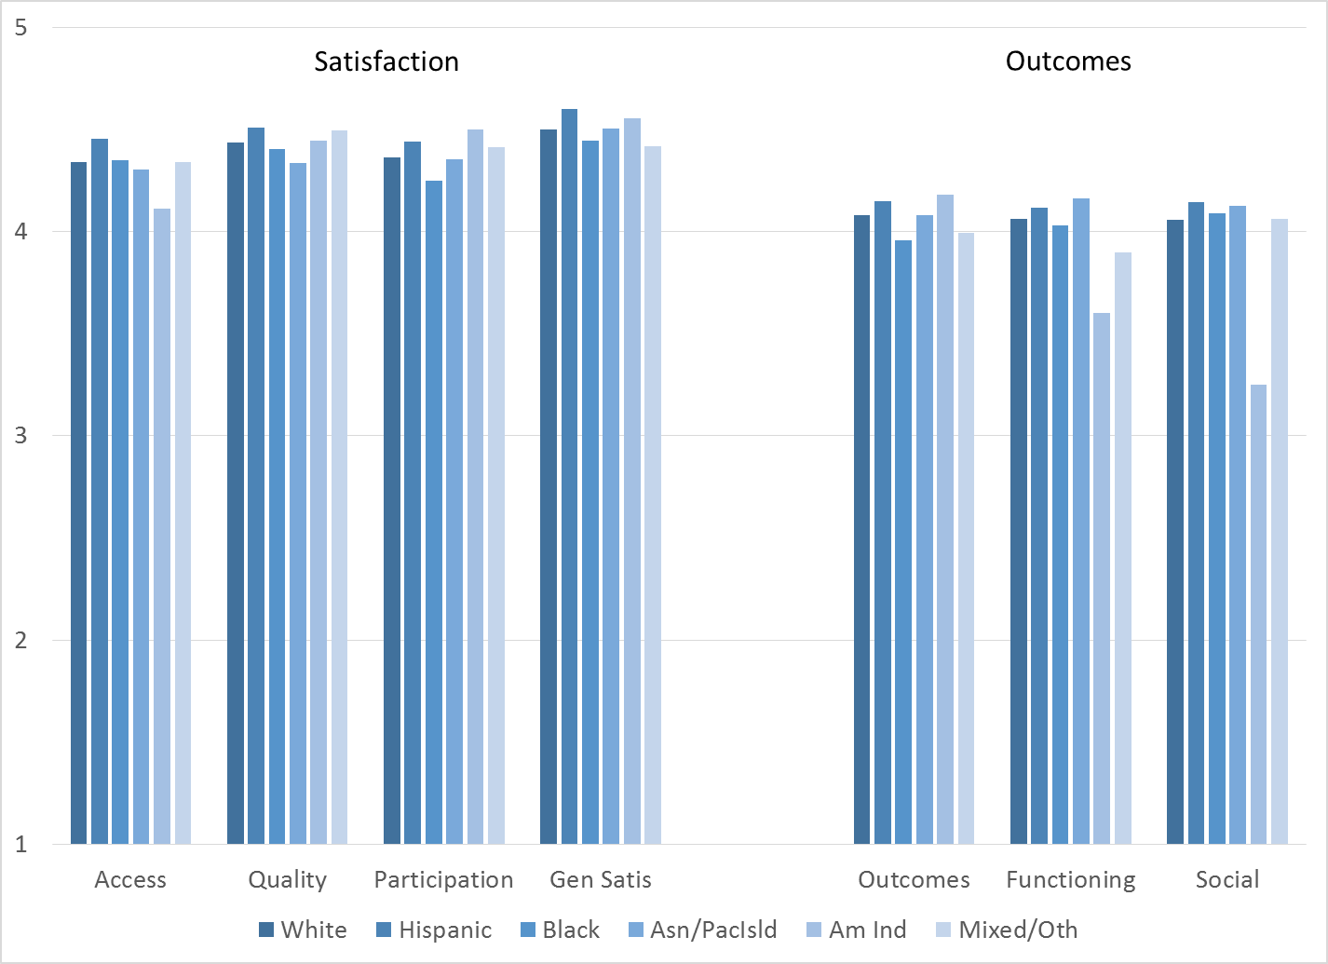

MHSIP scores differed by form language on the Access scale. Consumers who responded to the Spanish-language survey reported slightly better access than other clients (Figure 6).
Figure 6. MHSIP scores by form language
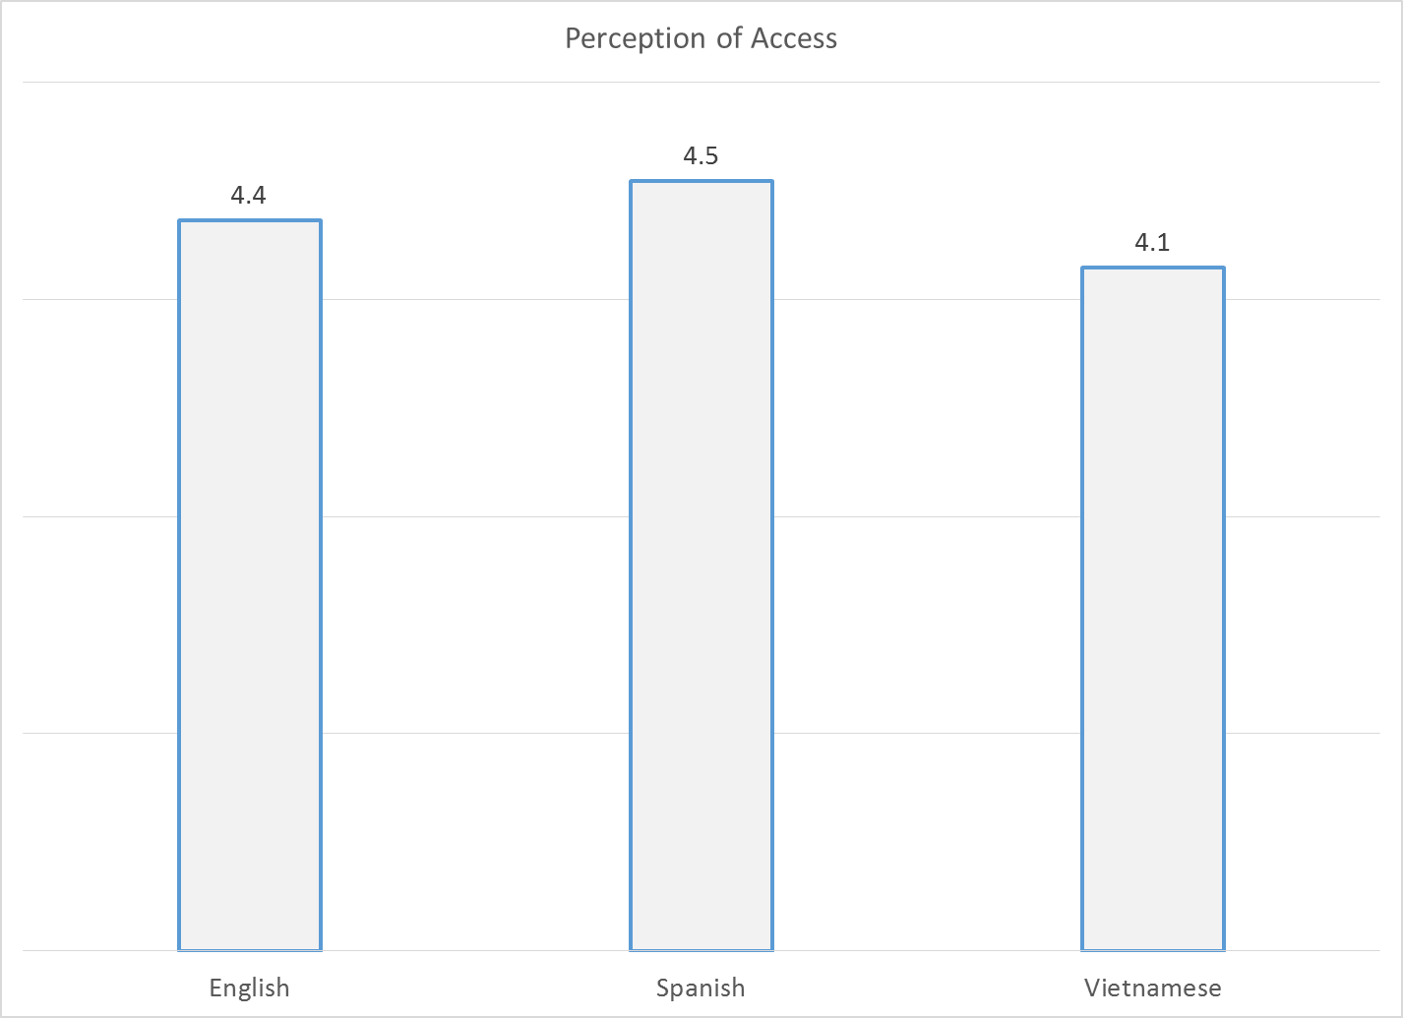

As seen in Figure 7, women’s ratings on the four satisfaction scales were slightly higher than men’s.
Figure 7. MHSIP differences by gender
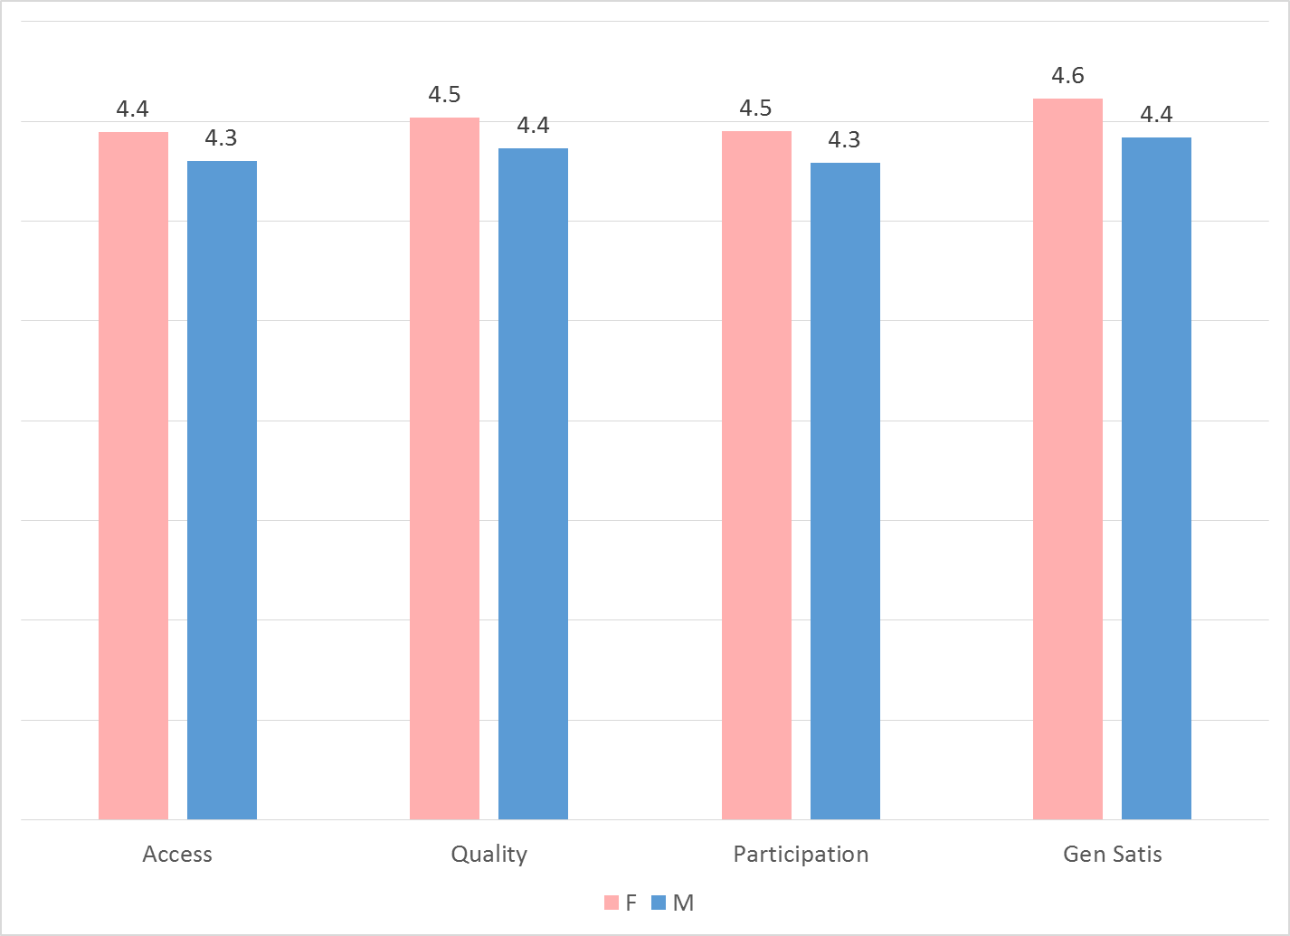

As reflected by Figure 8, all MHSIP scales differed by function area. Consumers in the CalWorks and Prevention & Intervention programs tended to give the highest satisfaction ratings. Consumers in Substance Use Disorder programs and Prevention & Intervention tended to rate their own functioning highest.

Figure 8. MHSIP differences by function area
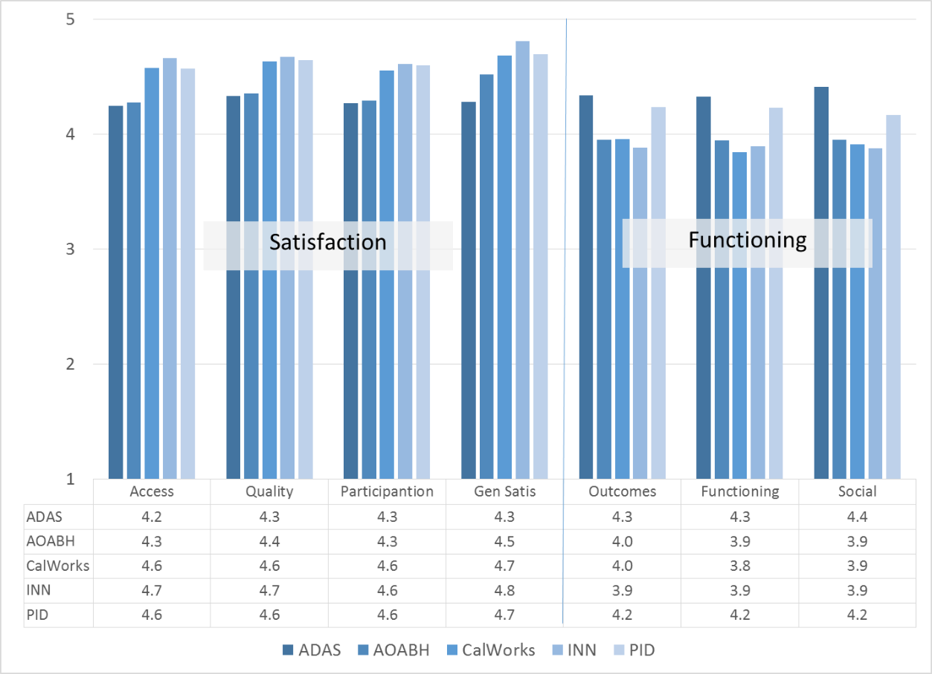

There were significant positive correlations with time in treatment for the Functioning (r = .11) and Perception of Outcomes (r = .13), indicating that ratings of both areas increase with more time in treatment.

Figure 9. Perception of Outcomes & Functioning by time in treatment
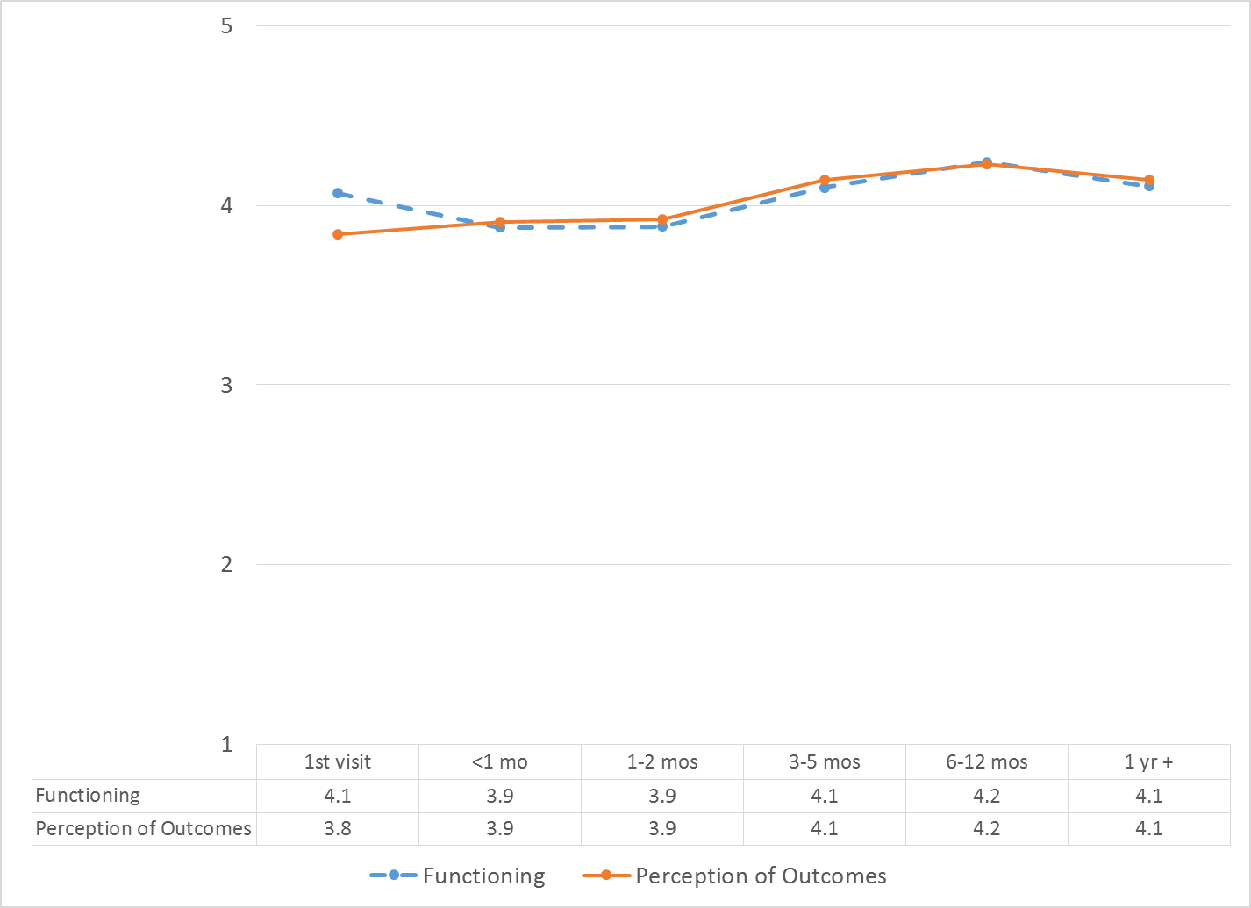

There was a significant difference on the Function and Perception of Outcomes scales for County vs. contract clinics. Consumers at the County clinics gave higher mean reports on both scales.

Figure 10. County vs. contract clinics: Mean scores on Outcomes and Functioning scales
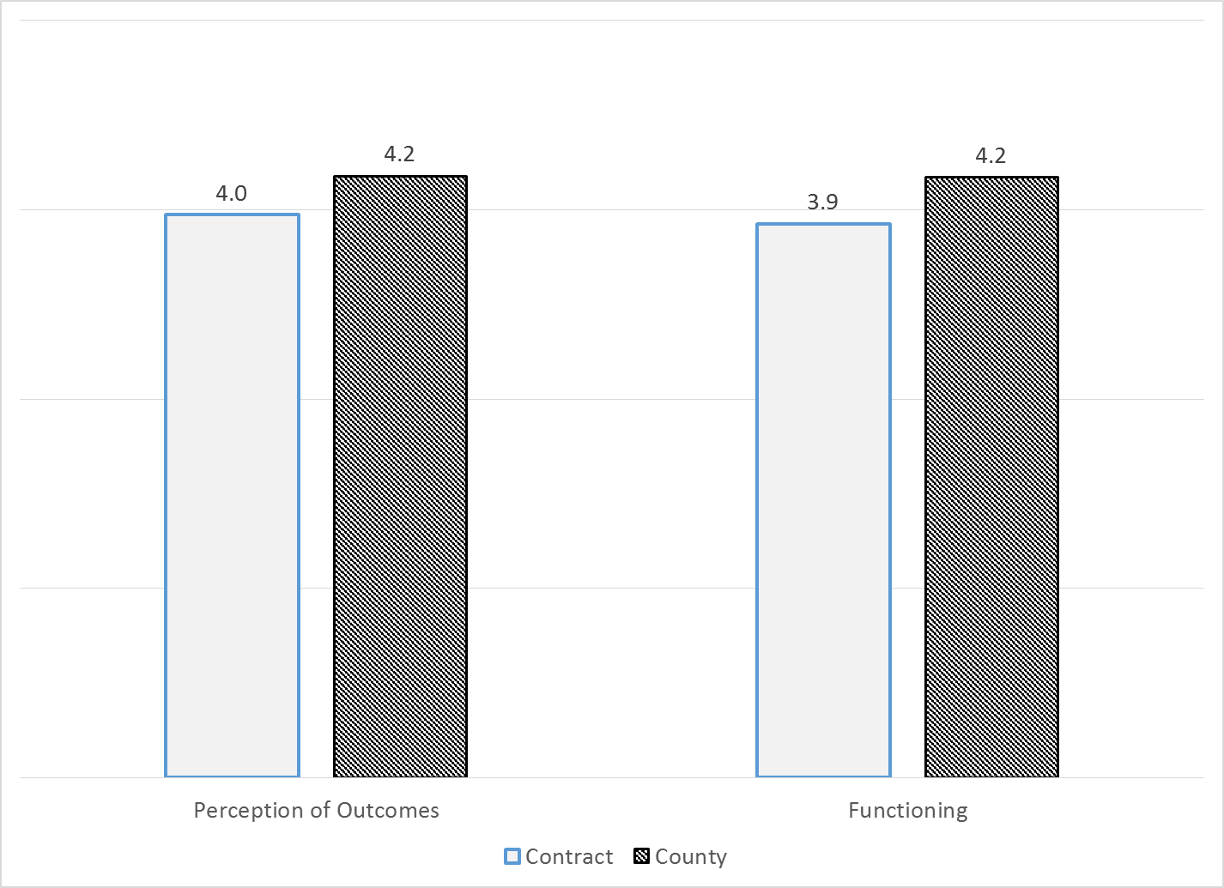

Table 1. MHSIP results by program
Program | Access | Quality | Partic | Gen Satis | Out-comes | Func | Social | N
ADAS Aliso Viejo Drug Court | 5.0 | 5.0 | 5.0 | 5.0 | 5.0 | 5.0 | 5.0 | 2
ADAS AOD Aliso Viejo | 4.0 | 3.1 | 4.0 | 2.7 | 3.9 | 3.4 | 3.5 | 1
ADAS AOD Anaheim Clinic | 4.1 | 4.1 | 4.2 | 4.3 | 4.3 | 4.2 | 4.3 | 17
ADAS AOD Westminster | 4.4 | 4.6 | 4.7 | 3.7 | 4.6 | 4.7 | 4.3 | 3
ADAS AOD, Santa Ana | 5.0 | 5.0 | 5.0 | 3.7 | 5.0 | 4.6 | 4.3 | 1
ADAS Perinatal, Aliso Viejo | 4.2 | 4.2 | 4.3 | 4.5 | 4.2 | 4.4 | 4.6 | 5
ADAS Perinatal, Anaheim | 4.3 | 4.4 | 4.1 | 4.5 | 4.1 | 4.2 | 4.5 | 13
Anaheim N. DUI Cout | 4.5 | 4.3 | 4.0 | 4.2 | 4.3 | 4.3 | 4.2 | 3
AOABH Mental Health Assoc. GG | 4.2 | 4.3 | 4.3 | 4.5 | 4.0 | 4.0 | 4.1 | 27
AOABH AB109 | 5.0 | 5.0 | 5.0 | 5.0 | 4.8 | 5.0 | 5.0 | 1
AOABH Aliso Viejo Clinic | 3.8 | 4.9 | 4.5 | 5.0 | 3.6 | 4.2 | 4.8 | 1
AOABH Anaheim I | 4.5 | 4.5 | 4.4 | 4.6 | 3.6 | 3.5 | 3.5 | 14
AOABH Anaheim II | 4.2 | 4.5 | 3.8 | 4.2 | 3.6 | 3.5 | 3.8 | 3
AOABH Anaheim PACT | 4.8 | 4.7 | 4.8 | 4.8 | 4.2 | 4.2 | 3.7 | 4
AOABH CalWORKs: Westminster | 4.6 | 4.7 | 4.7 | 4.7 | 3.7 | 3.5 | 3.8 | 15
AOABH Costa Mesa PACT | 4.3 | 4.4 | 4.3 | 4.5 | 4.2 | 4.1 | 4.0 | 21
AOABH FSP Opportunity Knocks | 4.3 | 4.4 | 4.1 | 4.8 | 4.0 | 4.0 | 4.1 | 32
AOABH FSP WIT | 4.4 | 4.1 | 3.5 | 4.0 | 4.4 | 4.0 | 4.5 | 1
AOABH Fullerton PACT I | 4.3 | 4.4 | 4.4 | 4.4 | 3.9 | 4.1 | 4.2 | 7
AOABH Fullerton PACT II | 4.2 | 4.3 | 4.5 | 4.5 | 4.0 | 4.0 | 3.8 | 15
AOABH PACT TSR | 3.9 | 4.1 | 3.8 | 4.0 | 3.9 | 3.6 | 3.5 | 6
AOABH Santa Ana | 4.2 | 4.4 | 4.4 | 4.5 | 3.7 | 3.8 | 3.6 | 28
AOABH Santa Ana Pac Asian | 4.3 | 4.1 | 4.0 | 4.3 | 4.1 | 4.1 | 4.3 | 4
AOABH SUD/Perinatal Outpatient: Westminster | 4.0 | 4.3 | 4.2 | 4.3 | 3.9 | 4.0 | 4.1 | 8
AOABH Westminster Clinic | 4.5 | 4.6 | 4.5 | 4.5 | 3.6 | 3.8 | 3.0 | 2
AOABH Westminster PACT | 3.8 | 3.6 | 4.0 | 4.0 | 3.6 | 3.6 | -- | 1
Behavioral Health Services for Military Families Child Guidance Center | 4.5 | 4.5 | 4.5 | 4.6 | 3.7 | 3.4 | 3.6 | 3
CalWORKS Mariposa Women & Family Center | 4.6 | 4.7 | 4.6 | 4.8 | 3.9 | 3.8 | 3.8 | 19
Camino Nuevo | 4.1 | 3.9 | 4.4 | 4.5 | 4.0 | 3.8 | 3.8 | 5
CCS CalWORKS Anaheim | 4.7 | 4.7 | 4.5 | 4.7 | 4.0 | 3.9 | 4.1 | 28
CCS CalWORKs Santa Ana | 4.3 | 4.2 | 4.2 | 4.3 | 3.9 | 4.0 | 3.9 | 11
Community Counseling and Supportive Services | 4.5 | 4.6 | 4.6 | 4.7 | 4.2 | 4.2 | 4.1 | 61
Drug/DUI/DV Court | 4.2 | 4.3 | 4.2 | 4.2 | 4.3 | 4.2 | 4.3 | 40
Harbor Drug Court | 4.1 | 4.2 | 4.1 | 4.2 | 4.3 | 4.3 | 4.3 | 22
Mariposa CalWORKs San Juan Capistrano | 4.5 | 4.6 | 4.5 | 4.7 | 4.2 | 4.0 | 3.9 | 17
Mission Viejo PACT Services | 5.0 | 5.0 | 5.0 | -- | 4.7 | 5.0 | 5.0 | 1
North Drug Court | 4.4 | 4.5 | 4.5 | 4.5 | 4.6 | 4.7 | 4.7 | 31
North Recovery Center | 4.6 | 3.9 | 4.1 | 3.9 | 4.4 | 4.7 | 3.5 | 4
OA Mental Health Recovery Program | 4.2 | 4.2 | 4.3 | 4.7 | 3.8 | 3.5 | 4.0 | 3
OC Accept | 4.3 | 4.6 | 4.8 | 4.4 | 4.1 | 3.9 | 4.0 | 11
Older Adult Support and Intervention System (OASIS) | 4.2 | 4.2 | 4.2 | 4.2 | 3.6 | 3.7 | 3.8 | 9
Orange County Center for Resiliency, Education & Wellness(OC CREW) | 4.2 | 4.5 | 4.2 | 4.4 | 4.1 | 4.2 | 4.0 | 11
Orange County Postpartum Wellness (OCPPW) | 4.7 | 4.7 | 4.6 | 4.8 | 4.3 | 4.2 | 4.2 | 55
South Recovery Center | 4.8 | 4.8 | 3.0 | 5.0 | 4.2 | 4.4 | 3.9 | 2
Step Forward Program Collaborative On Site Engagement | 4.7 | 4.7 | 4.6 | 4.9 | 3.9 | 4.1 | 4.0 | 11
Stress Free Families | 4.8 | 4.7 | 4.6 | 4.6 | 4.5 | 4.5 | 4.5 | 19
Telecare and Orange (TAO South) | 4.3 | 4.4 | 4.4 | 4.5 | 4.0 | 4.1 | 4.1 | 54
Youth as Parents | 5.0 | 5.0 | 5.0 | 5.0 | 4.7 | 4.9 | 4.4 | 3
Total | 4.4 | 4.5 | 4.4 | 4.5 | 4.1 | 4.1 | 4.1

Highlighting shows scores that are significantly HIGHER or LOWER than the overall program mean.

