Consumer Perception Survey: MHSIP

April/May 2014 Administration
Adults and Seniors
Jonathan Rich, Ph.D.

The Mental Health Statistical Improvement Program (MHSIP) was offered to all clients attending mental health services at a County or contract adult program from April – May 2014. Records were discarded if program was missing or if the program was part of Children and Youth Behavioral Health.

Results

Sample description:

N: 1064
Gender (n = 935): F 56.5%, M 42.8%, O 0.6%
Age: [Due to scanner malfunctions, age and birth date was not available]
Form Language (n = 702): English, 89.8% Spanish, 8.7%, Vietnamese, 1.5%
County/ Contract (n = 702): County 56.3% vs. Contract 43.7%
Division (n = 1064): AOABH 61.4%, ADAS 24.8%, CalWorks 13.7% PID 0.1%

Race/Ethnicity (n = 940):
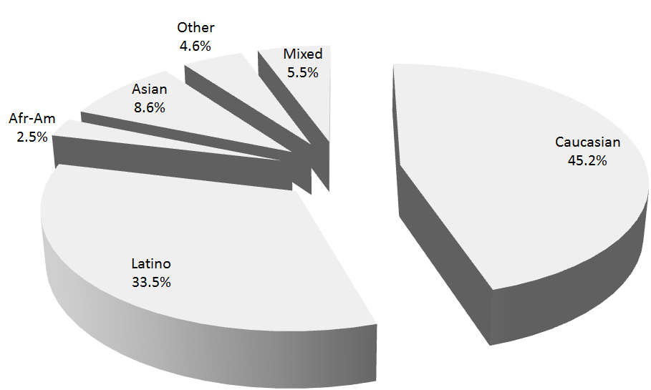

Form Language (n = 1064)

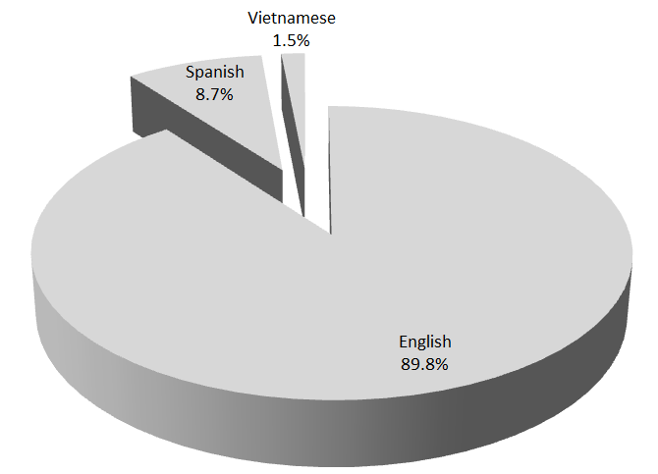

MHSIP Scale Scores:

Figure 1. Mean Scores: MHSIP Service Satisfaction
(Error bars show SD; scale is 1-"strongly disagree" to 5-"strongly agree")
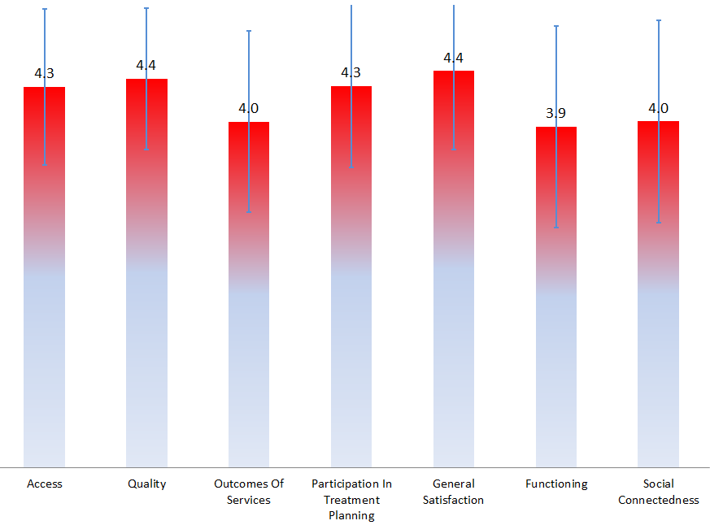

Figure 2. Percent with scores above 3.5, "Agree" and "Strongly Agree"
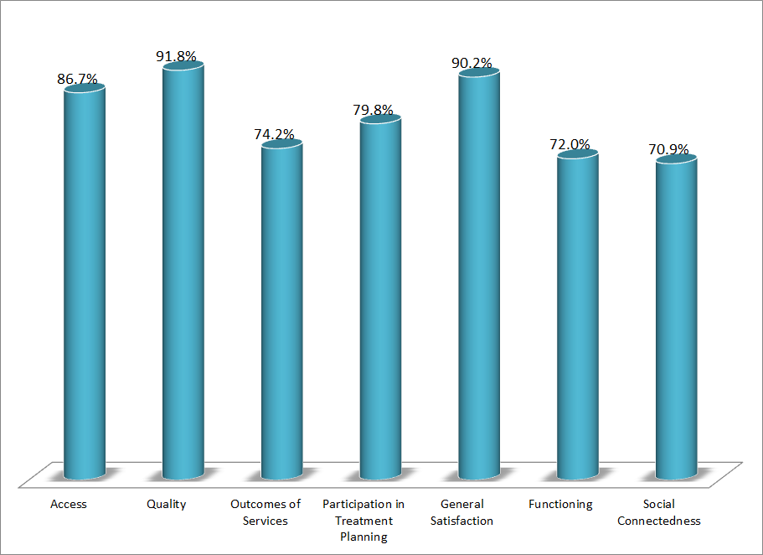

Factors affecting scores:

Factors affecting MHSIP scores are examined below. Because multiple comparisons are being made, a conservative alpha level of .01 is used.

Gender: General Satisfaction was slightly but significantly higher for women than for men, 4.5 vs. 4.4.

Form Language: Spanish-speakers’ perception of access was higher than the perceptions of English or Vietnamese-speakers, 4.5 for Spanish, vs. 4.3 for English and Vietnamese.

Adult vs Older Adult: Scores did not differ significantly by age group.

County vs. Contract Clinics: Clients at County clinics scored higher than contract clinic clients on their perception of outcomes of services, functioning, and social connectedness, 4.1 vs. 3.9, 4.0 vs. 3.8, and 4.1 vs. 3.9, respectively. Contract clinic clients reported higher general satisfaction, 4.5 vs. 4.3.

Division: There were significant differences across divisions on all MHSIP scales except “Participation in Treatment Planning.” In general, CalWorks clients gave the highest ratings of service satisfaction and ADAS clients gave the highest ratings of personal function.

Figure 3. MHSIP scores by division
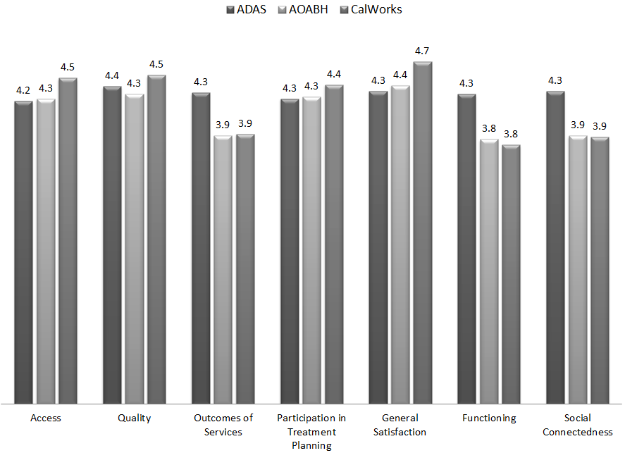

Race/Ethnicity: The Outcomes of Services and Functioning scales differed across ethnic/racial groups, with African-Americans and those of mixed race tending to score lower on these scales.

Figure 4. Outcomes of Services and Functioning by Ethnicity
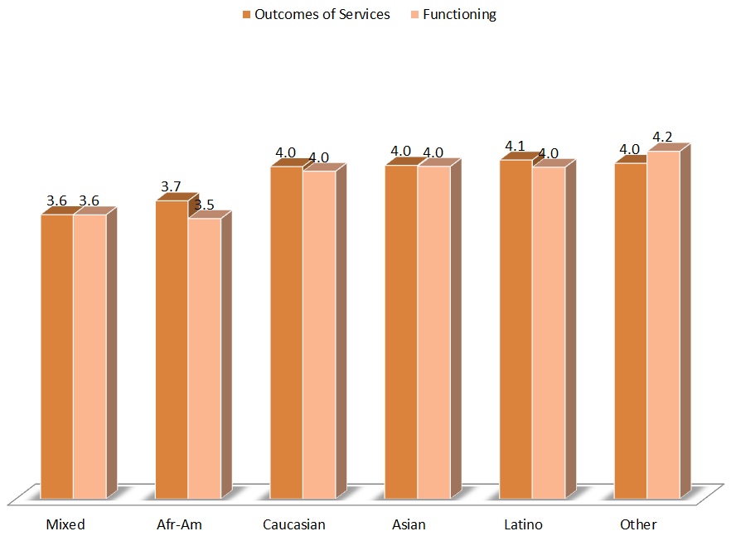

Time in Service

The Outcomes of Services and Functioning scales were positively correlated with time in service, r = .10 and .09, respectively. The relationship is reflected by Figure 5.

Figure 5. Outcomes of Services and Functioning by Time in Service
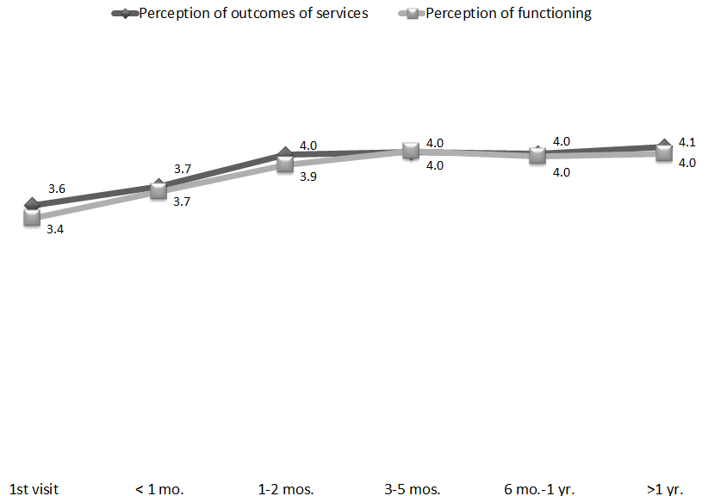

The table below shows the mean MHSIP scores and the number of surveys returned, by program.

Table 1. Mean MHSIP scores and number of surveys returned, by program
Program | Access | Quality | Outcomes | Partici- pation | General Satisfaction | Func- tioning | Social | N
ADAS Perinatal, Santa Ana | 4.5 | 4.6 | 4.5 | 4.4 | 4.7 | 4.3 | 4.7 | 6
ADAS Aliso Viejo Drug Court | 4.3 | 4.3 | 4.4 | 4.3 | 4.2 | 4.4 | 4.4 | 23
ADAS AOD Aliso Viejo | 4.4 | 4.5 | 4.1 | 4.3 | 4.2 | 3.8 | 4.1 | 10
ADAS AOD Anaheim Clinic | 4.3 | 4.7 | 4.2 | 4.4 | 4.5 | 4.1 | 4.3 | 18
ADAS AOD Westminster | 4.5 | 4.5 | 4.4 | 4.8 | 4.7 | 4.4 | 4.3 | 6
ADAS AOD, Santa Ana | 3.5 | 4.6 | 2.4 | 3.5 | 4.0 | 3.2 | 3.5 | 1
ADAS Perinatal, Aliso Viejo | 4.8 | 4.7 | 4.5 | 4.3 | 5.0 | 4.7 | 4.6 | 6
ADAS Perinatal, Anaheim | 4.3 | 4.3 | 4.4 | 4.2 | 4.4 | 4.4 | 4.6 | 26
ADAS Perinatal, Westminster | 4.5 | 4.7 | 4.5 | 4.6 | 4.7 | 4.5 | 4.5 | 29
Aliso Viejo PACT Services | 4.5 | 4.2 | 3.7 | 4.7 | 4.4 | 3.7 | 3.7 | 7
Anaheim N. DUI Cout | 4.0 | 4.3 | 4.3 | 4.2 | 4.3 | 4.0 | 4.1 | 19
AOABH AB109 | 4.9 | 4.8 | 4.8 | 4.6 | 4.9 | 4.6 | 5.0 | 4
AOABH Aliso Viejo PACT TAY | 5.0 | 5.0 | 2.0 |  | 5.0 | 1.0 | 2.8 | 1
AOABH College Community Services Anaheim | 4.3 | 4.2 | 4.0 | 4.3 | 4.5 | 4.0 | 4.0 | 53
AOABH Costa Mesa PACT | 4.3 | 4.3 | 4.0 | 4.4 | 4.3 | 4.3 | 4.0 | 27
AOABH Fullerton PACT | 4.6 | 4.5 | 3.9 | 4.3 | 4.6 | 4.0 | 4.2 | 9
AOABH Mission Viejo Clinic | 4.2 | 4.2 | 3.5 | 4.0 | 4.3 | 3.5 | 3.7 | 30
AOABH PACT TAY | 4.0 | 4.1 | 4.5 | 4.0 | 4.0 | 4.5 | 4.7 | 3
AOABH PACT TSR | 4.3 | 4.3 | 3.9 | 4.3 | 4.3 | 4.0 | 4.0 | 10
AOABH Santa Ana | 4.1 | 4.3 | 3.7 | 4.2 | 4.1 | 3.6 | 3.8 | 65
AOABH Santa Ana Pac Asian | 4.4 | 4.4 | 4.2 | 4.5 | 4.1 | 4.2 | 4.1 | 6
AOABH Westminster Clinic | 4.3 | 4.4 | 3.7 | 4.3 | 4.5 | 3.7 | 3.6 | 22
AOABH Westminster PACT | 4.5 | 4.5 | 4.3 | 4.7 | 4.5 | 4.3 | 4.4 | 11
AOABH Westminster, Pac Asian | 4.2 | 4.3 | 4.0 | 4.0 | 5.0 | 4.0 | 4.0 | 1
AOABH- Mental Health Assoc.- CM | 4.8 | 4.8 | 4.4 | 4.8 | 4.7 | 4.3 | 3.9 | 3
AOABH- Mental Health Assoc.- GG | 4.3 | 4.3 | 3.7 | 4.3 | 4.5 | 3.6 | 3.7 | 16
AOABH-Anaheim I | 4.0 | 4.3 | 3.5 | 4.2 | 4.2 | 3.6 | 3.7 | 36
AOABH-Anaheim II | 3.8 | 4.0 | 3.5 | 3.9 | 4.0 | 3.8 | 3.4 | 17
AOABH-Anaheim PACT | 4.7 | 4.6 | 3.7 | 4.3 | 4.3 | 3.6 | 3.8 | 4
CalWORKS Mariposa Women & Family Center | 4.4 | 4.4 | 4.0 | 4.4 | 4.8 | 3.8 | 3.7 | 45
Camino Nuevo | 4.5 | 4.6 | 4.2 | 4.6 | 4.7 | 4.0 | 4.1 | 45
CCS CalWORKS Anaheim | 4.5 | 4.6 | 3.8 | 4.5 | 4.5 | 3.7 | 4.1 | 24
CCS CalWORKs Santa Ana | 4.5 | 4.5 | 4.0 | 4.4 | 4.5 | 3.9 | 3.9 | 33
CCS CalWORKs Westminster | 4.4 | 4.5 | 3.7 | 4.4 | 4.7 | 3.4 | 3.7 | 20
College Community Services, Opportunity Knocks | 4.6 | 4.4 | 4.3 | 4.2 | 4.7 | 4.3 | 4.4 | 29
Drug/DUI/DV Court | 4.1 | 4.3 | 4.3 | 4.1 | 4.2 | 4.3 | 4.3 | 94
Mariposa CalWORKs San Juan Capistrano | 4.7 | 4.7 | 3.9 | 4.5 | 4.8 | 3.9 | 3.9 | 23
Mental Health Assoc.  Lake Forest | 4.4 | 4.4 | 4.1 | 4.3 | 4.7 | 4.0 | 3.8 | 9
North Drug Court | 4.2 | 4.4 | 4.3 | 4.4 | 4.3 | 4.4 | 4.4 | 24
North Recovery Center | 4.4 | 4.5 | 4.2 | 4.5 | 4.6 | 4.1 | 4.1 | 46
OA Mental Health Recovery Program | 4.5 | 4.5 | 4.0 | 4.5 | 4.8 | 3.9 | 3.8 | 23
Older Adult Services PACT | 3.3 | 3.6 | 3.3 | 4.0 | 4.0 | 2.8 | 3.5 | 1
Orange County Postpartum Wellness (OCPPW) | 5.0 | 5.0 |  | 5.0 | 5.0 | 3.6 | 4.0 | 1
PC1210 | 5.0 | 5.0 | 5.0 | 5.0 | 3.7 | 5.0 | 4.0 | 1
South Recovery Center | 4.3 | 4.1 | 3.4 | 4.1 | 4.3 | 3.8 | 3.4 | 6
Telecare and Orange (TAO-South) | 4.0 | 4.2 | 3.7 | 4.3 | 4.3 | 3.7 | 3.7 | 61
Telecare and Orange (TAO) | 4.2 | 4.2 | 3.7 | 4.2 | 4.4 | 3.7 | 3.7 | 103

