Consumer Perception Surveys
May 2018 YSS-F Administration
Children and Youth (Family Report)
Jonathan Rich, Ph.D.
February 1, 2019

The Youth Satisfaction Survey for Families (YSS-F) was offered to all parents and guardians of children and youths attending mental health services at a County or contract CYBH clinic from May 2018. There were 984 surveys returned. YSS-F records with birthdates corresponding to an age of 0 – 25, with a valid program code, and with a CYBH, ADAS or Prevention & Intervention program indicated were retained for this analysis. This reduced the file to 1045 surveys.

YSS-F Results

Sample description:

N: 1045
Gender (n = 1009): F-370 (507), M-498 (49.4%), O-4 (0.4%)
Age (n = 1045): Mean = 11.5, s = 4.1, range = 0-21.
Form Language (n = 1045): English- 574 (54.9%), Spanish- 437 (41.8%), and Vietnamese-31 (3.0%), Chinese- 3 (0.3%).
Function Area (n = 1045): CYBH-983 (94.1%), P&I-59 (5.6%), Innovations-3 (0.3%).
County vs. Contract (n = 1045): County 166 (15.9%) vs. Contract 879 (84.1%)

Race/Ethnicity (n = 983):

Survey respondents describe their race and ethnicity by selecting as many of the following categories as applicable: Hispanic, American Indian, Asian, Black, Pacific Islander, White, Other Race, and Unknown Race. These selections were reduced to six categories as follows. If either Asian, Pacific Island, or both are selected, that is considered a single category, “Asian/Pacific Islander.” If only one category is selected, then the participant is assigned to that category. If more than one category is selected, or if “Other Race” or “Unknown Race” is selected, the participant is classified as “Mixed/Other.” If “Hispanic” is selected, the client is classified as “Hispanic,” regardless of the other selections.

Figure 1. Client race/ethnicity
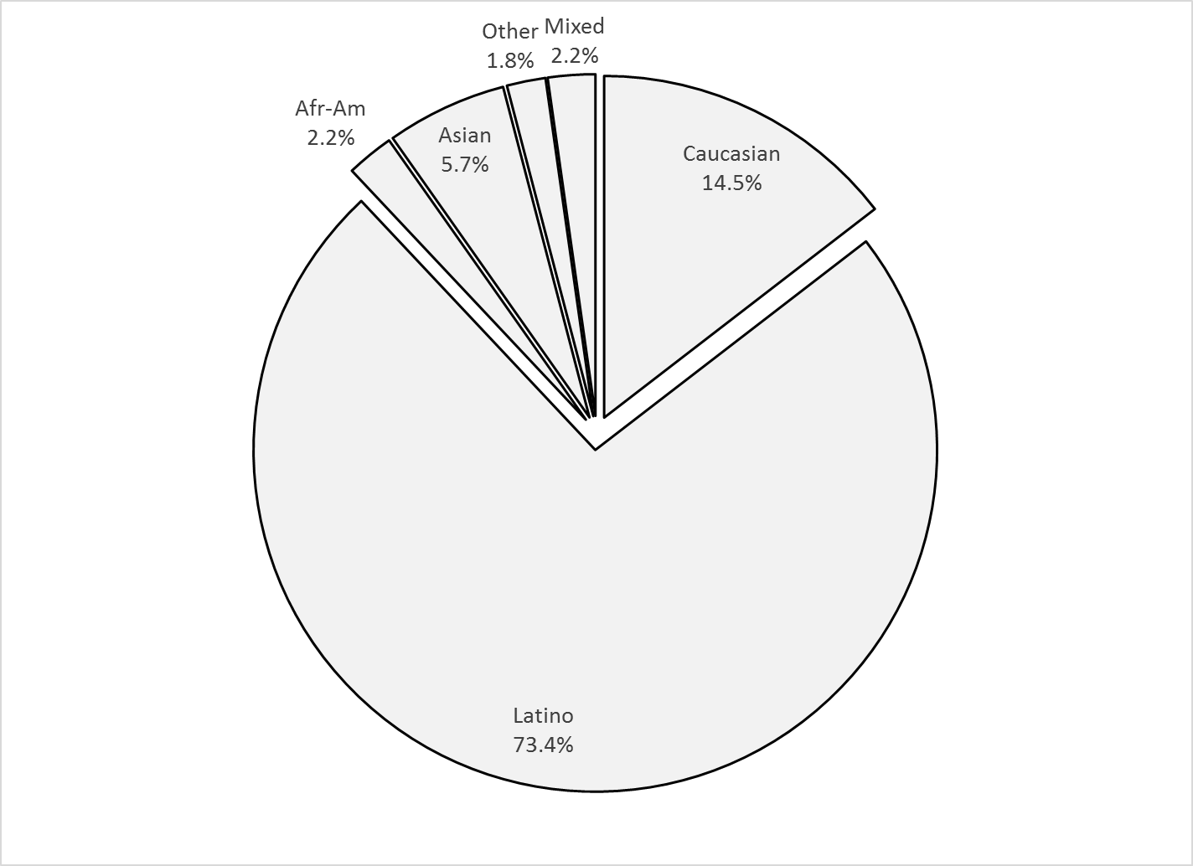

Mean YSS-F scale scores:

Figure 2. Mean Scores: YSS-F
(Scale is 1-"strongly disagree" to 5-"strongly agree")

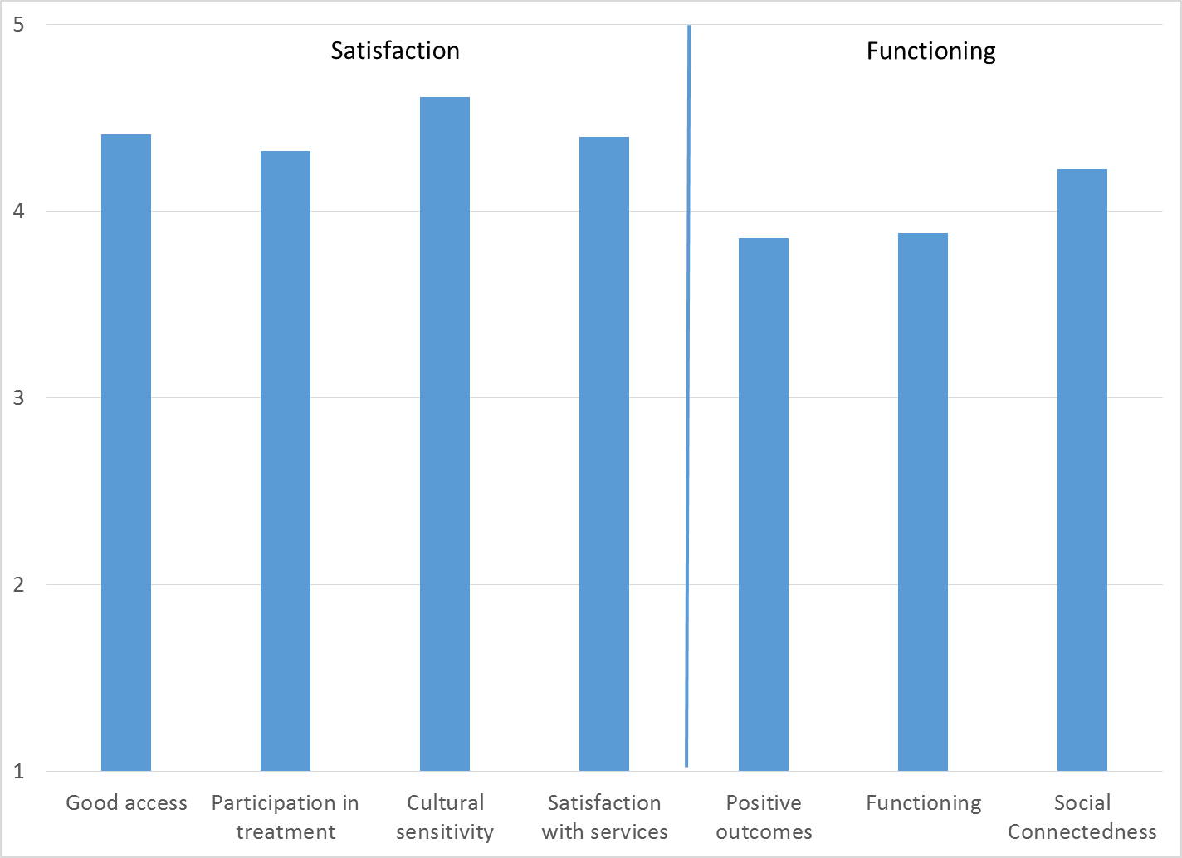

Factors affecting YSS-F scores:

YSS-F scales did not differ significantly by race/ethnicity, shown in Figure 3.

Figure 3. YSS-F scores by race/ethnicity
(No significant differences, p > .01 for all scales)
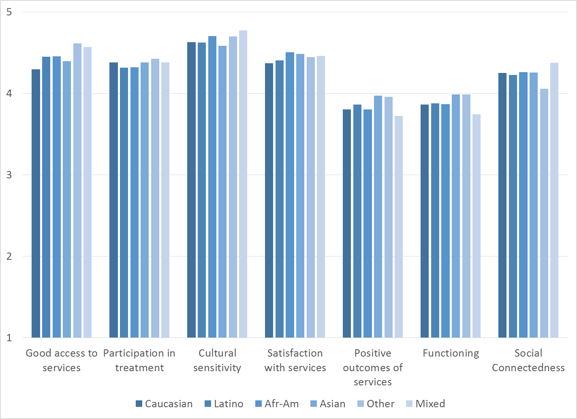

Participants completing the form in English were compared to those completing the form in Spanish and Vietnamese. English-speakers rated Cultural Sensitivity and Participation in Treatment slightly higher than Spanish-speaker.

Figure 4. Positive Outcomes of Services, English vs. Spanish vs. Vietnamese forms
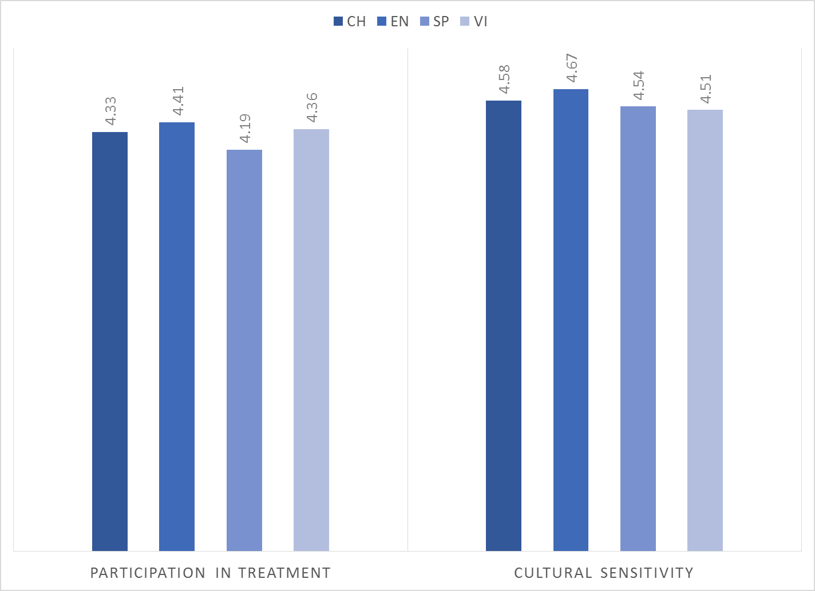

There were no significant gender differences.

Clients who had been enrolled longer in services tended to score higher on all the Participation, Satisfaction, and Social Functioning YSS-F scales. These relationships are depicted in Figure 5 along with the non-significant relationships of other scales with time in service.

Figure 5. YSS-F Scores by time in service (*p < .01)
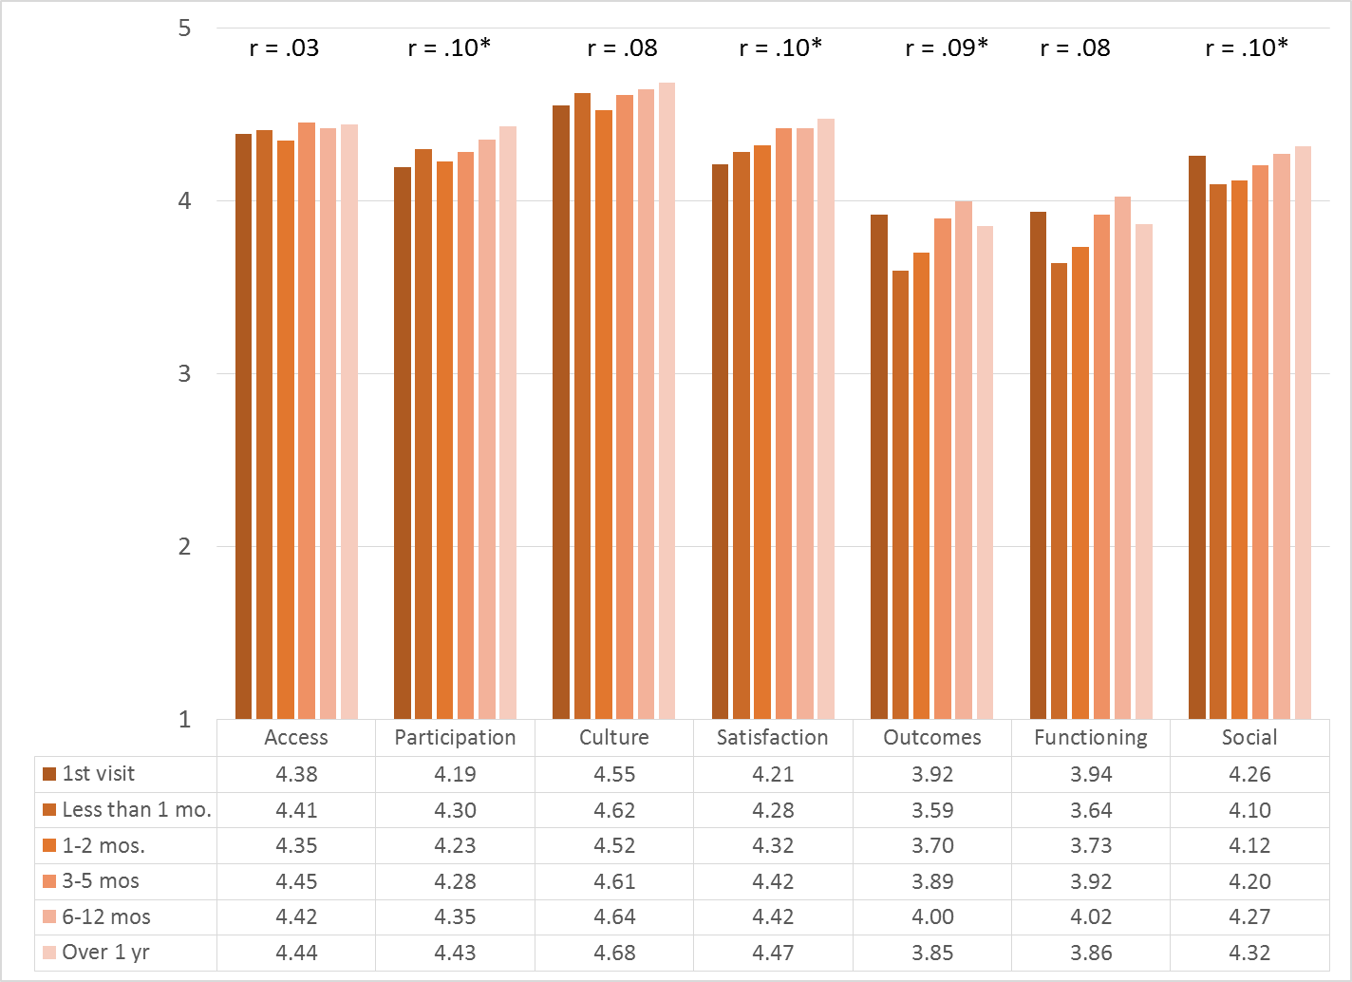

Living Situation

Parents/guardians were asked, “Has your child lived in any of the following places in the last 6 months? (Mark all that apply.)”

Figure 6. Percentage in living situation over past 6 months
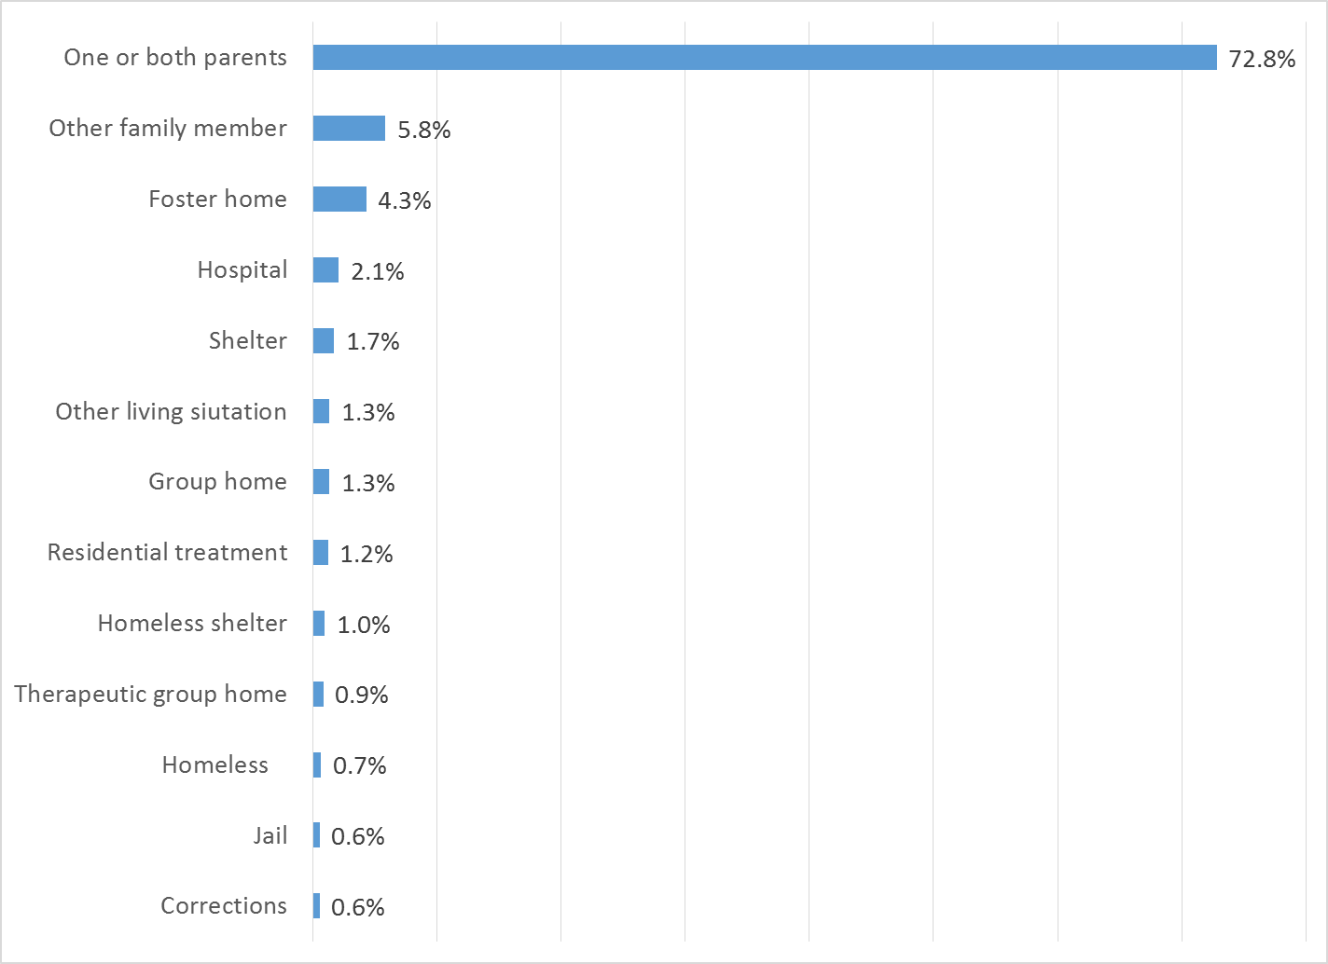

Doctor visits and medication

As seen in Figure 7, 69.2% of clients reporting (668/966) were seen for a medical clinic or office visit in the prior year. The rate did not differ by age, ethnicity, form language or gender.

Figure 7. "In the last year, did you see a medical doctor (or nurse)
for a health check-up or because you were sick?"
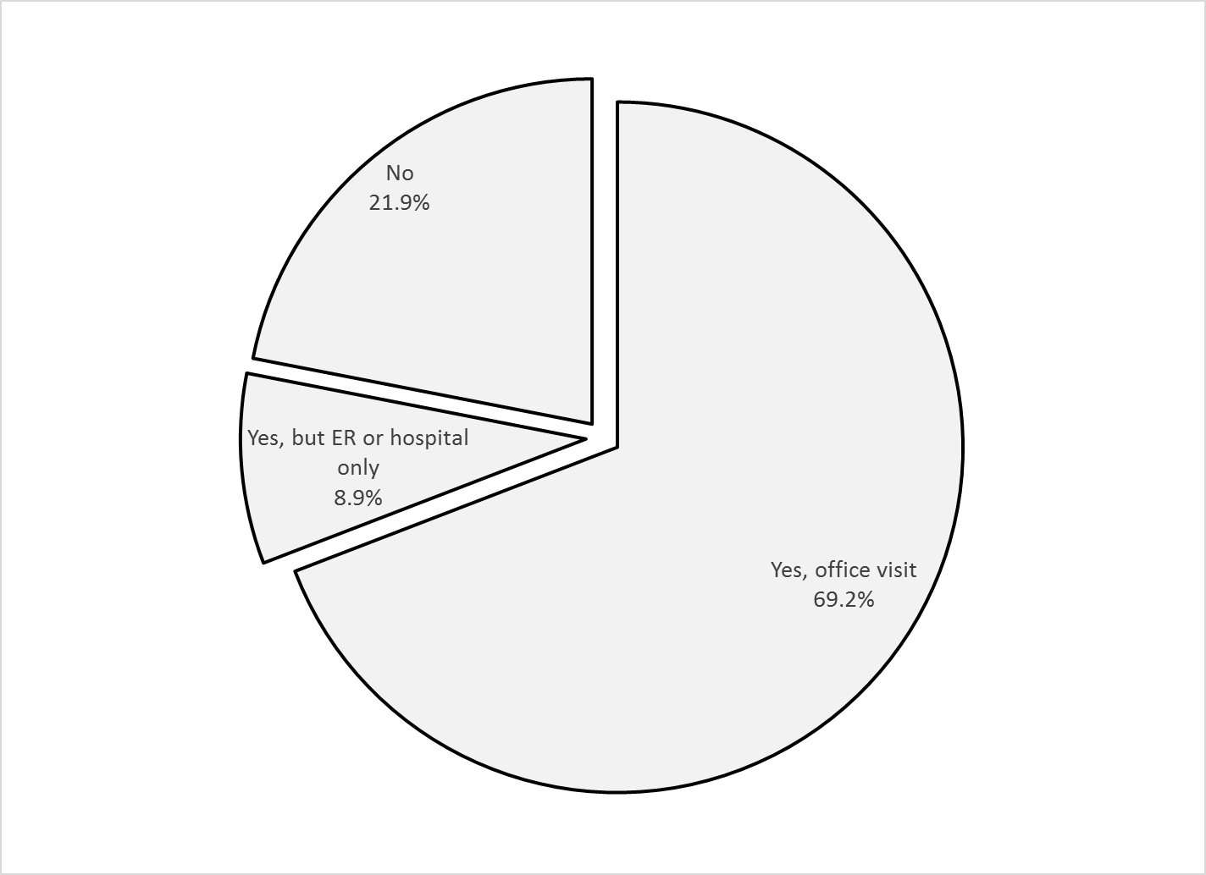

One out of three clients (27.6%, 288/947) are taking psychotropic medication. Of the clients taking medication, 93.6% (234/250) reported that their medical provider had discussed side-effects with them.

Table 1. YSS-F mean scores by program
Program | Access | Partic | Culture | Satis | Outcomes | Functioning | Social | N
Behavioral Health Services for Military Families Child Guidance Center | 3.83 | 4.33 | 4.58 | 4.32 | 3.80 | 3.93 | 4.25 | 3
Child Guidance Center, BP | 4.44 | 4.42 | 4.61 | 4.43 | 3.77 | 3.78 | 4.19 | 42
Child Guidance Center, FUL | 4.36 | 4.39 | 4.58 | 4.45 | 3.82 | 3.86 | 4.28 | 69
Children’s Hospital of Orange County Co Occurring Clinic | 4.27 | 4.12 | 4.46 | 4.24 | 3.93 | 3.96 | 4.11 | 37
Collaborative Courts FSP | 4.63 | 4.52 | 4.83 | 4.76 | 4.18 | 4.25 | 4.46 | 25
Community Counseling and Supportive Services | 5.00 | 5.00 | 5.00 | 4.67 | 3.50 | 3.50 | 3.75 | 1
Connect the Tots | 4.71 | 4.53 | 4.79 | 4.54 | 4.22 | 4.22 | 4.47 | 50
CYBH Aliso Viejo | 3.00 | 3.33 | 3.00 | 3.00 | 3.08 | 3.08 | 3.88 | 2
CYBH CCPU | 4.50 | 3.00 |  | 4.75 | 3.80 | 4.10 | 4.08 | 2
CYBH CM | 4.00 | 3.88 | 4.14 | 3.88 | 3.38 | 3.38 | 3.82 | 7
CYBH East | 4.40 | 4.43 | 4.66 | 4.49 | 3.84 | 3.89 | 4.19 | 33
CYBH South RH Dana: Dana Point | 4.59 | 4.46 | 4.65 | 4.27 | 3.92 | 3.92 | 4.50 | 11
CYBH South, LB Wesley | 4.33 | 4.33 | 4.75 | 4.55 | 4.05 | 3.99 | 4.44 | 9
CYBH West Region | 4.21 | 4.08 | 4.51 | 4.21 | 3.62 | 3.57 | 3.59 | 8
CYBH, North | 4.49 | 4.30 | 4.67 | 4.36 | 3.67 | 3.73 | 4.25 | 34
KCS (Korean Community Services) | 4.50 | 4.83 | 5.00 | 5.00 | 4.92 | 4.83 | 5.00 | 2
New Alternatives WRAP | 3.88 | 4.05 | 4.19 | 4.04 | 3.60 | 3.63 | 3.81 | 8
OCAPICA FSP | 4.33 | 4.27 | 4.74 | 4.47 | 4.01 | 4.02 | 4.14 | 18
Orange County Center for Resiliency, Education & Wellness(OC CREW) | 4.75 | 4.57 | 4.97 | 4.90 | 4.14 | 4.19 | 4.39 | 8
Pathways RENEW | 4.63 | 4.50 | 4.79 | 4.64 | 3.79 | 3.82 | 4.41 | 34
Pathways, Anaheim | 4.65 | 4.32 | 4.62 | 4.48 | 4.10 | 4.10 | 4.27 | 42
Pathways, Santa Ana | 4.44 | 4.20 | 4.47 | 4.36 | 3.79 | 3.80 | 4.08 | 64
Phoenix House Wraparound | 5.00 | 5.00 | 5.00 | 5.00 | 4.44 | 4.44 | 4.92 | 3
SCCS-Outpatient | 4.32 | 4.18 | 4.64 | 4.12 | 3.89 | 3.91 | 4.39 | 30
Seneca OC Outpatient | 4.24 | 4.43 | 4.78 | 4.50 | 3.86 | 3.92 | 4.36 | 58
Seneca OC Wraparound | 5.00 | 5.00 | 5.00 | 5.00 | 4.17 | 4.17 | 5.00 | 1
SIS Southland Integrated Services OCAPICA FSP | 4.50 | 4.44 | 4.67 | 4.72 | 3.91 | 3.89 | 4.42 | 3
Touchstones (Adolescent) | 4.75 | 4.50 | 4.81 | 4.68 | 4.26 | 4.28 | 4.21 | 8
Wayfinders-Families First | 4.31 | 4.00 | 4.38 | 4.28 | 4.13 | 4.13 | 4.29 | 14
Western Youth Services West: Fountain Valley | 4.42 | 4.42 | 4.68 | 4.45 | 3.88 | 3.91 | 4.23 | 117
WYS East (Santa Ana) | 4.35 | 4.10 | 4.48 | 4.22 | 3.59 | 3.63 | 4.07 | 87
WYS North (Anaheim) | 4.37 | 4.22 | 4.47 | 4.24 | 3.76 | 3.79 | 4.06 | 111
WYS, Mission Viejo | 4.31 | 4.36 | 4.62 | 4.38 | 3.84 | 3.85 | 4.26 | 86
Total | 4.41 | 4.32 | 4.61 | 4.40 | 3.86 | 3.88 | 4.22 | 1019
Yellow Highlight: +3 Std. Errors
Grey Highlight: -3 Std. Errors

