Consumer Perception Survey
May 2016 YSS-F Administration
Children and Youth
Jonathan Rich, Ph.D.
January 5, 2017

The Youth Satisfaction Survey for Families (YSS-F) was offered to all parents and guardians of children and youths attending mental health services at a County or contract CYBH clinic from May 16-20, 2016. YSS-F records with birthdates corresponding to an age of 0 – 25, with a valid program code, and with a CYBH or Prevention & Intervention program indicated were retained for this analysis. This reduced an initial YSS-F file of 497 surveys to 462 surveys.

YSS-F Results

Sample description:

N: 462
Gender (n = 448): F-184 (41.1%), M-263 (58.7%), O-1 (0.1%)
Age (n = 462): Mean = 11.7, s = 4.0, range = 0-25.
Form Language (n = 462): English-227 (49.1%), Spanish-211 (45.7%), and Vietnamese-24 (5.2%).

Race/Ethnicity (n = 436):

Survey respondents describe their race and ethnicity by selecting as many of the following categories as applicable: Hispanic, American Indian, Asian, Black, Pacific Islander, White, Other Race, and Unknown Race. These selections were reduced to six categories as follows. If either Asian, Pacific Island, or both are selected, that is considered a single category, “Asian/Pacific Islander.” If only one category is selected, then the participant is assigned to that category. If more than one category is selected, or if “Other Race” or “Unknown Race” is selected, the participant is classified as “Mixed/Other.” If “Hispanic” is selected, the client is classified as “Hispanic,” regardless of the other selections.

Figure 1. Client race/ethnicity
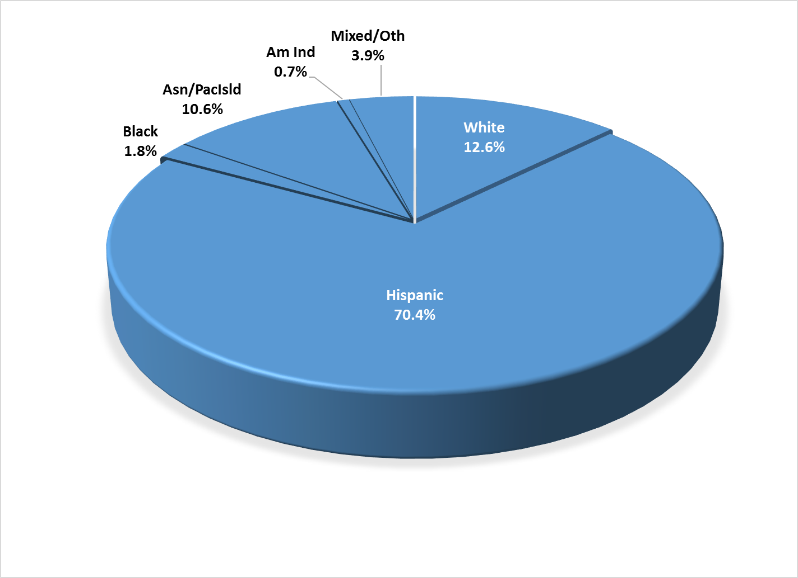

County vs. Contract (n = 462): County 19.7% vs. Contract 80.3%
Division (n = 462): CYBH 98.5%, P&I 1.5%
Mean YSS-F scale scores:

Figure 2. Mean Scores: YSS-F
(Scale is 1-"strongly disagree" to 5-"strongly agree")

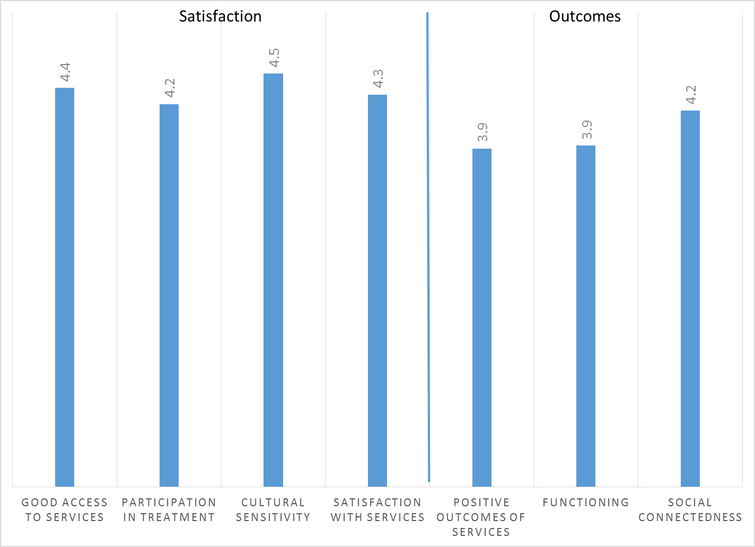

Factors affecting YSS-F scores:

“Cultural Sensitivity” and “Social Connectedness” varied significantly by ethnic group. However, this significant difference was due entirely to lower ratings by American Indians. (Figure 3). However, while the mean American Indian response was markedly lower on these two scales, these means were based on only two (Culture) or three (Social) responses and may not be stable.

Figure 3. YSS-F scores by race/ethnicity
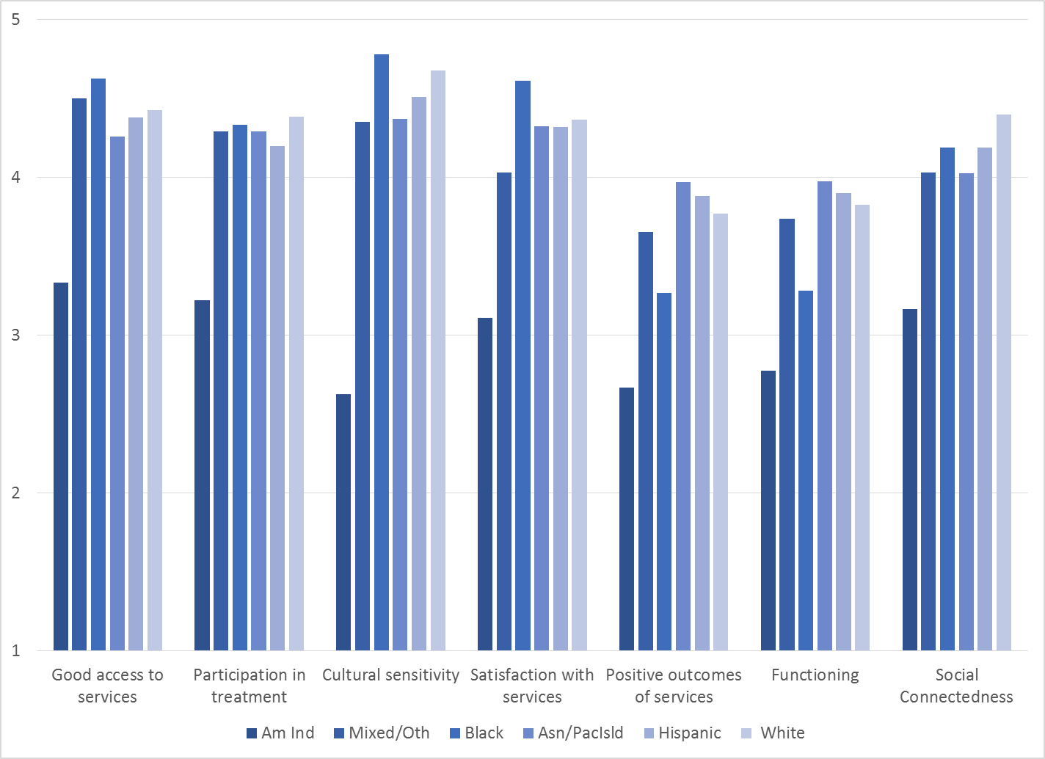

Participants completing the form in English were compared to those completing the form in Spanish. As seen in Figure 4, English-speakers gave the highest ratings to Cultural Sensitivity and Social Connectedness and Vietnamese-speakers the lowest.

Figure 4. YSS-F mean ratings, English vs. Spanish vs. Vietnamese forms
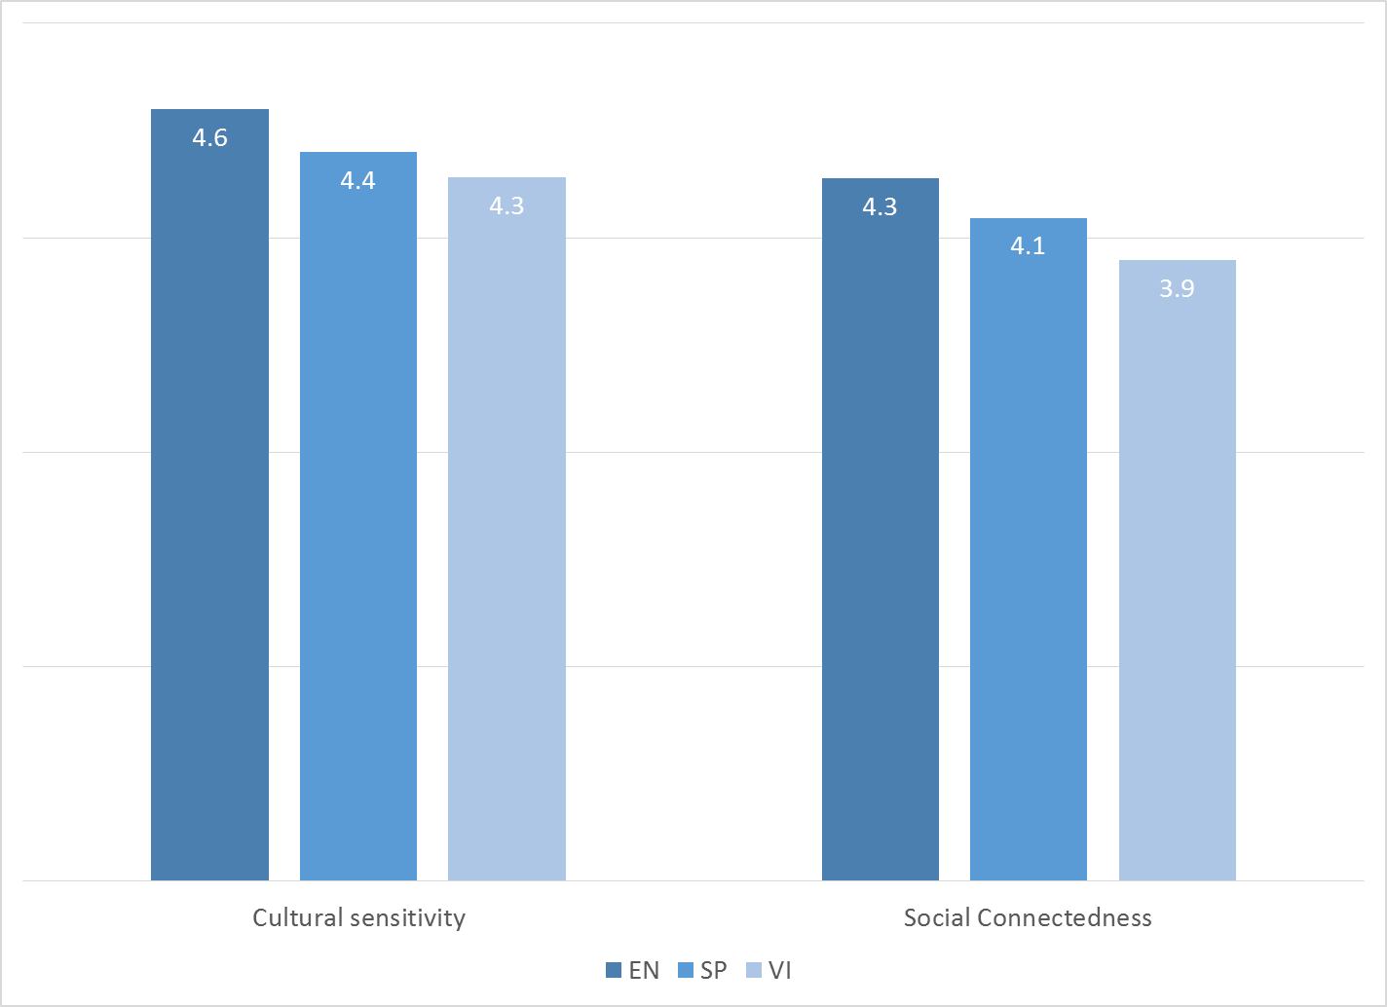

There were no significant gender differences.

Clients who had been enrolled longer in services tended to score higher on the Outcomes and Functioning scales. These relationships are depicted in Figure 5.

Figure 5. YSS-F Scores by time in service (*p < .01)
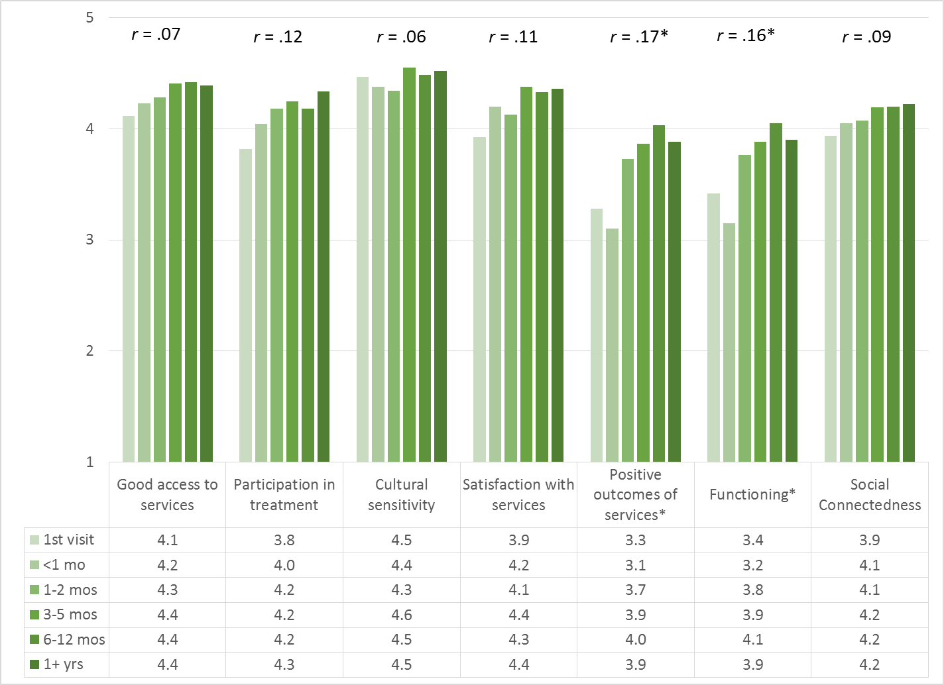

Living Situation

Parents/guardians were asked, “Has your child lived in any of the following places in the last 6 months? (Mark all that apply.)”

Figure 6. Percentage in living situation over past 6 months
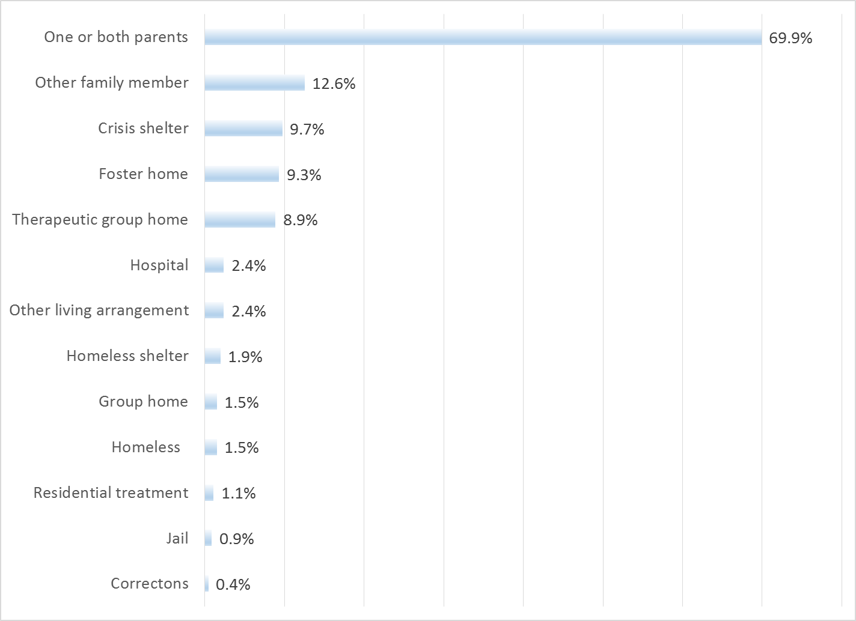

Doctor visits and medication

As seen in Figure 7, 71.3% of clients reporting (301/422) were seen for a medical clinic or office visit in the prior year. The rate did not differ by age, County vs. contract clinic, form language or gender.

Figure 7. "In the last year, did you see a medical doctor (or nurse)
for a health check-up or because you were sick?"
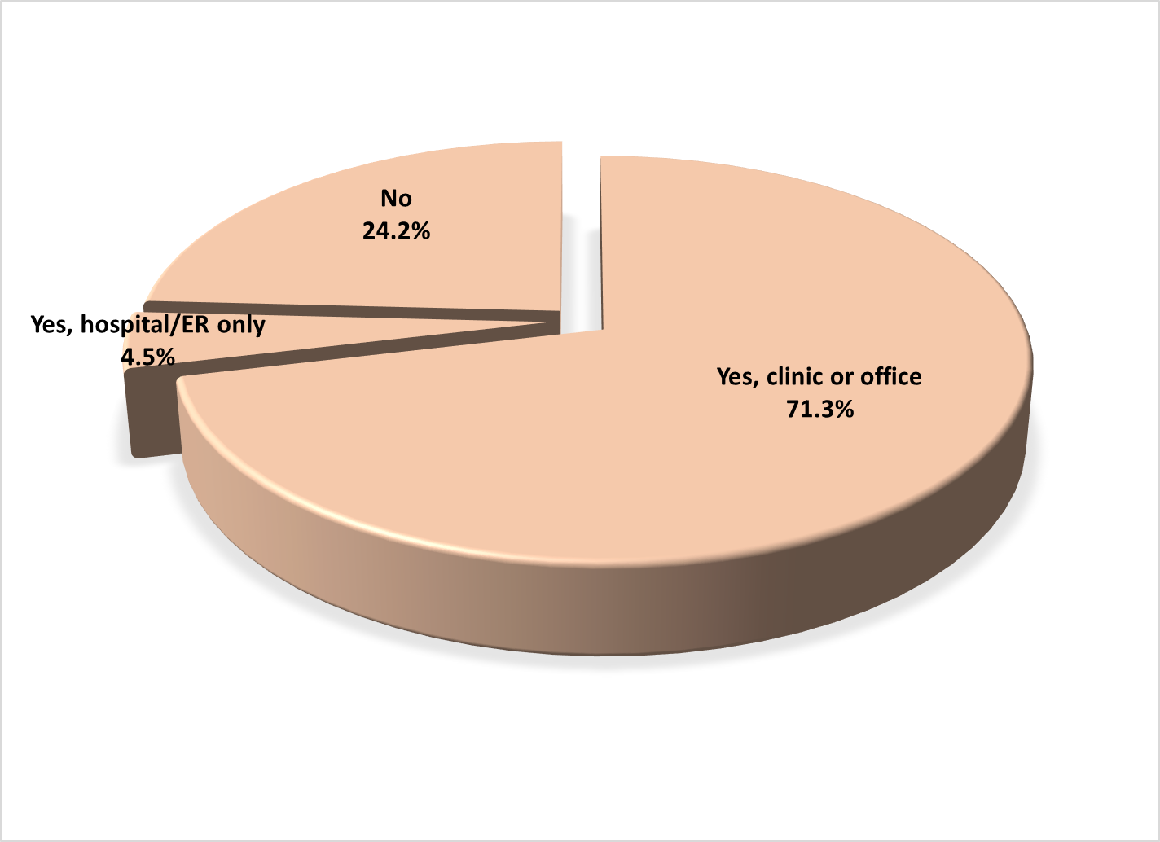

Forty-two percent of clients (42.3%, 175/414) are taking psychotropic medication. Of the clients taking medication, 92.0% (138/150) reported that their medical provider had discussed side-effects with them.

Table 1. YSS-F mean scores by program
Program | Access | Partic. | Culture | Satis | Outcomes | Func | Social | N
Child Guidance Center, BP | 4.4 | 4.3 | 4.5 | 4.3 | 3.8 | 3.8 | 4.3 | 24
Child Guidance Center, Fullerton | 4.5 | 4.3 | 4.5 | 4.2 | 3.6 | 3.6 | 4.2 | 11
Child Guidance Center, Santa Ana | 4.3 | 4.2 | 4.4 | 4.3 | 4.0 | 4.0 | 4.3 | 58
Children’s Hospital of Orange County Co Occurring Clinic | 4.0 | 3.9 | 4.2 | 4.2 | 4.0 | 4.0 | 4.1 | 5
Collaborative Courts FSP | 4.6 | 4.4 | 4.6 | 4.5 | 4.3 | 4.3 | 4.4 | 14
CYBH CM | 4.7 | 4.5 | 4.8 | 4.6 | 4.0 | 4.0 | 4.2 | 17
CYBH East | 4.6 | 4.4 | 4.7 | 4.6 | 3.7 | 3.7 | 4.4 | 18
CYBH South RH Dana: Dana Point | 4.4 | 4.3 | 4.6 | 4.3 | 3.8 | 3.9 | 3.9 | 7
CYBH South, LB Wesley | 3.6 | 4.0 | 4.5 | 4.1 | 3.7 | 3.9 | 4.2 | 10
CYBH West Region | 4.6 | 4.3 | 4.6 | 4.4 | 4.1 | 4.1 | 4.2 | 27
CYBH, North | 4.2 | 4.2 | 4.2 | 4.2 | 4.2 | 4.1 | 4.0 | 5
KCS (Korean Community Services) [Distribute through OCAPICA, 22120] | 4.3 | 4.4 | 4.6 | 4.4 | 4.1 | 4.1 | 4.3 | 3
OCAPICA FSP | 4.6 | 4.7 | 4.6 | 4.7 | 3.6 | 3.7 | 4.3 | 4
Orange County Center for Resiliency, Education & Wellness(OC CREW) | 4.6 | 4.5 | 4.6 | 4.5 | 4.2 | 4.1 | 4.5 | 7
Pathways, Anaheim | 4.5 | 4.1 | 4.7 | 4.4 | 3.7 | 3.7 | 4.2 | 25
Pathways, Santa Ana | 4.4 | 4.1 | 4.5 | 4.2 | 3.8 | 3.9 | 4.4 | 8
Seneca OC Wraparound | 4.6 | 4.6 | 4.8 | 4.4 | 3.9 | 4.1 | 4.6 | 9
South Coast Children's Society | 4.8 | 4.8 | 4.5 | 4.8 | 4.3 | 4.3 | 4.9 | 2
VNCOC (Vietnamese Community of OC) OCAPICA FSP | 4.3 | 4.3 | 4.3 | 4.4 | 4.3 | 4.2 | 4.1 | 6
Western Youth Services West: Fountain Valley | 4.4 | 4.3 | 4.5 | 4.4 | 3.9 | 4.0 | 4.2 | 61
WYS East (Anaheim) | 4.1 | 4.0 | 4.2 | 4.1 | 3.6 | 3.6 | 3.8 | 84
WYS North (Anaheim) | 4.4 | 4.2 | 4.5 | 4.3 | 3.9 | 3.9 | 4.1 | 53
Total | 4.4 | 4.2 | 4.5 | 4.3 | 3.9 | 3.9 | 4.2
 | Significantly higher
 | Significantly lower

