Consumer Perception Survey
May 2015 YSS Administration
Children and Youth
Jonathan Rich, Ph.D.
June 15, 2016

The Youth Satisfaction Survey (YSS) was offered to all teen and transitional age youth clients attending mental health services at a County or contract CYBH clinic from May 16-20, 2016. The intended age range for the YSS is 13 and older. YSS records with birthdates corresponding to an age of 13 – 21 and with a CYBH, ADAS, Innovations or Prevention & Intervention program indicated were retained for this analysis.

YSS Results

Sample description:

N: 455
Gender (n = 455): F-243 (54.7%), M-191 (43.0%), O-10 (2.3%)
Age (n = 455): Mean = 16.2, s = 2.1, range = 13-21.
Form Language (n = 455): English-448 (98.5%), Spanish-6 (1.3%), Viet-1 (0.2%)

Race/Ethnicity (n = 436):
Figure 1. Client race/ethnicity
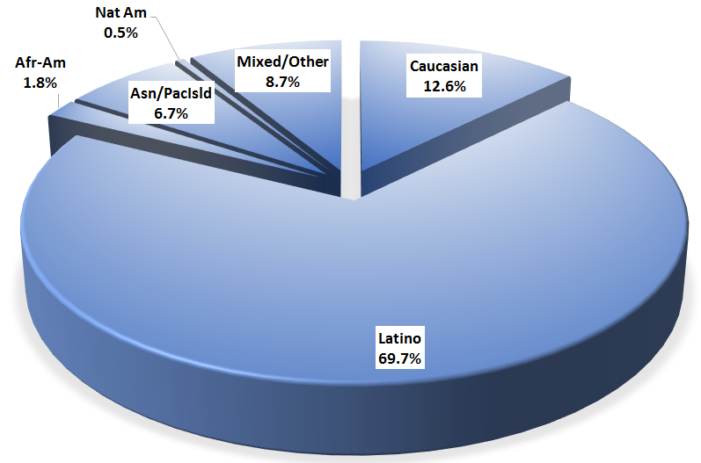

County vs. Contract (n = 555): County 28.4% vs. Contract 71.6%
Division (n = 555): CYBH 87.9%, P&I 9.9%, ADAS 2.2%

Mean YSS scale scores:

Figure 2. Mean Scores: YSS
(Scale is 1-"strongly disagree" to 5-"strongly agree")
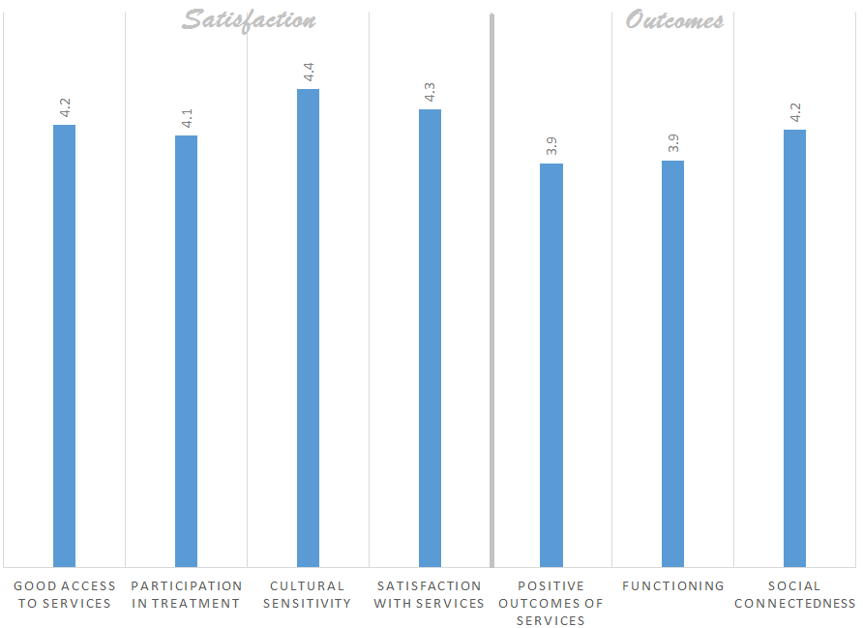

Factors affecting YSS scores:

There were no significant ethnic differences on any of the YSS scores (Figure 3).

Figure 3. YSS scores by race/ethnicity (no statistically significant differences)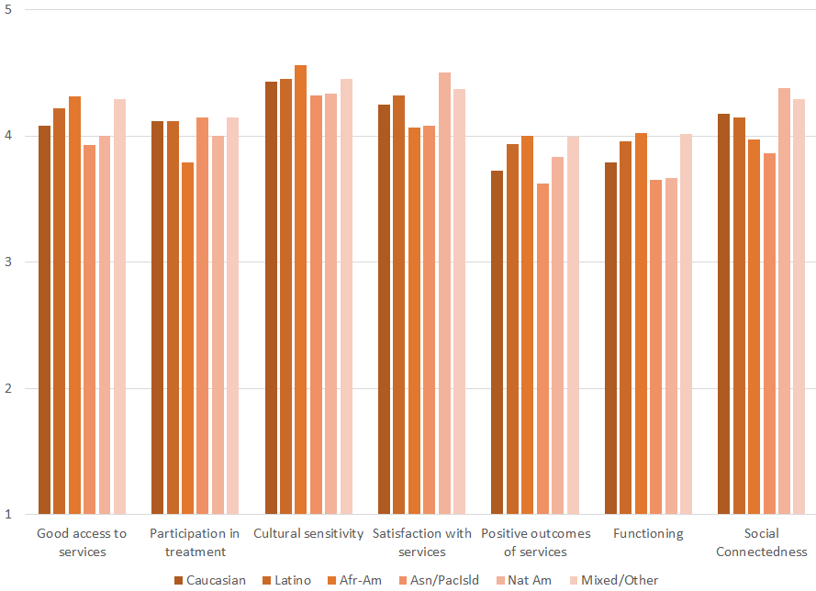

There were no significant gender differences across the YSS scores. Clients who had been enrolled longer in services tended to score higher on all YSS scales. These relationships are depicted in Figure 5. All except Access and Cultural Sensitivity are significant at p < .01.

Figure 4. YSS Scores by time in service
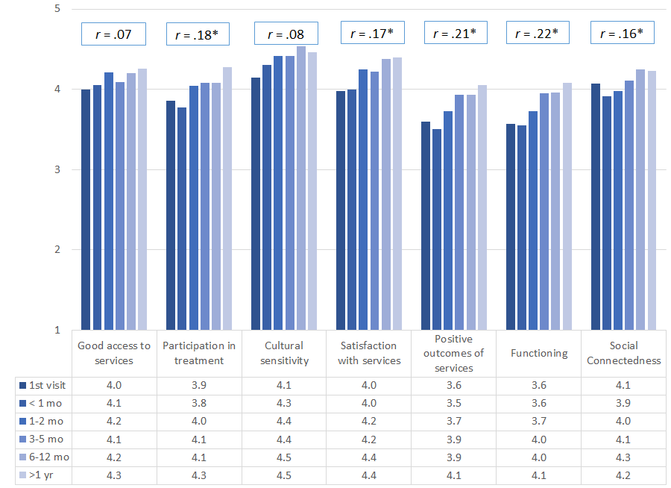
*p < .01.

Living Situation

Clients were asked, “Have you lived in any of the following places in the last 6 months? (Mark all that apply.)” The responses to this question are seen in Figure 5. More than three out of four youths resided with one or both parents during the prior six months. Four percent of youth reported homelessness during this same period. Homelessness differed by age, with the percent of youths reporting homelessness peaking at ages 15 and 19 (Figure 6).

Figure 5. Percentage in living situation over past 6 months
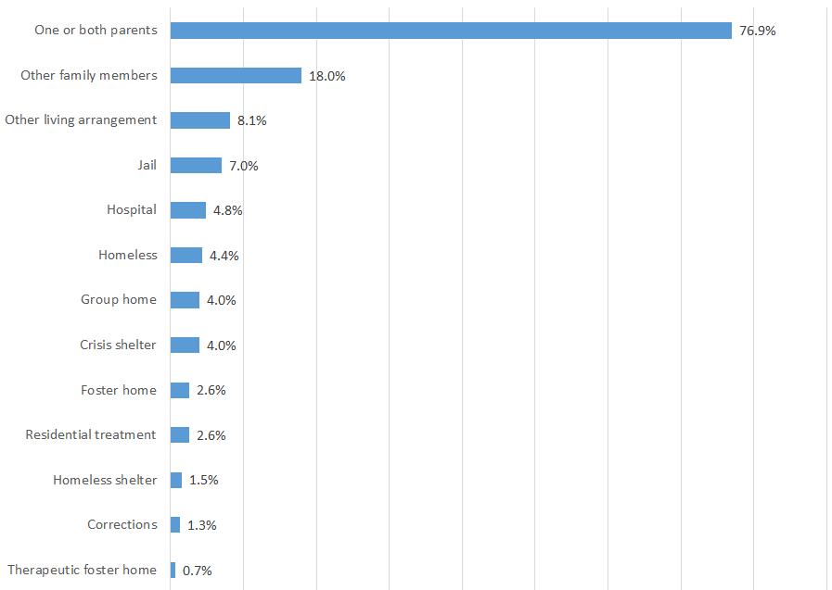

Figure 6. Homelessness by age
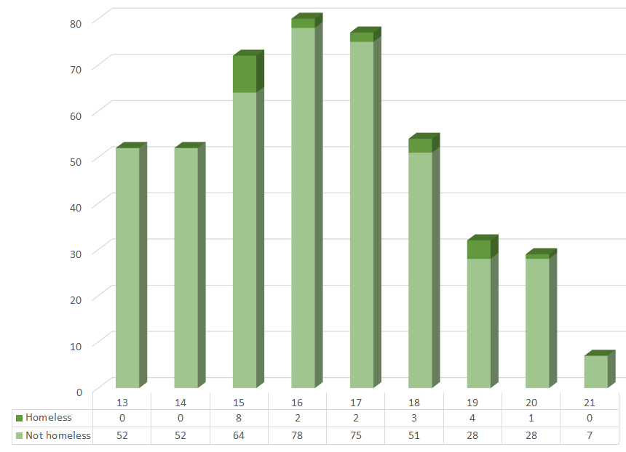

Doctor visits and medication

Figure 4. "In the last year, did you see a medical doctor (or nurse)
for a health check-up or because you were sick?"
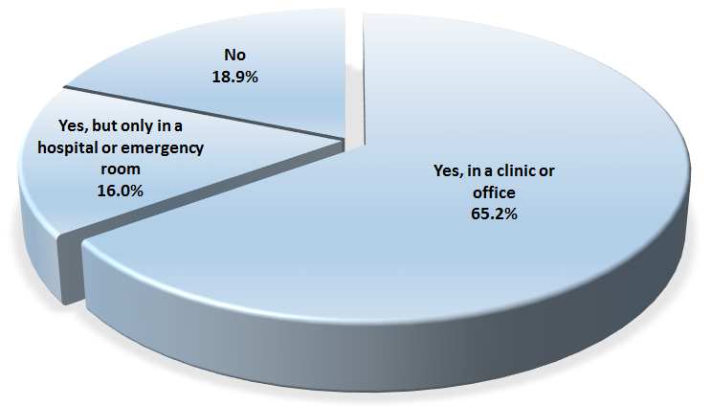
Sixty-four percent of clients reporting (245/376) were seen for a medical clinic or office visit in the prior year. This rate did not differ significantly by age, ethnicity, county vs. contract clinic, or gender.

One out of three clients, 34.8%, (153/440) reported taking psychotropic medication. Of the clients taking medication, 86.3% (126/146) reported that their medical provider had discussed side-effects with them.

Table 2. YSS mean scores by program
Program | Access | Partic. | Culture | Satis | Outcomes | Function | Social | N
ADAS AOD Westminster | 3.5 | 3.7 | 4.0 | 3.9 | 3.8 | 3.8 | 4.4 | 10
Canyon Acres Seneca, Anaheim | 3.9 | 4.0 | 4.3 | 4.1 | 4.0 | 4.0 | 4.1 | 10
CEGU, Probation | 4.2 | 4.2 | 4.4 | 4.4 | 4.0 | 4.0 | 4.0 | 11
Child Guidance Center | 4.0 | 4.0 | 4.2 | 4.1 | 3.9 | 3.9 | 4.2 | 26
Child Guidance Center, BP | 3.9 | 3.6 | 4.0 | 3.8 | 3.2 | 3.2 | 3.4 | 8
Collaborative Courts FSP | 4.5 | 4.4 | 4.6 | 4.6 | 4.3 | 4.3 | 4.4 | 30
Community Counseling and Supportive Services | 4.0 | 3.8 | 4.0 | 4.3 | 3.8 | 3.8 | 3.9 | 2
CYBH CCPU | 4.5 | 4.2 | 4.6 | 4.5 | 4.4 | 4.6 | 4.6 | 6
CYBH CM | 4.1 | 3.7 | 4.4 | 4.4 | 3.8 | 3.9 | 4.2 | 5
CYBH East | 4.1 | 3.9 | 4.6 | 4.5 | 3.8 | 3.8 | 3.9 | 22
CYBH South, LB Wesley | 5.0 | 5.0 | 5.0 | 5.0 | 4.0 | 4.3 | 4.8 | 1
CYBH West Region | 4.0 | 4.1 | 4.6 | 4.2 | 4.0 | 4.1 | 4.1 | 18
Juvenile Recovery Court | 3.6 | 4.0 | 4.2 | 4.1 | 4.0 | 4.0 | 4.2 | 11
KCS (Korean Community Services) | 4.0 | 4.0 | 4.0 | 4.0 | 4.0 | 4.0 | 4.0 | 1
Kinship Seneca Tustin | 4.7 | 4.7 | 5.0 | 4.8 | 4.0 | 4.0 | 4.4 | 3
OC Accept | 3.0 |  | 4.8 | 4.7 | 3.7 | 4.0 | 3.5 | 1
OCAPICA FSP | 5.0 | 5.0 | 5.0 | 5.0 | 5.0 | 5.0 | 5.0 | 1
Orange County Center for Resiliency, Education & Wellness(OC CREW) | 4.5 | 4.1 | 4.7 | 4.5 | 3.8 | 3.6 | 4.1 | 12
Orangewood Children's Foundation FSP | 4.8 | 4.6 | 4.7 | 4.6 | 4.2 | 4.3 | 4.6 | 8
Pathways CS STAY | 4.4 | 4.5 | 4.6 | 4.6 | 4.4 | 4.5 | 4.4 | 20
Providence Garden Grove | 4.3 | 4.2 | 4.3 | 4.0 | 3.4 | 3.5 | 3.5 | 6
Providence RENEW | 4.1 | 4.0 | 4.3 | 4.2 | 3.7 | 3.7 | 4.1 | 20
Providence, Anaheim | 4.0 | 4.2 | 4.5 | 4.3 | 3.8 | 3.8 | 4.0 | 14
Providence, Santa Ana | 4.3 | 4.0 | 4.5 | 4.4 | 4.0 | 4.1 | 4.2 | 17
School Based Mental Health Services | 4.1 | 4.0 | 4.3 | 4.2 | 3.8 | 3.8 | 4.1 | 23
South Coast Children's Society | 4.5 | 4.1 | 4.8 | 4.5 | 4.0 | 4.1 | 4.4 | 10
VNCOC (Vietnamese Community of OC) OCAPICA FSP | 3.6 | 3.8 | 4.0 | 3.7 | 3.3 | 3.3 | 4.0 | 4
Western Youth Services West: Fountain Valley | 4.0 | 4.0 | 4.4 | 4.2 | 3.7 | 3.7 | 4.0 | 39
WYS East (Anaheim) | 4.1 | 3.9 | 4.3 | 4.1 | 3.9 | 3.9 | 4.2 | 51
WYS North (Anaheim) | 4.7 | 4.1 | 4.6 | 4.3 | 3.3 | 3.4 | 4.0 | 15
WYS, Mission Viejo | 4.4 | 3.9 | 4.1 | 4.2 | 3.9 | 3.9 | 3.9 | 5
Youth as Parents | 4.9 | 4.4 | 4.7 | 4.7 | 4.1 | 4.1 | 3.8 | 7
Youthful Offender Wraparound | 4.5 | 4.5 | 4.6 | 4.6 | 4.1 | 4.2 | 4.4 | 36
Total | 4.2 | 4.1 | 4.4 | 4.3 | 3.9 | 3.9 | 4.2

