Consumer Perception Survey
November 2014 Administration
Children and Youth

The Youth Satisfaction Survey (YSS) was offered to all teen and transitional age youth clients attending mental health services at a County or contract CYS clinic during November 2014. The intended age range for the YSS is 13 and older. YSS records with birthdates corresponding to an age of 13 – 21 and with a CYS, ADAS, Innovations or Prevention & Intervention program indicated were retained for this analysis.

YSS Results

Sample description:

N: 459
Gender (n = 430): F-262 (60.9%), M-162 (37.7%), O-6 (1.4%)
Age: Mean = 16.0, s = 1.9, range = 13-21.
Form Language (n = 459): English-453 (98.7%), Spanish-4 (0.9%), Viet-2 (0.4%)

Race/Ethnicity (n = 430):
Figure 1. Client race/ethnicity
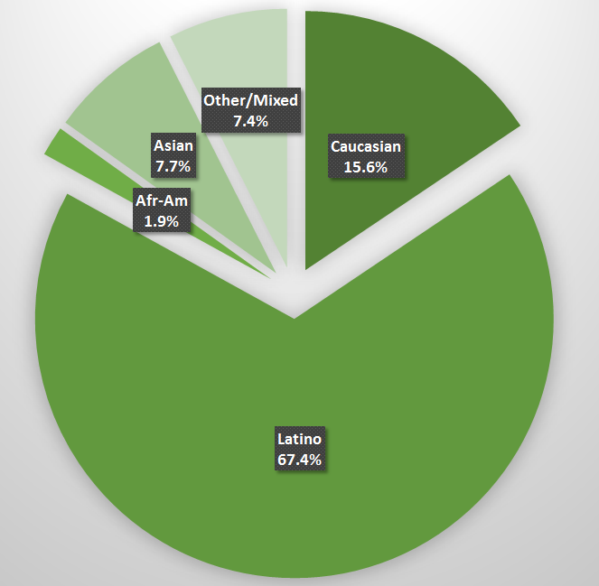

County vs. Contract (n = 459): County 25.3% vs. Contract 74.7%
Division (n = 459): CYBH 94.1%, ADAS 3.3%, Innovations 0.2%, P&I 2.4%

Mean YSS scale scores:

Figure 2. Mean Scores: YSS
(Scale is 1-"strongly disagree" to 5-"strongly agree")
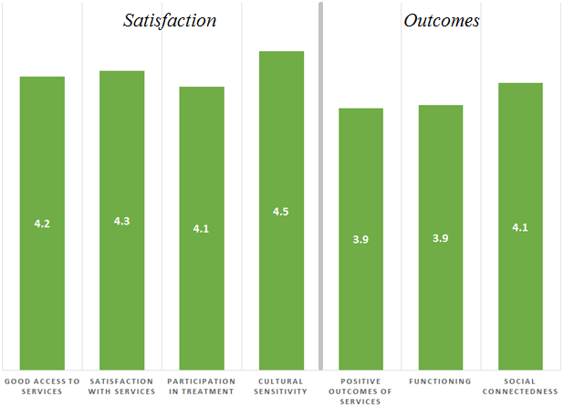

Factors affecting YSS scores:

There were no significant gender or ethnic differences on any of the YSS scores and no difference between County and contract clinics. Perceptions of cultural sensitivity differed by division, with ADAS consumers perceiving lower levels.

Figure 3. Cultural sensitivity by division
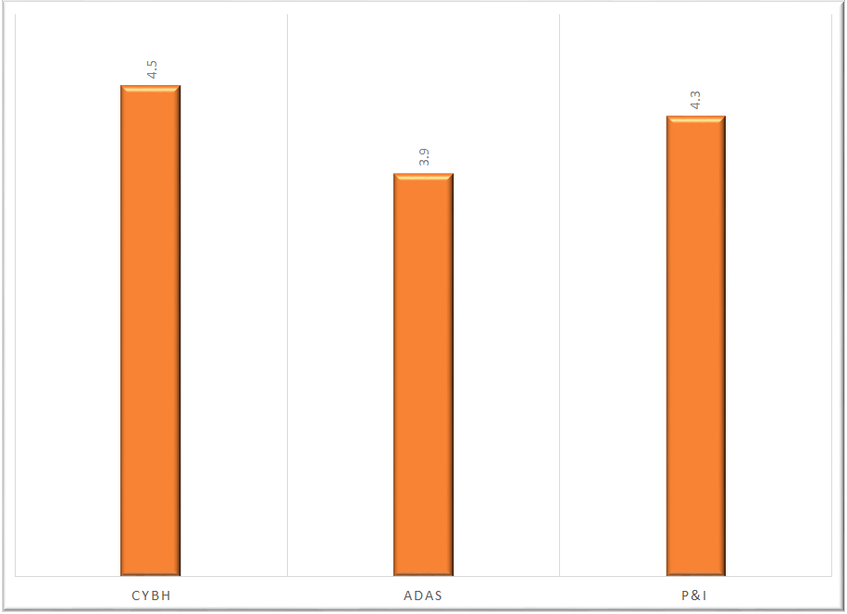

Clients who had been enrolled longer in services tended to score higher on all MHSIP scales.
These relationships are depicted in Figure 2. All are significant at p < .01.

Figure 4. YSS Scores by time in service
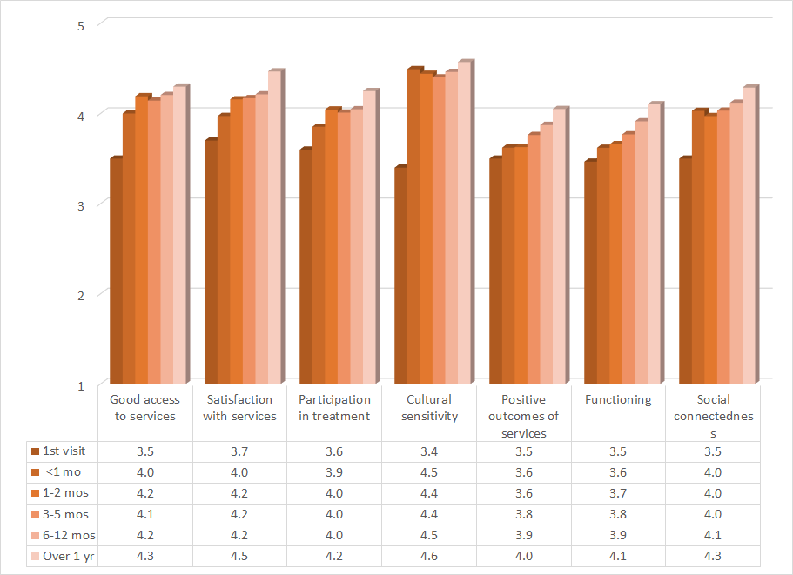

Living Situation

Clients were asked, “Have you lived in any of the following places in the last 6 months? (Mark all that apply.)”

Figure 5. Percentage in living situation over past 6 months
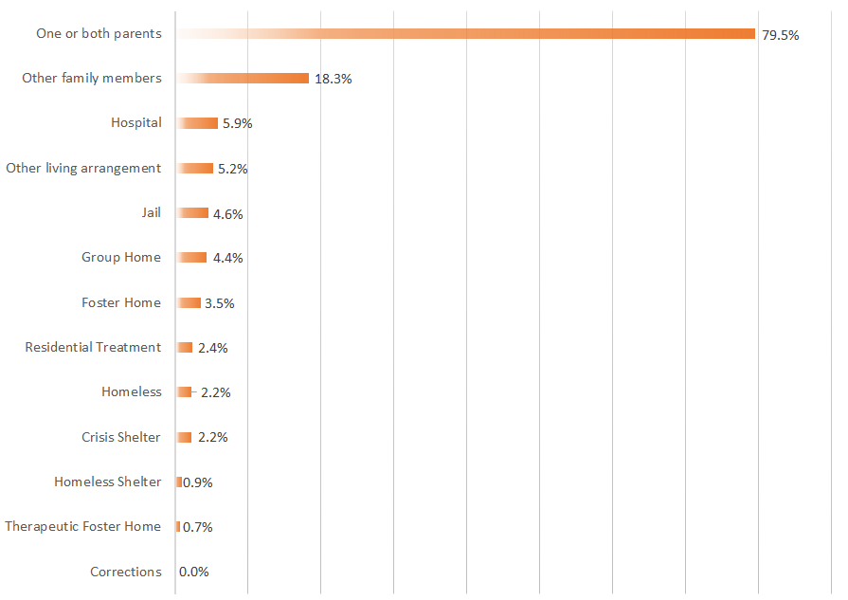

Doctor visits and medication

Figure 6. "In the last year, did you see a medical doctor (or nurse) for a health check-up or because you were sick?"
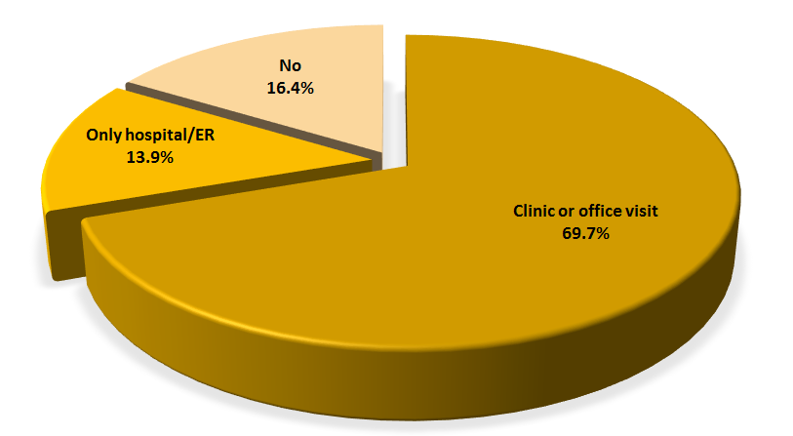
Seventy percent of clients reporting (260/373) were seen for a medical clinic or office visit in the prior year. This rate did not differ significantly by ethnicity, county vs. contract clinic, division or gender.

Fewer than half of the clients, 42.5%, (188/422) reported that they are taking psychotropic medication. Of the clients taking medication, 85.9% (152/177) reported that their medical provider had discussed side-effects with them.

Table 2. YSS mean scores by program
Program | Access | Satisfac- tion | Participa- tion | Cultural | Out- comes | Function- ing | Social | N
ADAS Adolescent Unit, Aliso Viejo | 3.7 | 3.8 | 3.7 | 3.9 | 4.0 | 4.0 | 4.0 | 13
Brighter Futures | 3.5 | 5.0 | 5.0 | 4.3 | 3.8 | 3.2 | 5.0 | 1
Canyon Acres Seneca, Anaheim | 3.8 | 4.6 | 4.4 | 4.8 | 3.4 | 3.5 | 3.8 | 3
Child Guidance Center | 4.1 | 4.3 | 4.0 | 4.5 | 3.8 | 3.9 | 4.1 | 17
Child Guidance Center, BP | 4.0 | 4.3 | 4.5 | 4.5 | 4.5 | 4.5 | 4.0 | 2
Collaborative Courts FSP | 4.3 | 4.5 | 4.3 | 4.5 | 4.2 | 4.3 | 4.3 | 42
CYBH CM | 3.6 | 4.3 | 4.4 | 4.4 | 3.8 | 3.8 | 4.0 | 7
CYBH Dana | 3.8 | 3.9 | 3.8 | 4.4 | 3.4 | 3.5 | 4.0 | 9
CYBH East | 4.2 | 4.1 | 4.1 | 4.4 | 3.6 | 3.6 | 4.2 | 27
CYBH MV Los Alisos | 4.0 | 3.8 | 3.3 | 4.5 | 3.0 | 3.3 | 3.8 | 1
CYBH South, LB-Wesley | 3.8 | 3.8 | 3.2 | 4.0 | 3.2 | 3.2 | 3.4 | 2
CYBH West | 4.3 | 4.3 | 4.2 | 4.5 | 3.9 | 3.9 | 4.1 | 26
CYBH, North | 4.2 | 4.3 | 4.0 | 4.8 | 4.0 | 4.0 | 4.3 | 16
Families First | 4.0 | 4.0 | 4.3 | 4.6 | 3.8 | 3.9 | 4.1 | 4
KCS (Korean Community Services) | 4.1 | 3.9 | 3.9 | 4.6 | 3.4 | 3.3 | 4.1 | 5
Kinship Seneca Center | 4.1 | 4.5 | 4.1 | 4.6 | 4.0 | 4.1 | 4.3 | 9
OCAPICA | 3.3 | 4.6 | 4.3 | 4.3 | 3.7 | 3.8 | 4.3 | 3
OC-CREW | 4.2 | 4.1 | 3.6 | 4.3 | 4.0 | 4.1 | 4.2 | 9
Orange County Postpartum Wellness (OCPPW) | 5.0 | 5.0 | 4.5 | 4.4 | 4.7 | 4.7 | 4.3 | 2
Orangewood Children's Foundation FSP | 4.9 | 4.9 | 4.8 | 4.8 | 4.4 | 4.4 | 4.6 | 11
Providence Garden Grove | 4.2 | 4.1 | 3.7 | 4.3 | 3.6 | 3.6 | 3.9 | 9
Providence RENEW | 4.3 | 4.3 | 4.1 | 4.5 | 3.9 | 3.9 | 4.2 | 36
Providence, Anaheim | 4.0 | 4.0 | 3.8 | 4.0 | 3.8 | 3.8 | 4.3 | 2
Providence, Costa Mesa | 3.5 | 4.2 | 4.0 | 5.0 | 3.5 | 3.5 | 3.3 | 1
Providence, Santa Ana | 4.3 | 4.3 | 4.1 | 4.5 | 3.9 | 4.0 | 4.3 | 9
South Coast Children's Society | 4.6 | 4.3 | 3.8 | 4.5 | 4.2 | 4.3 | 4.1 | 7
VNCOC (Vietnamese Community of OC) OCAPICA FSP | 4.7 | 4.4 | 4.3 | 4.6 | 3.7 | 3.8 | 4.1 | 5
WYS North (Anaheim) | 4.2 | 4.2 | 4.1 | 4.5 | 3.7 | 3.7 | 4.0 | 64
WYS, Mission Viejo | 4.3 | 4.2 | 4.1 | 4.5 | 4.0 | 4.0 | 4.0 | 12
WYS, West | 4.0 | 4.1 | 4.0 | 4.4 | 3.7 | 3.7 | 4.0 | 78
Youthful Offender Wraparound | 4.6 | 4.5 | 4.5 | 4.6 | 4.2 | 4.2 | 4.3 | 24
Total | 4.2 | 4.3 | 4.1 | 4.5 | 3.9 | 3.9 | 4.1 | 449

