Consumer Perception Survey
April 2014 Administration
Children and Youth

The Youth Satisfaction Survey (YSS) was offered to all teen and transitional age youth clients attending mental health services at a County or contract CYS clinic from April – May 2014. The intended age range for the YSS is 13 and older. YSS records with birthdates corresponding to an age of 13 – 25 and with a CYS or ADAS program indicated were retained for this analysis.

YSS Results

Sample description:

N: 538
Gender (n = 478): F-239 (50.0%), M-182 (49.6%), O-2 (0.4%)
Age: [Due to scanner error, birthdate and age were not available]
Form Language (n = 538): English-536 (99.6%), Spanish-1 (0.2%), Viet-1 (0.2%)

Race/Ethnicity (n = 398):
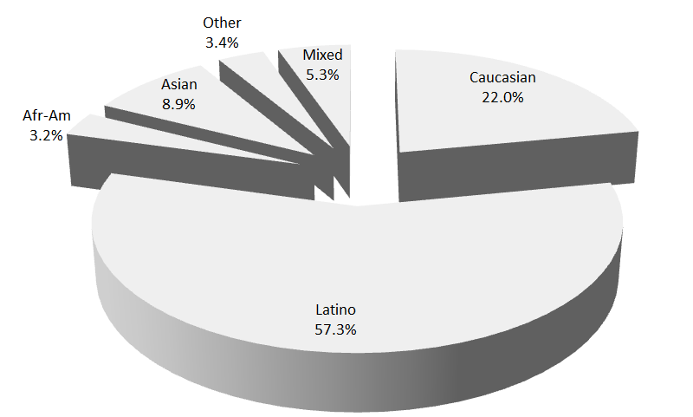

County vs. Contract (n = 538): County 19.7% vs. Contract 80.3%
Division (n = 418): CYS 99.3%, ADAS 0.7%

Mean YSS scale scores:

Figure 1. Figure 1. Mean Scores: YSS
(Error bars show SD; scale is 1-"strongly disagree" to 5-"strongly agree")
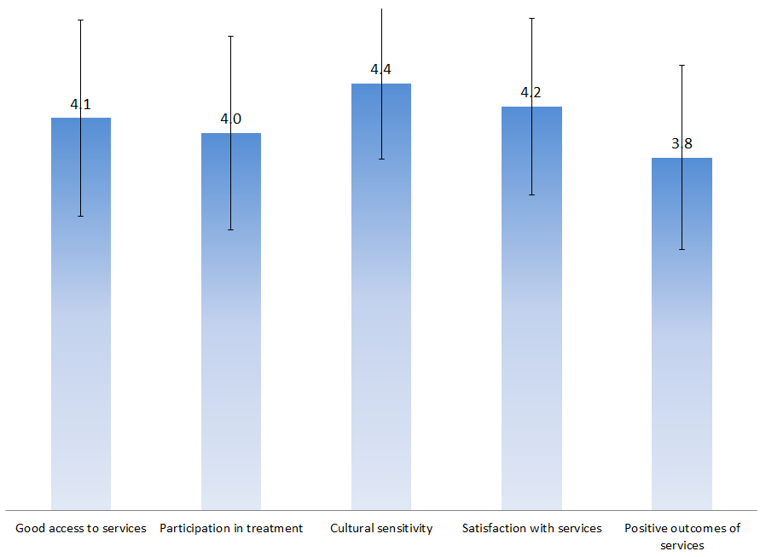

Factors affecting YSS scores:

There were no significant gender differences on any of the YSS scores. Access and Participation varied by ethnicity, with Asians scoring lowest on “Access to Treatment” and African-Americans giving the lowest ratings on “Participation in Treatment.” These ethnic differences are seen in Figure 2:

Figure 2. YSS Access and Participation, by Ethnicity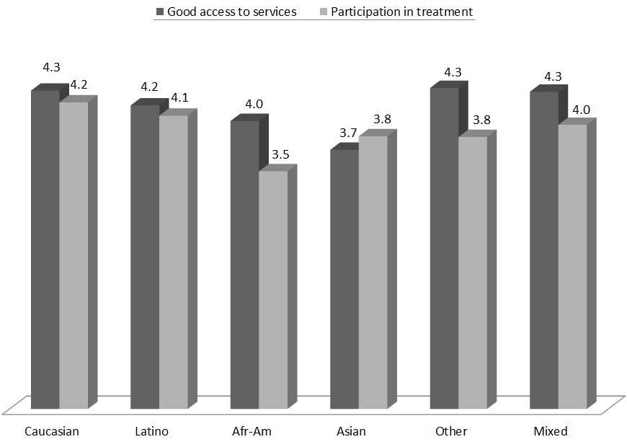

Figure 3 shows YSS scores for County vs. contract clinics. There was a significant difference for three scales. Mean scores were higher at contract clinics for Participation in Treatment, Cultural Sensitivity, and general Satisfaction with Services.

Figure 3. YSS: County vs. Contract clinics
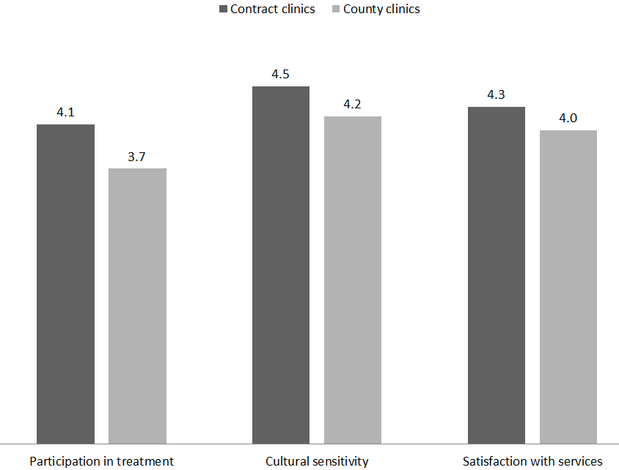

Clients who had been enrolled longer in services tended to score higher on “Participation in treatment,” “Cultural sensitivity,” “Satisfaction with services,” and “Positive outcomes of services,” r = ..15, .15, .16 and .24, respectively.

Table 1 shows the correlation between time-in-service and satisfaction. These relationships are depicted in Figure 2. All are significant at p < .01.

Figure 4. YSS Scores by time in service
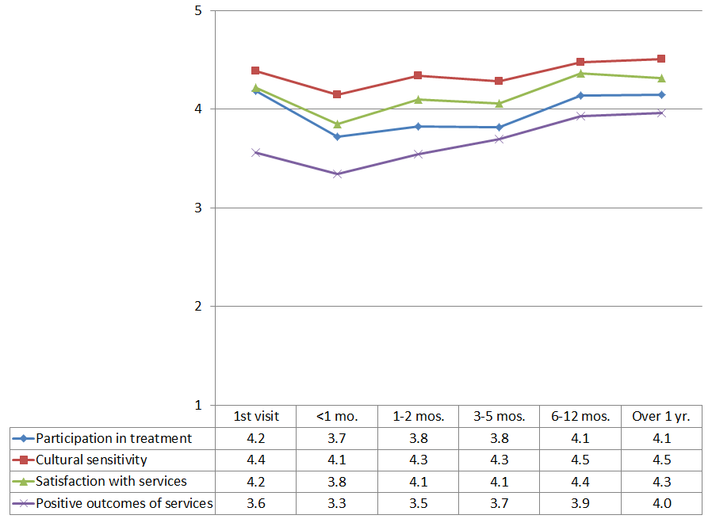

Living Situation

Clients were asked, “Have you lived in any of the following places in the last 6 months? (Mark all that apply.)”

Figure 5. Percentage in living situation over past 6 months
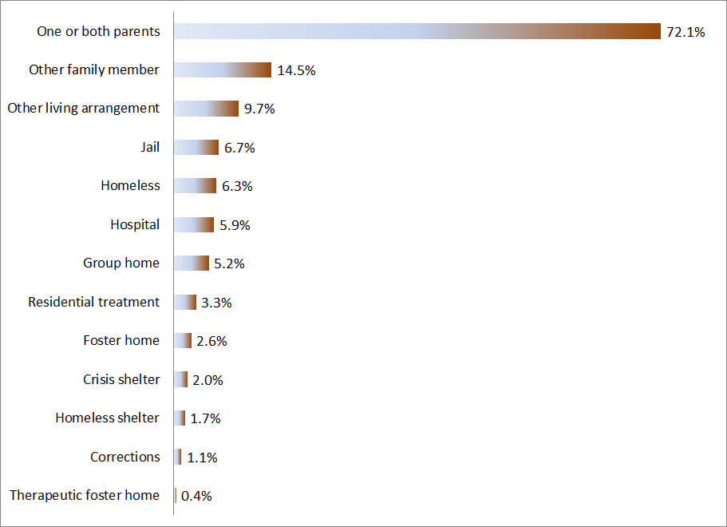

Doctor visits and medication

Figure 7. "In the last year, did you see a medical doctor (or nurse) for a health check-up or because you were sick?"
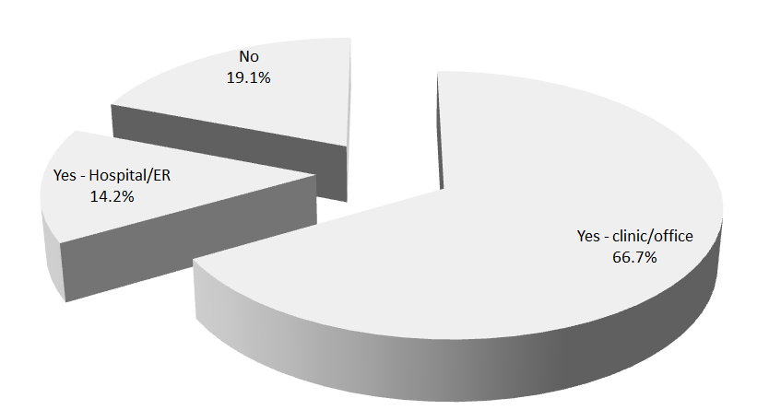
About two-thirds of clients (66.7%, 286/429) were seen for a medical clinic or office visit in the prior year. This rate did not differ significantly by ethnicity, county vs. contract clinic, division or gender.

Seventy percent of the clients (191/274) reported that they are taking psychotropic medication. Of the clients taking medication, 82.7% (158/191) reported that their medical provider had discussed side-effects with them.

Table 2. YSS mean scores by program
Program | Access | Partici- pation | Cultural | Satis- faction | Outcomes | n
ADAS Adolescent Unit, Aliso Viejo | 4.0 | 4.0 | 3.0 | 4.3 | 2.5 | 3
Canyon Acres Seneca, Anaheim | 3.9 | 3.6 | 4.3 | 3.9 | 3.7 | 12
Child Guidance Center | 4.2 | 4.0 | 4.4 | 4.3 | 4.0 | 22
Child Guidance Center, BP | 4.3 | 4.2 | 4.5 | 4.4 | 3.5 | 8
Collaborative Courts FSP | 4.4 | 4.4 | 4.7 | 4.6 | 4.2 | 50
CYBH CM | 4.6 | 4.0 | 4.1 | 4.2 | 3.7 | 6
CYBH Dana | 3.7 | 3.3 | 4.2 | 3.7 | 3.1 | 8
CYBH MV Los Alisos | 2.5 | 4.0 | 4.0 | -- | -- | 1
CYBH South, LB-Wesley | 4.1 | 4.0 | 4.7 | 4.1 | 3.7 | 7
CYBH West | 4.1 | 3.9 | 4.4 | 4.2 | 3.9 | 49
CYBH, North | 4.0 | 3.5 | 4.0 | 4.1 | 3.5 | 10
KCS (Korean Community Services) [Distribute through OCAPICA, 22120] | 3.6 | 3.9 | 4.4 | 4.3 | 3.3 | 4
Kinship Seneca Center | 4.1 | 3.9 | 4.4 | 4.2 | 3.9 | 24
OCAPICA | 3.4 | 3.9 | 4.2 | 3.8 | 3.2 | 7
Olivecrest WRAP | 3.9 | 4.2 | 4.4 | 4.0 | 3.7 | 6
Orangewood Children's Foundation FSP | 4.8 | 4.6 | 4.8 | 4.6 | 4.1 | 5
Phoenix Academy Orange County | 5.0 | 4.3 | 5.0 | 4.8 | 4.3 | 1
Providence Garden Grove | 4.3 | 3.9 | 4.5 | 4.2 | 3.8 | 12
Providence RENEW | 5.0 | 4.3 | 4.8 | 4.3 | 4.2 | 1
Providence STAY | 4.2 | 4.4 | 4.5 | 4.4 | 3.8 | 51
Providence, Anaheim | 3.9 | 4.2 | 4.4 | 4.1 | 3.8 | 10
Providence, Santa Ana | 4.1 | 3.7 | 4.5 | 4.0 | 3.9 | 8
SCCS TAY SRP | 4.1 | 4.3 | 4.9 | 4.5 | 4.1 | 5
South Coast Children's Society | 4.3 | 4.2 | 4.6 | 4.5 | 3.8 | 15
Touchstones (Adolescent) | 4.3 | 3.5 | 4.0 | 3.6 | 3.1 | 2
VNCOC (Vietnamese Community of OC) OCAPICA FSP | 4.5 | 4.4 | 4.6 | 4.6 | 4.2 | 7
WYS East (Anaheim) | 4.0 | 3.5 | 3.5 | 3.7 | 3.7 | 1
WYS North (Anaheim) | 4.1 | 3.8 | 4.3 | 4.0 | 3.6 | 56
WYS, Mission Viejo | 4.2 | 4.0 | 4.2 | 4.2 | 3.8 | 35
WYS, West | 3.9 | 3.9 | 4.3 | 4.2 | 3.8 | 45
Youthful Offender Wraparound | 4.4 | 4.3 | 4.6 | 4.5 | 3.9 | 41
YRC, North | 3.6 | 3.2 | 3.7 | 3.6 | 3.4 | 20
Total | 4.1 | 4.0 | 4.4 | 4.2 | 3.8

