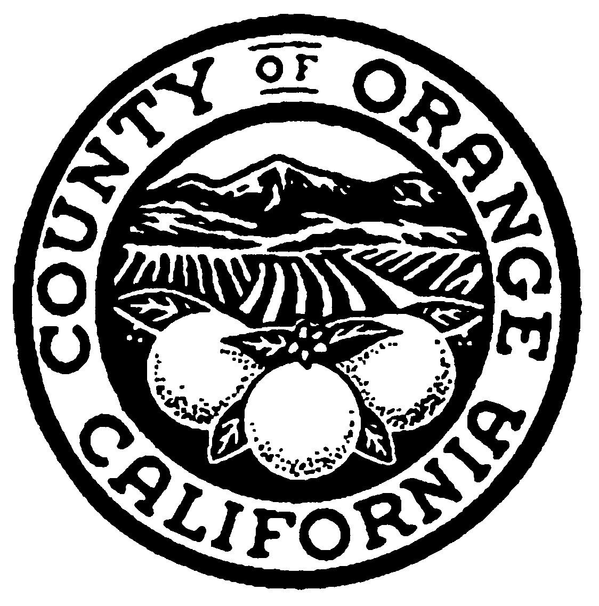
County of Orange
Health Care Agency, Behavioral Health Services
Mental Health Services Act (MHSA) Office
600 W. Santa Ana Blvd., Suite 510
Santa Ana, CA 92701

Phone: (714) 667-5620 E-mail: mhsa@ochca.com

Community Services and Supports
FY 2008/09 Plan Update

30 Day Public Comment Form
November 7, 2008 to December 8, 2008

PERSONAL INFORMATION
Name
Agency/Organization
Phone number |  |  |  |  | E-mail
Mailing address (street)
City, State, Zip
MY ROLE IN THE MENTAL HEALTH SYSTEM
 | Person in recovery |  |  | Probation
 | Family member |  |  | Education
 | Service provider |  |  | Social Services
 | Law enforcement/criminal justice |  |  | Other (please state)
COMMENTS
.

