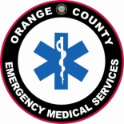
EMT Skills Competency Verifiers

Program name

Program type | Date | Submitted by | Reason for submission
EMT/paramedic training program  approved CE provider  public safety agency  private ambulance provider  other EMS provider |  | (name & title: role within Program) | change / update  annual listing  (due to OCEMS by Jan 15 of each year)

RETURN COMPLETED FORM TO ORANGE COUNTY EMS; ATTENTION CE & TRAINING COORDINATOR

Name (typed) | Certification / license # | Signature

ems share:EMT training programs\misc info & forms\SCV approved signers_TEMPLATE

