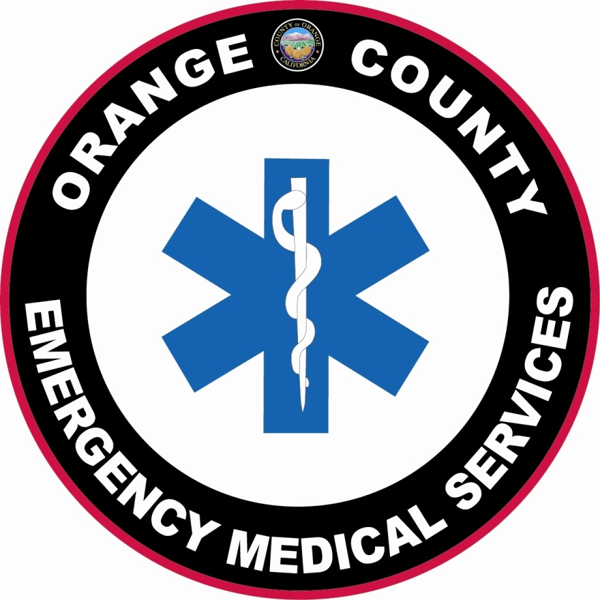County of Orange / Health Care Agency
HEALTH DISASTER MANAGEMENT
EMERGENCY MEDICAL SERVICES
Phone: (714) 834-3500

Education & Training Advisory Subcommittee
Wednesday, September 3, 2014
9:00 a.m.

Location of Meeting:
Orange County EMS
405 W. 5th Street, Conference Room 433
Santa Ana, CA 92701

***Draft*** A G E N D A

- CALL TO ORDER: 9:00 am
- INTRODUCTIONS / ANNOUNCEMENTS
- APPROVAL OF MINUTES
- July 2, 2014
- OCEMS REPORT / CORRESPONDENCE
  - Medical Director Update
- UNFINSHED BUSINESS
- OCEMS EMT Accreditation Curriculum (Revisions/Update)

- NEW BUSINESS
- OCEMS Policy/Procedure Updates effective 9/2/14
- New OCEMS Policy – EMT Skills Competency Verification Process

OTHER BUSINESS
- CE Provider Status – provider responsibilities discussion

VIII. NEXT MEETING - Wednesday, November 5, 2014, 9:00 a.m. in Conference Room 325

IX. ADJOURNMENT

