County of Orange
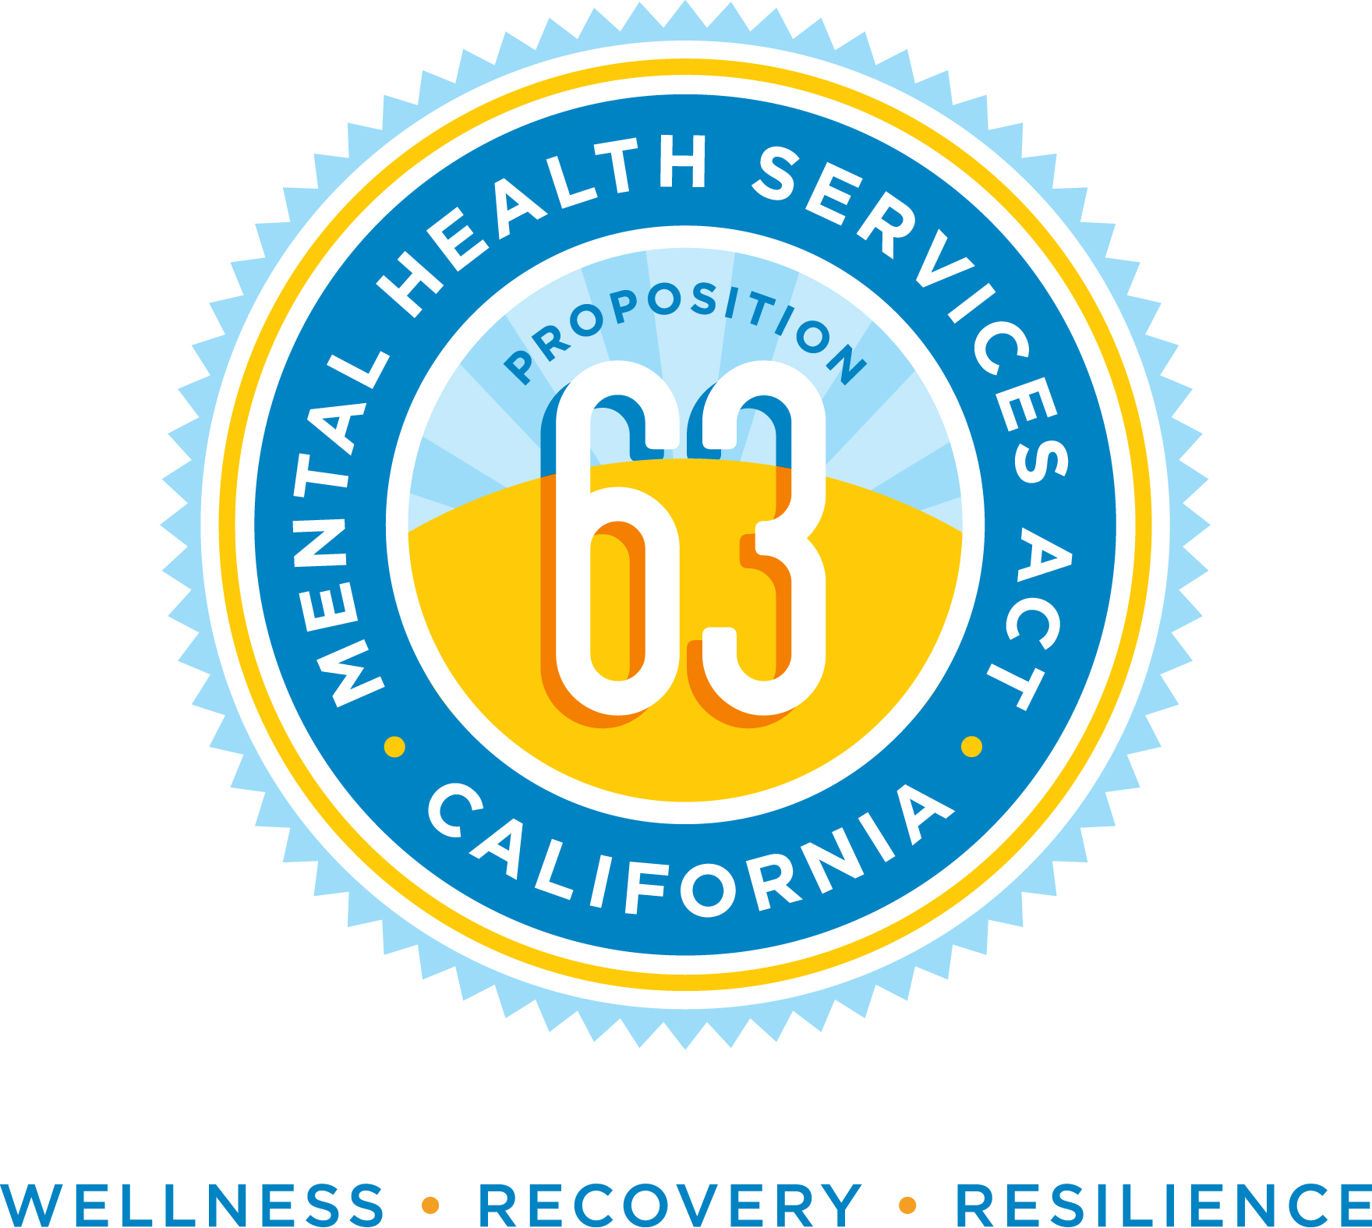

Health Care Agency, Behavioral Health Services
MHSA Office
405 W. 5th St. Suite 354
Santa Ana, CA 92701

Phone: (714) 834-3104 E-mail: mhsa@ochca.com

Mental Health Services Act

30-Day Public Comment Form

PERSONAL INFORMATION
Name
Agency/Organization
Phone number |  |  |  |  | E-mail
Mailing address (street)
City, State, Zip
MY ROLE IN THE MENTAL HEALTH SYSTEM
 | Person in recovery |  |  | Probation
 | Family member |  |  | Education
 | Service provider |  |  | Social Services
 | Law enforcement/criminal justice |  |  | Other (please state)
COMMENTS

