Consumer Perception Survey
May 2018 YSS Administration
Children and Youth
Jonathan Rich, Ph.D.
January 23, 2019

The Youth Satisfaction Survey (YSS) was offered to all teen and transitional age youth clients attending mental health services at a County or contract CYBH clinic from May 14 to 18, 2018. The intended age range for the YSS is 12 and older. The initial file contained 914 client records. YSS records with birthdates corresponding to an age of 12 – 25 and with a CYBH, Innovations or Prevention & Intervention program indicated were retained for this analysis. Records with no birthdate, a birthdate outside of the age range, or a program code that was missing or incorrect, or that was associated with an AOABH program were eliminated from this analysis. This left 774 records.

YSS Results

Sample description:

N: 774
Gender (n = 744): F-445 (59.8%), M-287 (38.6%), O-12 (1.6%)
Age (n = 774): Mean = 15.4, s = 2.2, range = 12-25.
Form Language (n = 774): English-763 (98.6%), Spanish - 6 (0.8%), Vietnamese -2 (0.3%), Chinese – 3 (0.4%)
Race/Ethnicity (n = 735):
Figure 1. Client race/ethnicity (569)
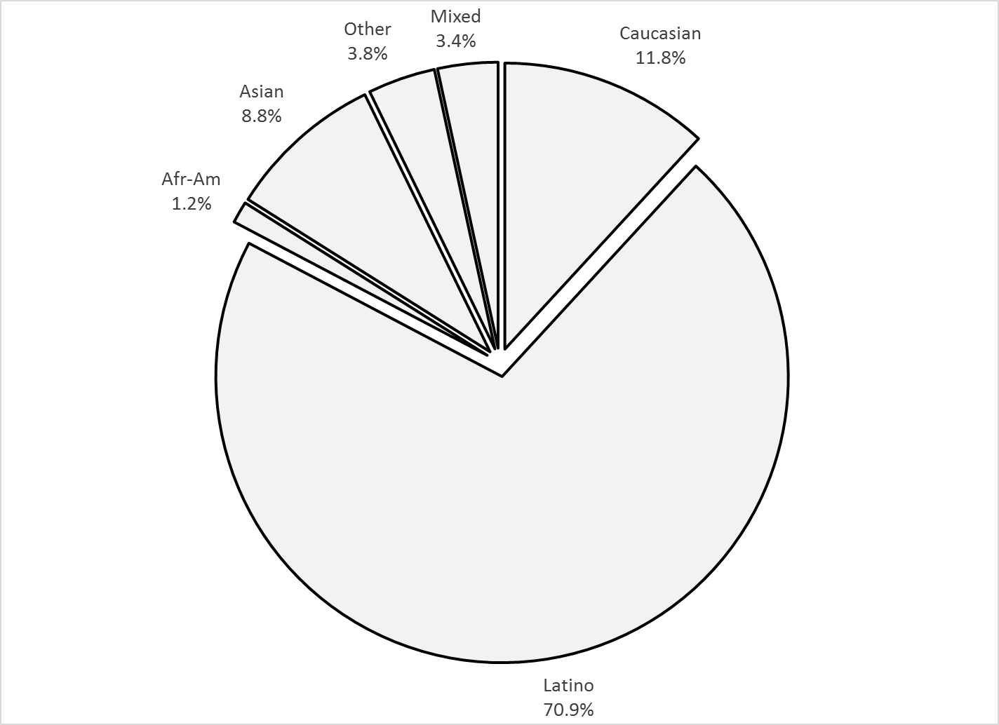

County vs. Contract (n = 774): County 26.6% vs. Contract 73.4%
Division (n = 589): CYBH 87.9%, P&I 11.8% Innovations 0.4%

Mean YSS scale scores:

Figure 2. Mean Scores: YSS
(Scale is 1-"strongly disagree" to 5-"strongly agree", n = 766)
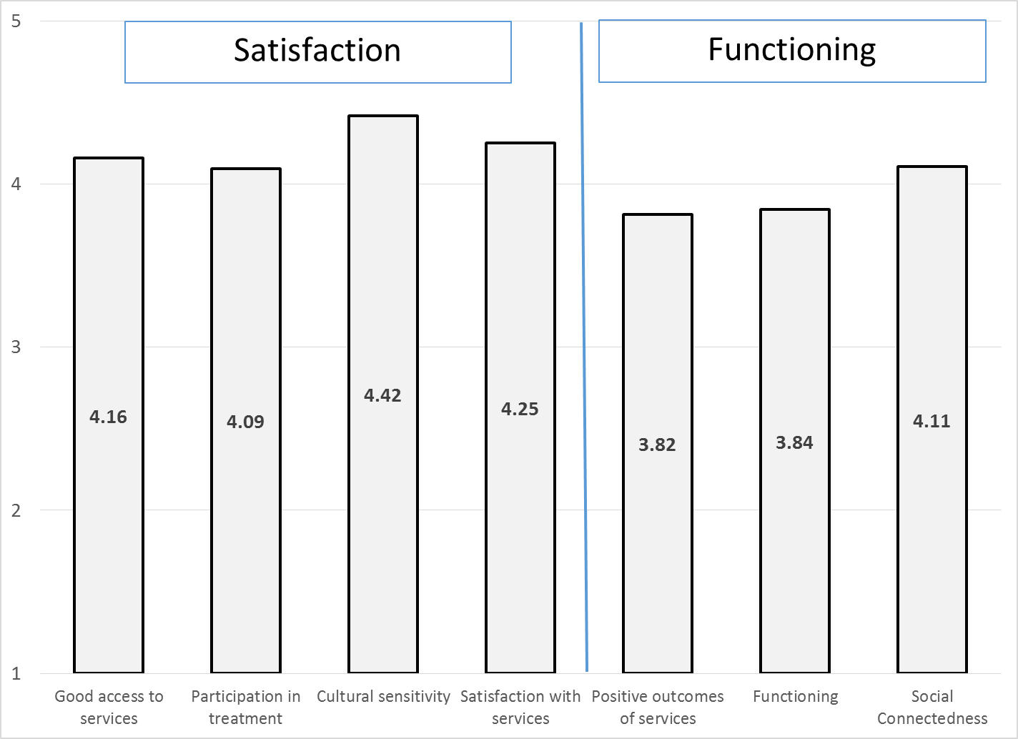
Factors affecting YSS scores:

Race/ethnicity was associated with two YSS scales, Access and General Satisfaction, p < .01. On these scales, Other and Asian clients tended to provide slightly lower ratings.

Figure 3. YSS scores by race/ethnicity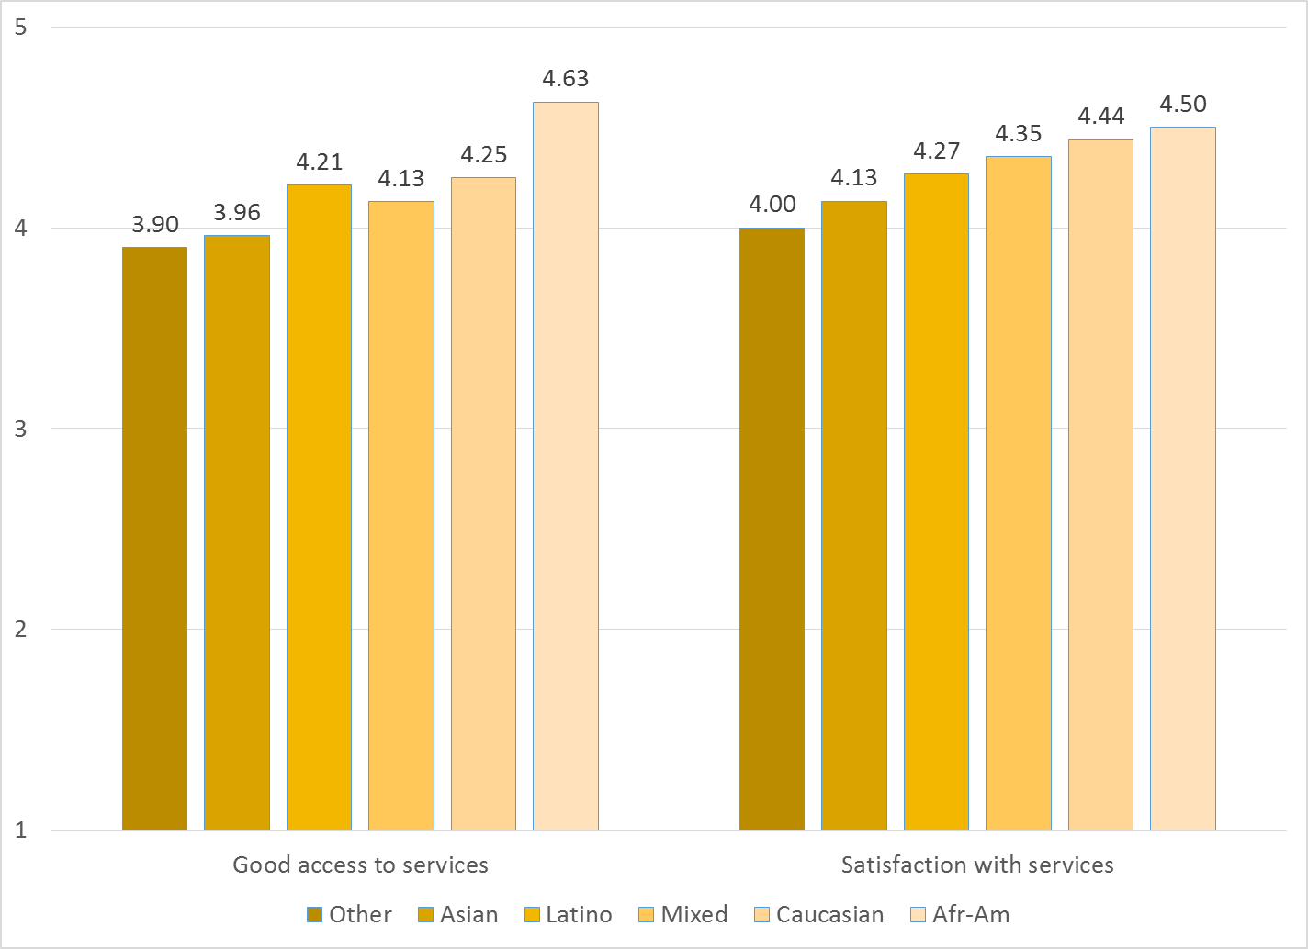

There were significant gender differences (p < .01) across the YSS Participation, Culture and General Satisfaction scales. On these scales, females scored higher than males.

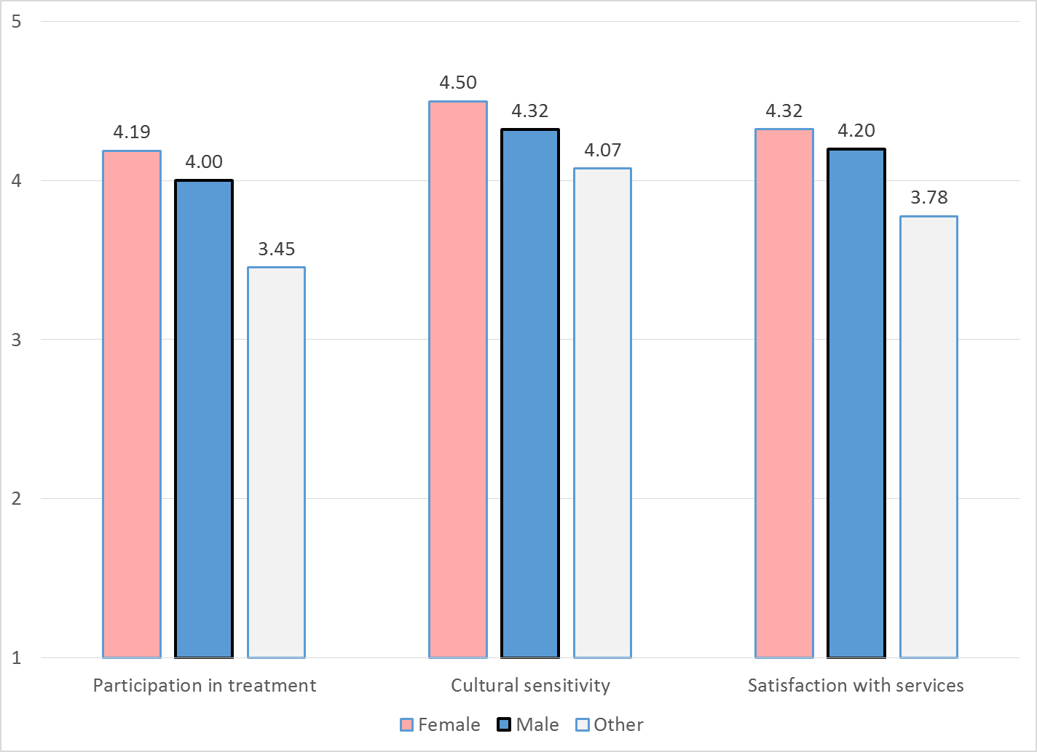

Clients who had been enrolled longer in services tended to score higher on YSS scales. These relationships are depicted in Figure 4. All are significant at p < .01.

Figure 4. YSS Scores by time in service
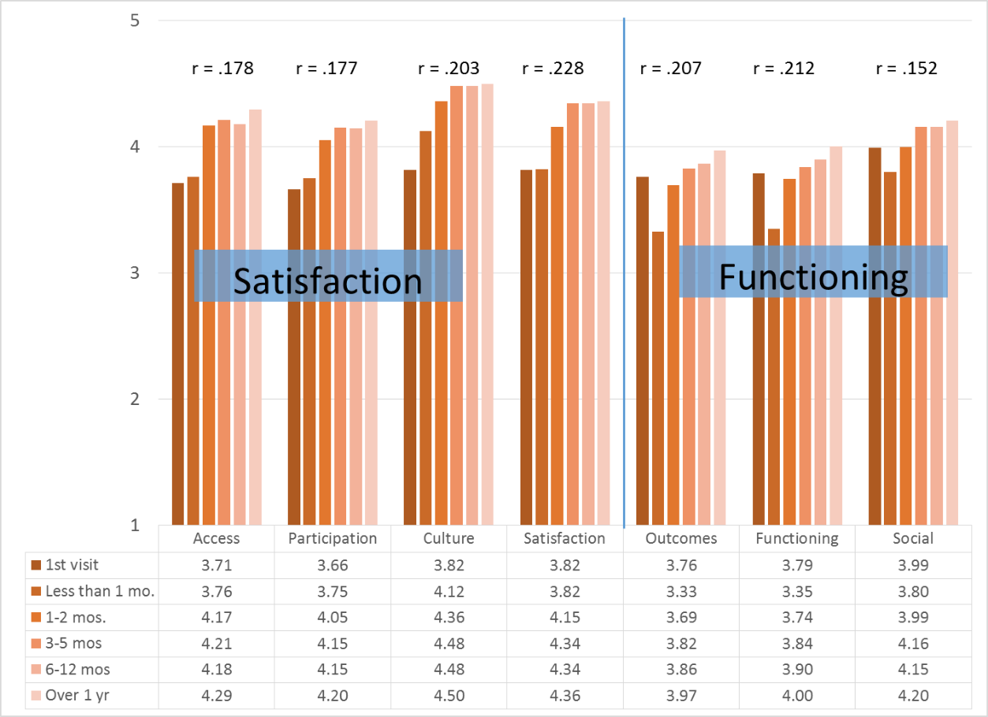

There was not a significant correlation between the YSS scales and age.

Living Situation

Clients were asked, “Have you lived in any of the following places in the last 6 months? (Mark all that apply.)” The responses to this question are seen in Figure 6. Four out of five youths resided with one or both parents during the prior six months. Three percent of youth reported homelessness during this same period and 4.0% had either been homeless or lived in a homeless shelter. Homelessness is about twice as high for clients who are age 18 or older compared to younger clients (Figure 7).

Figure 6. Percentage in living situation over past 6 months
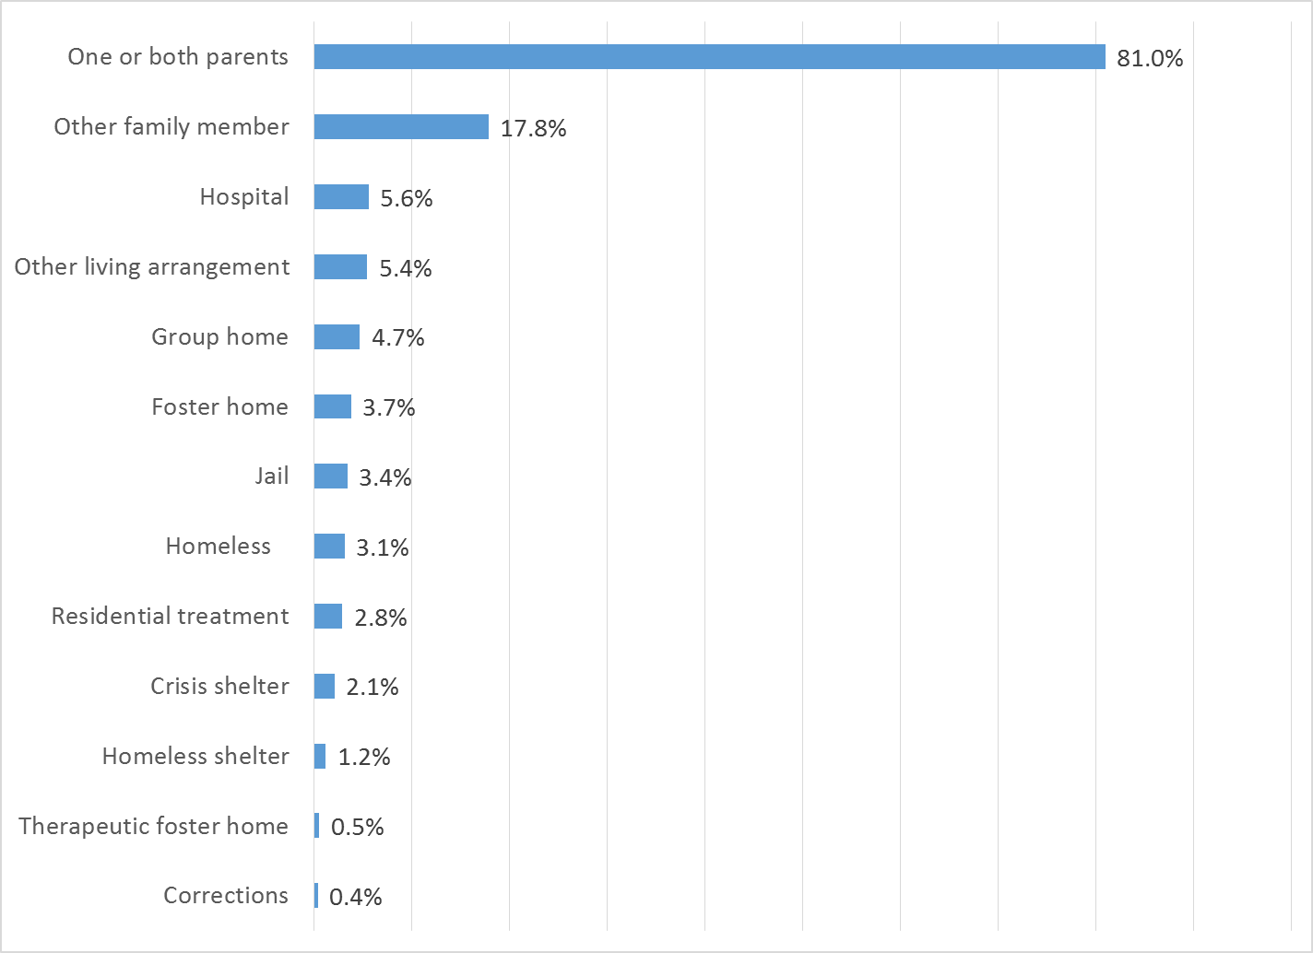

Figure 7. Homeless or in homeless shelter in last 6 months, by age
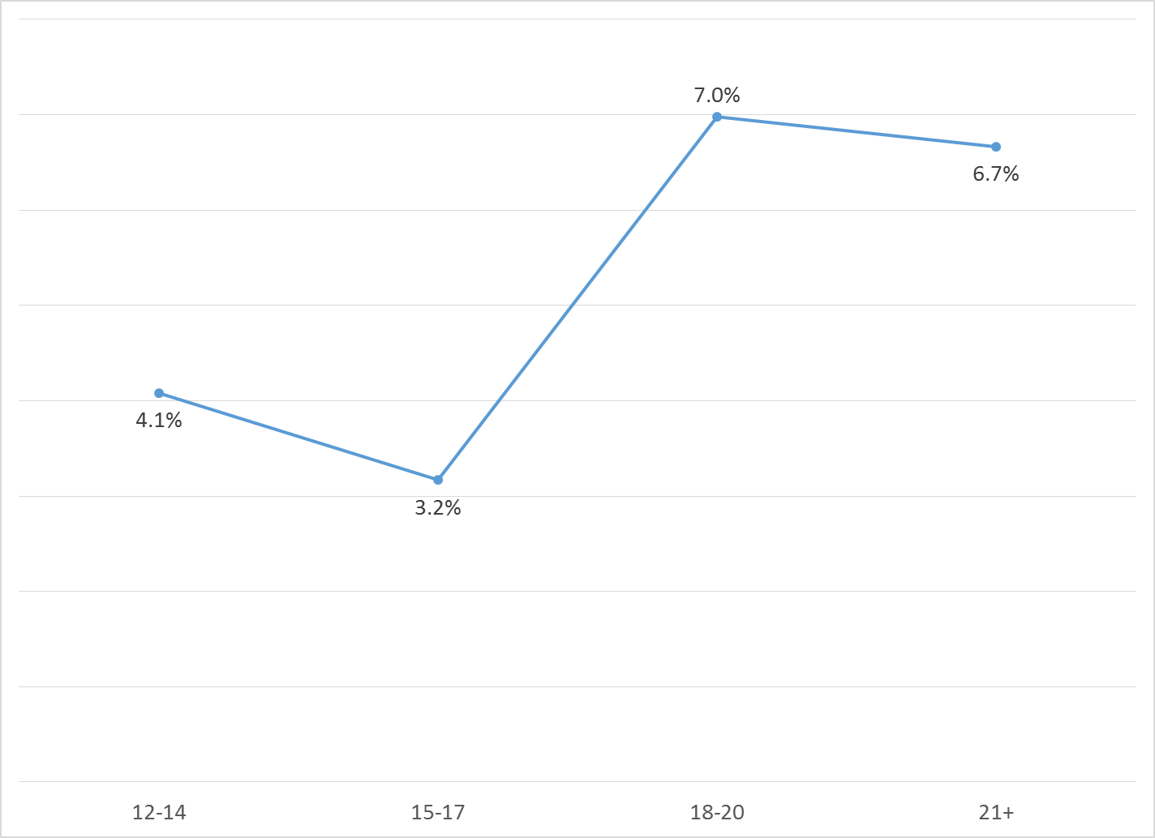

Doctor visits and medication

As reflected by Figure 8, 65.4% of clients reporting (411/628) were seen for a medical clinic or office visit in the prior year. The rate was higher for females than for males: 71.0% vs. 55.7%. There was no difference by race, County/contract, or function area.

Figure 8. "In the last year, did you see a medical doctor (or nurse)
for a health check-up or because you were sick?" (n = 628)
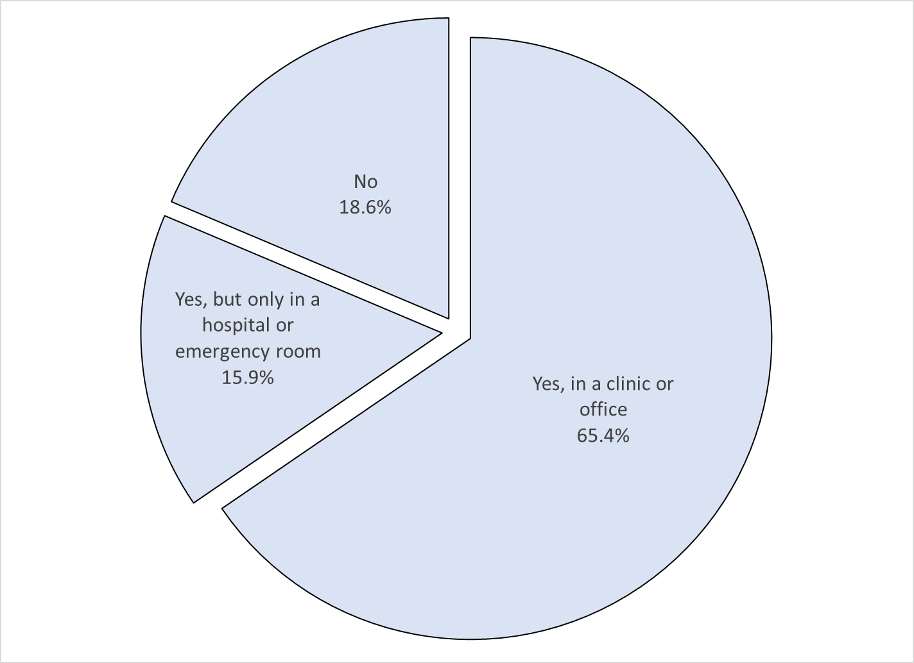

Psychotropic medication is taken by 31.7% of clients reporting this information (234/738). Of those receiving medication, 82.6% (181/219) indicated that the doctor or nurse told them what side effects to watch for.

Table 1. YSS mean scores by program
Program | Access | Partic | Culture | Satis | Outcm | Func | Social | N
Behavioral Health Services for Military Families Child Guidance Center | 4.50 | 4.00 | 4.33 | 4.44 | 4.17 | 4.17 | 4.00 | 3
Child Guidance Center, BP | 4.06 | 4.38 | 4.50 | 4.44 | 3.55 | 3.58 | 4.38 | 8
Child Guidance Center, FUL | 4.53 | 4.21 | 4.80 | 4.53 | 3.69 | 3.80 | 4.22 | 16
Children’s Hospital of Orange County Co Occurring Clinic | 3.71 | 3.86 | 4.38 | 4.04 | 4.01 | 3.97 | 4.28 | 21
Collaborative Courts FSP | 4.38 | 4.29 | 4.46 | 4.45 | 4.01 | 4.03 | 4.20 | 52
Community Counseling and Supportive Services | 3.00 | 4.00 | 3.67 | 4.00 | 3.83 | 3.83 | 3.50 | 1
CYBH Aliso Viejo | 3.00 | 3.00 | 4.33 | 3.50 | 2.83 | 2.67 | 3.00 | 1
CYBH CCPU | 5.00 | 5.00 | 4.00 | 5.00 | 4.92 | 4.92 | 5.00 | 2
CYBH CM | 4.50 | 4.67 | 5.00 | 5.00 | 4.50 | 4.33 | 5.00 | 1
CYBH East | 4.15 | 4.18 | 4.56 | 4.39 | 3.66 | 3.64 | 4.06 | 34
CYBH PACT | 4.00 | 3.83 | 4.00 | 3.92 | 4.17 | 4.17 | 4.00 | 2
CYBH South RH Dana: Dana Point | 3.88 | 3.83 | 4.69 | 3.75 | 3.42 | 3.50 | 3.94 | 4
CYBH South, LB Wesley | 4.25 | 4.24 | 4.46 | 4.25 | 4.14 | 4.12 | 4.17 | 7
CYBH West Region | 4.31 | 3.95 | 4.48 | 4.30 | 3.74 | 3.78 | 4.18 | 20
CYBH, North | 4.15 | 4.00 | 4.27 | 4.29 | 3.72 | 3.76 | 4.08 | 23
KCS (Korean Community Services) | 3.40 | 3.73 | 4.56 | 4.27 | 3.57 | 3.63 | 4.35 | 5
New Alternatives WRAP | 4.50 | 4.33 | 4.00 | 4.00 | 3.17 | 3.33 | 4.00 | 2
OCAPICA FSP | 3.85 | 4.09 | 4.37 | 4.13 | 3.77 | 3.83 | 3.85 | 25
Orange County Center for Resiliency, Education & Wellness(OC CREW) | 4.33 | 4.20 | 4.17 | 4.38 | 4.23 | 4.37 | 4.50 | 6
Orange County Parent Wellness Program (OCPWP) | 4.80 | 4.73 | 4.80 | 4.77 | 4.57 | 4.57 | 4.30 | 5
Pathways CS STAY | 4.25 | 4.23 | 4.63 | 4.59 | 4.08 | 4.19 | 4.33 | 13
Pathways RENEW | 4.47 | 4.20 | 4.49 | 4.45 | 3.89 | 3.95 | 4.21 | 18
Pathways, Anaheim | 4.18 | 4.11 | 4.45 | 4.47 | 3.93 | 3.92 | 4.31 | 12
Pathways, Santa Ana | 4.29 | 4.13 | 4.54 | 4.37 | 3.85 | 3.90 | 4.03 | 36
Phoenix House Wraparound | 3.00 | 3.67 | 4.25 | 4.17 | 3.33 | 3.42 | 4.13 | 2
SCCS-Outpatient | 4.03 | 4.03 | 4.42 | 4.48 | 4.18 | 4.23 | 3.98 | 15
School Based Mental Health Services - Early Intervention | 4.22 | 4.14 | 4.51 | 4.30 | 3.81 | 3.86 | 4.19 | 78
Seneca OC Outpatient | 4.08 | 4.19 | 4.48 | 4.27 | 4.13 | 4.15 | 4.32 | 25
Seneca OC Wraparound | 4.00 | 3.67 | 4.00 | 3.83 | 3.83 | 3.83 | 4.00 | 1
SIS Southland Integrated Services OCAPICA FSP | 4.67 | 4.22 | 4.17 | 4.17 | 4.17 | 4.11 | 4.33 | 3
Touchstones (Adolescent) | 4.20 | 4.33 | 4.18 | 4.37 | 4.13 | 4.10 | 4.27 | 10
Wayfinders-Families First | 3.89 | 3.79 | 4.19 | 4.13 | 3.80 | 3.77 | 4.08 | 9
Western Youth Services West: Fountain Valley | 4.20 | 4.11 | 4.38 | 4.18 | 3.78 | 3.80 | 4.09 | 63
WYS East (Santa Ana) | 4.13 | 4.09 | 4.38 | 4.12 | 3.60 | 3.63 | 3.92 | 56
WYS North (Anaheim) | 4.16 | 4.07 | 4.42 | 4.12 | 3.71 | 3.73 | 4.03 | 86
WYS, Mission Viejo | 4.11 | 3.99 | 4.40 | 4.15 | 3.68 | 3.70 | 4.03 | 77
Youthful Offender Wraparound | 4.42 | 3.94 | 4.46 | 4.36 | 4.28 | 4.31 | 4.46 | 6
YRC, Central | 3.70 | 3.60 | 3.48 | 3.57 | 3.83 | 3.80 | 4.10 | 5
YRC, North | 3.57 | 3.58 | 3.83 | 3.93 | 3.79 | 3.83 | 3.91 | 15
Total | 4.16 | 4.09 | 4.42 | 4.25 | 3.82 | 3.84 | 4.11
Significantly Higher
Significantly Lower
(+/- 2 std.errors)

