Consumer Perception Survey
May 2015 YSS-F Administration
Children and Youth
Jonathan Rich, Ph.D.
January 6, 2016

The Youth Satisfaction Survey for Families (YSS-F) was offered to all parents and guardians of children and youths attending mental health services at a County or contract CYBH clinic from May 11-15, 2015. YSS-F records with birthdates corresponding to an age of 0 – 21 and with a CYBH, ADAS, Innovations or Prevention & Intervention program indicated were retained for this analysis.

YSS-F Results

Sample description:

N: 961
Gender (n = 924): F-396 (56.9%), M-526 (42.9%), O-2 (0.2%)
Age: Mean = 10.9, s = 4.1, range = 0-21.
Form Language (n = 961): English-542 (56.4%), Spanish-389 (40.5%), Vietnamese-29 (3.0%), Chinese-1 (0.1).
Race/Ethnicity (n = 919):
Figure 1. Client race/ethnicity
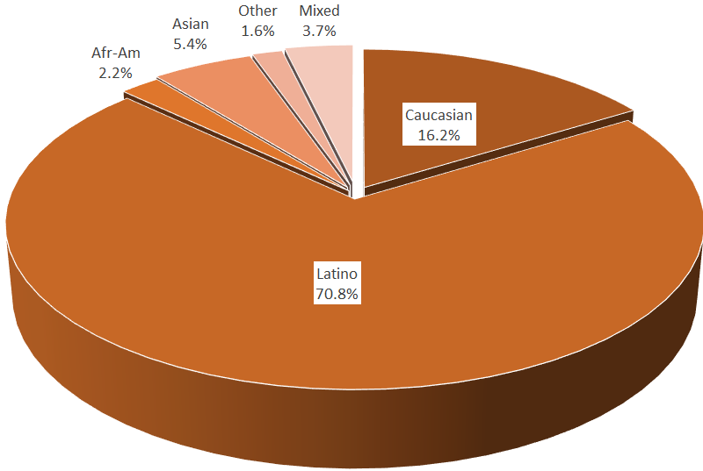

County vs. Contract (n = 961): County 12.8% vs. Contract 87.2%
Division (n = 961): CYBH 99.2%, Innovations 0.6%, P&I 0.1%, ADAS 0.1%

Mean YSS-F scale scores:

Figure 2. Mean Scores: YSS-F
(Scale is 1-"strongly disagree" to 5-"strongly agree")
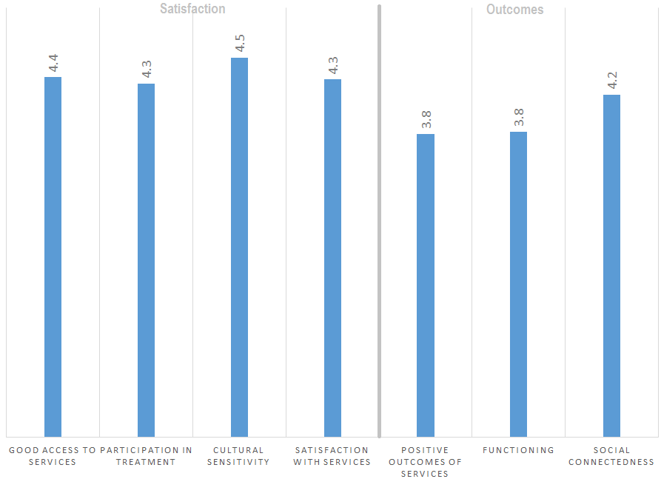

Factors affecting YSS-F scores:

There were no significant ethnic differences on any of the YSS-F scores (Figure 3).

Figure 3. YSS-F scores by race/ethnicity (no statistically significant differences) 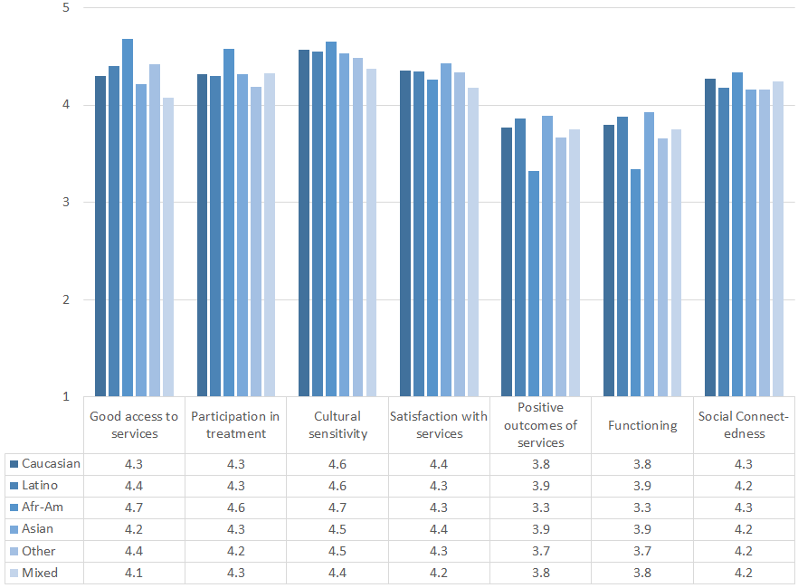

Participants completing the form in English were compared to those completing the form in Spanish. Those responding to the Spanish forms gave significantly more favorable ratings on the Access, Outcomes, and Functioning scales.

Figure 3. YSS-F mean ratings, English vs. Spanish forms
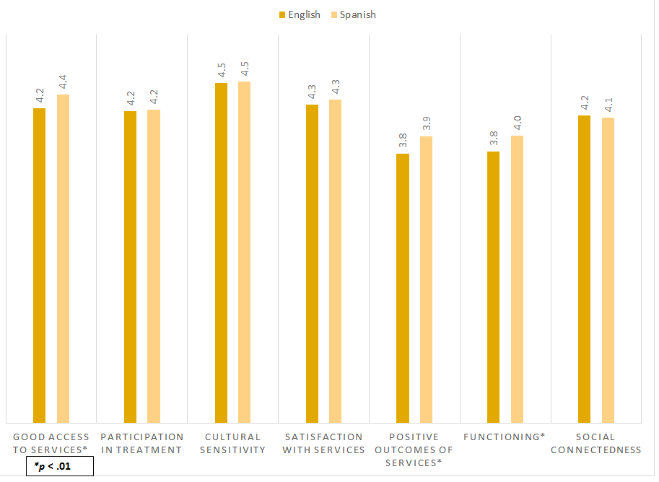

There were no significant gender differences.

Clients who had been enrolled longer in services tended to score higher on the Satisfaction, Outcomes, Functioning and Social Connectedness scales. These relationships are depicted in Figure 5.
Figure 4. YSS-F Scores by time in service (*p < .01)
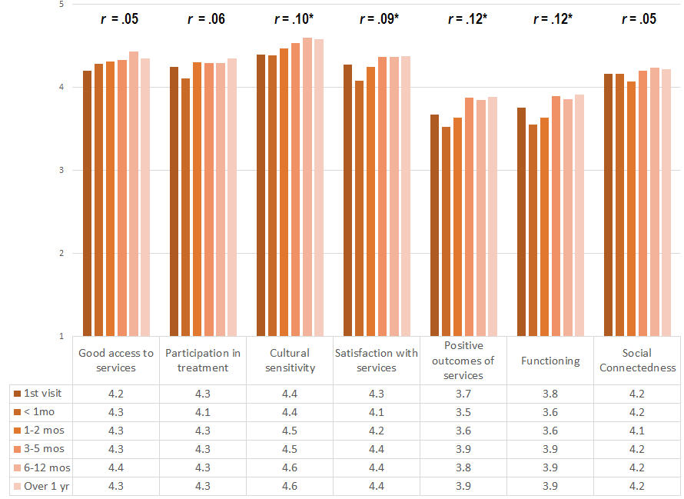

Living Situation

Clients were asked, “Have you lived in any of the following places in the last 6 months? (Mark all that apply.)”

Figure 5. Percentage in living situation over past 6 months
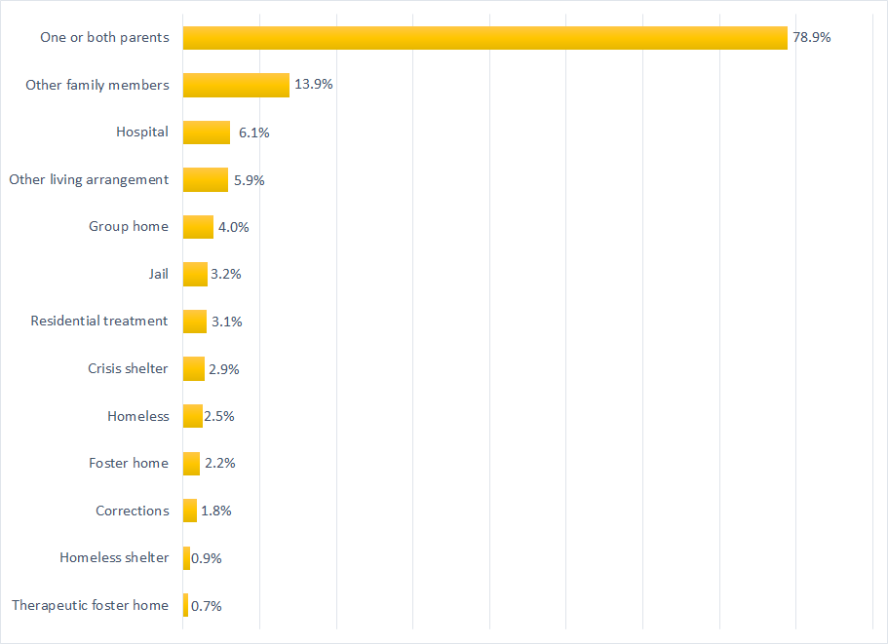

Doctor visits and medication

Figure 6. "In the last year, did you see a medical doctor (or nurse)
for a health check-up or because you were sick?"
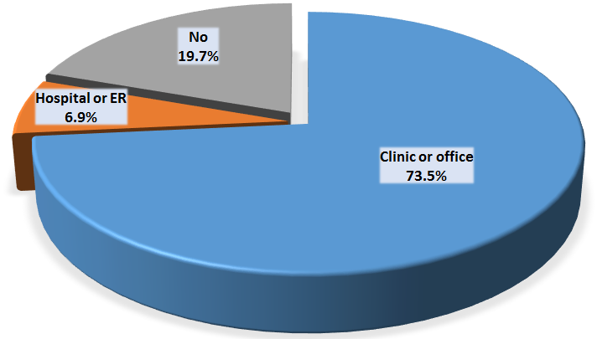
Seventy-three percent of clients reporting (654/890) were seen for a medical clinic or office visit in the prior year. This rate did not differ significantly by age, county vs. contract clinic, or gender. The rate differed by ethnicity, with only 70.1% of Latinos seeing a medical provider in a clinic or office vs. 83.6% of non-Latinos.

Fewer than half of the clients, 36.2%, (320/884) reported that they are taking psychotropic medication. Of the clients taking medication, 93.2% (261/280) reported that their medical provider had discussed side-effects with them.

Table 2. YSS-F mean scores by program (scores in red are about 2 standard errors lower than overall mean)
Program | Access | Partici- pation | Culture | Satis- faction | Outcomes | Func- tioning | Social | N
Associates in Counseling | 4.0 | 3.7 | 5.0 | 3.2 | 3.2 | 3.0 | 4.3 | 1
Brighter Futures | 4.6 | 4.5 | 4.8 | 4.5 | 4.1 | 4.1 | 4.7 | 5
Canyon Acres Seneca, Anaheim | 4.3 | 4.3 | 4.6 | 4.4 | 3.8 | 3.8 | 4.4 | 66
CGC, BP | 4.3 | 4.1 | 4.6 | 4.2 | 3.6 | 3.6 | 4.2 | 54
CGC, Fullerton | 4.3 | 4.3 | 4.5 | 4.3 | 3.9 | 3.9 | 4.2 | 88
CGC, Santa Ana | 4.2 | 4.2 | 4.5 | 4.3 | 3.9 | 3.9 | 4.1 | 56
Collaborative Courts FSP | 4.4 | 4.4 | 4.6 | 4.5 | 4.1 | 4.1 | 4.4 | 60
CYBH CM | 4.4 | 4.3 | 4.9 | 4.4 | 3.9 | 3.9 | 4.3 | 24
CYBH Dana | 4.0 | 3.9 | 4.1 | 4.2 | 3.9 | 3.8 | 4.2 | 26
CYBH East | 4.4 | 4.2 | 4.6 | 4.4 | 3.7 | 3.7 | 4.1 | 64
CYBH MV Los Alisos | 4.6 | 4.6 | 4.7 | 4.9 | 4.2 | 4.1 | 4.8 | 5
CYBH South, LB-Wesley | 4.1 | 4.2 | 4.7 | 4.6 | 4.0 | 4.0 | 4.3 | 25
CYBH West | 4.1 | 3.9 | 4.3 | 4.2 | 3.9 | 3.9 | 4.1 | 48
CYBH, North | 4.1 | 3.8 | 4.4 | 4.0 | 3.6 | 3.6 | 3.9 | 23
Families First | 4.4 | 4.3 | 4.5 | 4.5 | 3.9 | 3.9 | 4.1 | 13
ICS-Southland Health Center | 5.0 | 5.0 | 5.0 | 5.0 | 3.5 | 3.5 | 4.0 | 1
Kinship Seneca Center | 4.3 | 4.4 | 4.5 | 4.2 | 3.8 | 3.8 | 4.2 | 50
New Alternatives | 4.0 | 5.0 | 5.0 | 5.0 | 4.5 | 4.5 | 5.0 | 1
OC ACCEPT | 3.5 | 4.5 | 5.0 | 5.0 | 3.5 | 3.7 | 4.0 | 1
OCAPICA | 4.4 | 4.4 | 4.6 | 4.4 | 3.8 | 3.8 | 4.1 | 17
Olivecrest WRAP | 3.5 | 3.3 | 4.1 | 3.8 | 3.2 | 3.5 | 4.5 | 2
OC CREW | 3.0 | 4.3 | 5.0 | 4.2 | 4.2 | 4.2 | 4.5 | 1
Orangewood Children's Found. FSP | 4.8 | 4.7 | 4.8 | 4.7 | 4.5 | 4.6 | 4.6 | 9
Providence Garden Grove | 4.3 | 4.2 | 4.5 | 4.3 | 4.0 | 4.0 | 4.0 | 38
Providence RENEW | 4.5 | 4.4 | 4.6 | 4.5 | 3.9 | 4.0 | 4.2 | 136
Providence STAY | 4.2 | 4.3 | 4.5 | 4.3 | 3.7 | 3.8 | 4.1 | 22
Providence, Anaheim | 4.4 | 4.4 | 4.7 | 4.4 | 4.0 | 4.0 | 4.0 | 33
Providence, Santa Ana | 4.3 | 4.1 | 4.5 | 4.2 | 3.7 | 3.7 | 4.1 | 38
South Coast Children's Society | 4.0 | 4.0 | 4.2 | 4.1 | 3.5 | 3.5 | 4.3 | 13
Vietnamese Community FSP | 4.4 | 4.3 | 4.5 | 4.5 | 4.0 | 4.0 | 4.1 | 5
WYS CEGU- OCFC | 4.5 | 4.7 | 4.3 | 4.3 | 4.2 | 4.2 | 4.5 | 1
WYS East (Anaheim) | 4.2 | 4.1 | 4.4 | 4.2 | 3.7 | 3.8 | 4.1 | 181
WYS North (Anaheim) | 4.4 | 4.3 | 4.6 | 4.3 | 3.8 | 3.8 | 4.1 | 151
WYS, Mission Viejo | 4.1 | 4.1 | 4.4 | 4.0 | 3.7 | 3.7 | 4.1 | 45
WYS, West | 4.0 | 4.1 | 4.3 | 4.2 | 3.7 | 3.7 | 4.1 | 152
Youthful Offender Wraparound | 4.4 | 4.4 | 4.7 | 4.5 | 4.1 | 4.2 | 4.4 | 36
Total | 4.3 | 4.2 | 4.5 | 4.3 | 3.8 | 3.8 | 4.2 | 1483

