Consumer Perception Survey
May 2015 YSS Administration
Children and Youth
Jonathan Rich, Ph.D.
December 31, 2015

The Youth Satisfaction Survey (YSS) was offered to all teen and transitional age youth clients attending mental health services at a County or contract CYBH clinic from May 11-15, 2015. The intended age range for the YSS is 13 and older. YSS records with birthdates corresponding to an age of 13 – 21 and with a CYBH, ADAS, Innovations or Prevention & Intervention program indicated were retained for this analysis.

YSS Results

Sample description:

N: 555
Gender (n = 532): F-321 (60.3%), M-202 (38.0%), O-9 (1.7%)
Age: Mean = 16.0, s = 1.9, range = 13-21.
Form Language (n = 555): English-549 (98.9%), Spanish-5 (0.9%), Viet-1 (0.2%)

Race/Ethnicity (n = 532):
Figure 1. Client race/ethnicity
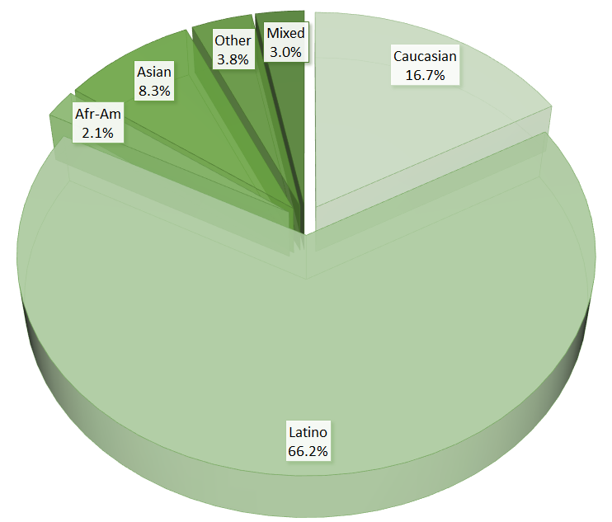

County vs. Contract (n = 555): County 19.5% vs. Contract 80.5%
Division (n = 555): CYBH 99.8%, Innovations 0.2%

Mean YSS scale scores:

Figure 2. Mean Scores: YSS
(Scale is 1-"strongly disagree" to 5-"strongly agree")
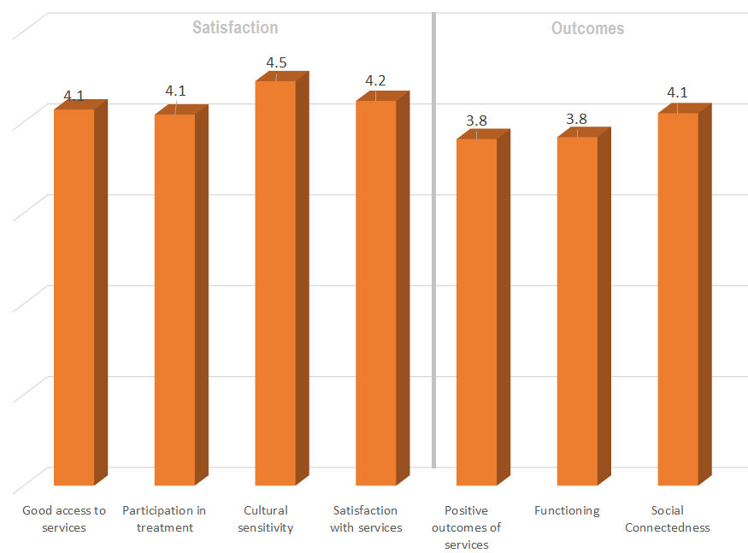

Factors affecting YSS scores:

There were no significant ethnic differences on any of the YSS scores (Figure 3).

Figure 3. YSS scores by race/ethnicity (no statistically significant differences)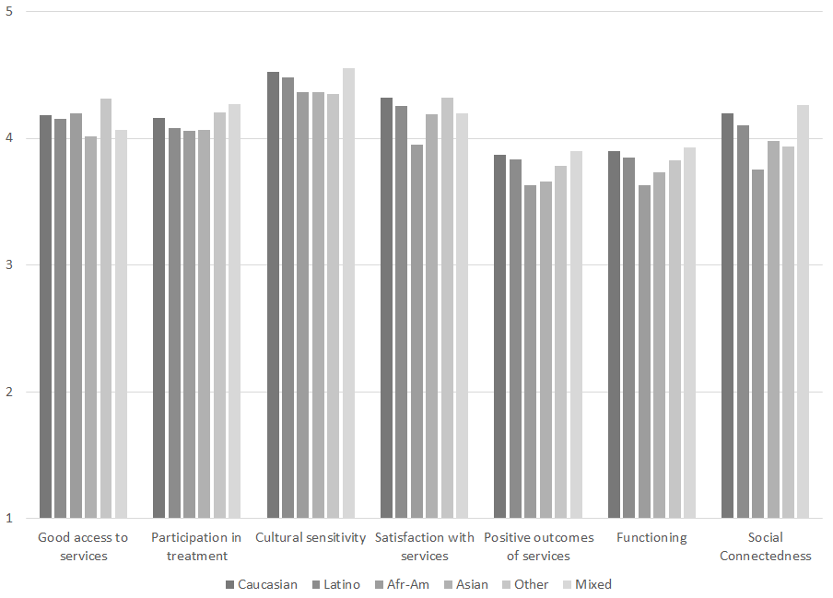

With regard to gender differences, women rated treatment access and participation in treatment higher than did men (Figure 4).

Figure 4. YSS Scores by gender
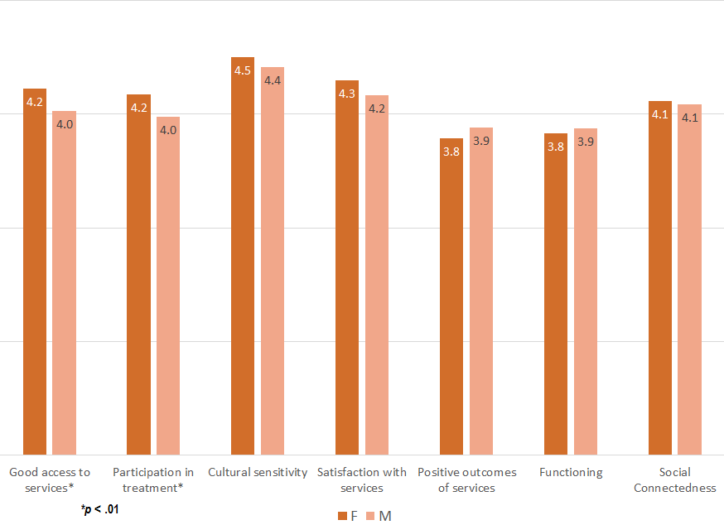

Clients who had been enrolled longer in services tended to score higher on all YSS scales.
These relationships are depicted in Figure 5. All are significant at p < .01.

Figure 5. YSS Scores by time in service
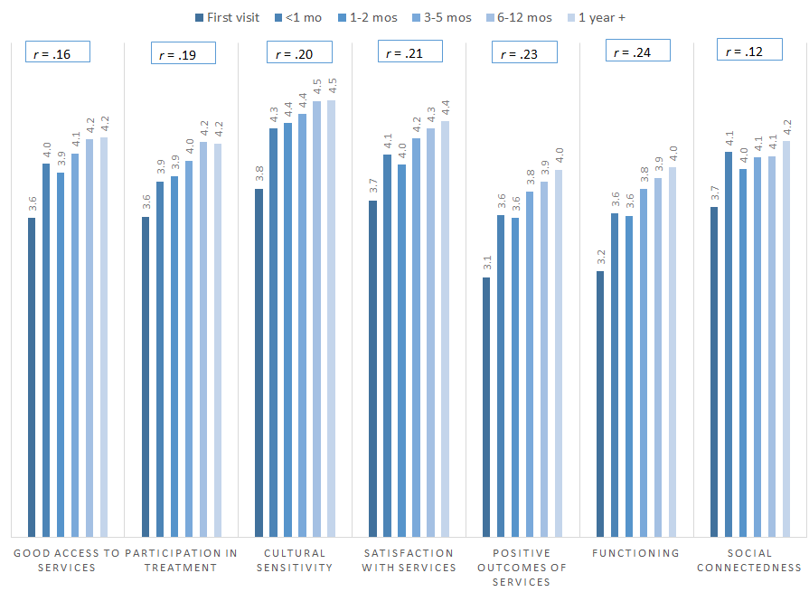

Living Situation

Clients were asked, “Have you lived in any of the following places in the last 6 months? (Mark all that apply.)”

Figure 6. Percentage in living situation over past 6 months
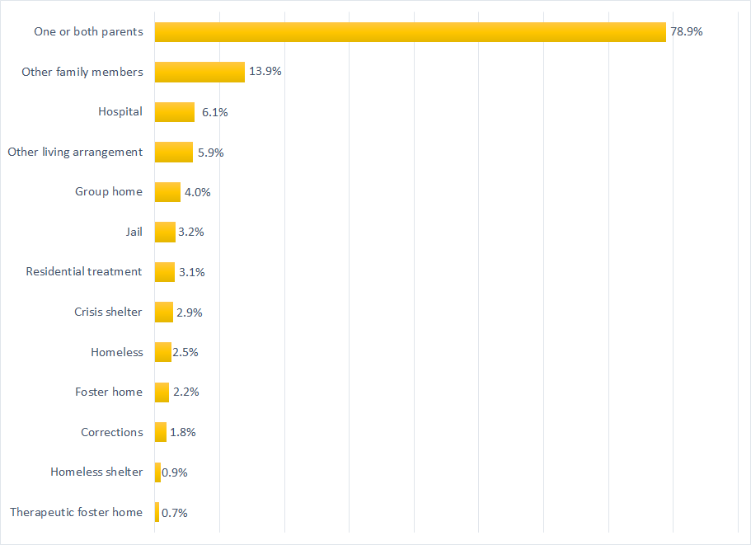

Doctor visits and medication

Figure 7. "In the last year, did you see a medical doctor (or nurse)
for a health check-up or because you were sick?"
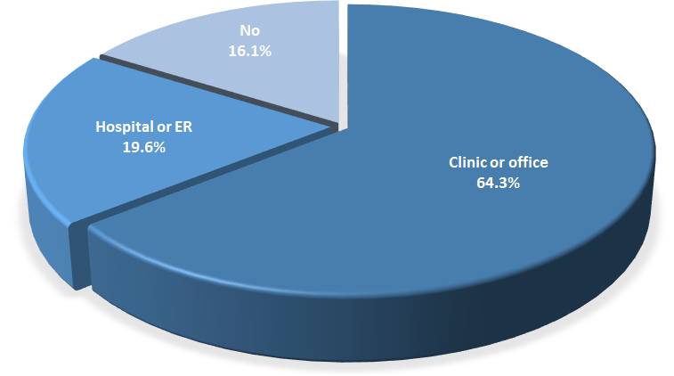
Sixty-four percent of clients reporting (299/465) were seen for a medical clinic or office visit in the prior year. This rate did not differ significantly by age, ethnicity, county vs. contract clinic, or gender.

Fewer than half of the clients, 43.7%, (230/296) reported that they are taking psychotropic medication. Of the clients taking medication, 95.6% (195/216) reported that their medical provider had discussed side-effects with them.

Table 2. YSS mean scores by program (scores in red are about two standard errors lower than overall mean)
Program | Access | Partici- pation | Cultural | Satis- faction | Outcomes | Func- tioning | Social | N
Canyon Acres Seneca, Anaheim | 4.2 | 4.0 | 4.4 | 4.3 | 3.8 | 3.8 | 4.0 | 14
Child Guidance Center, BP | 4.0 | 3.8 | 4.6 | 4.2 | 3.9 | 3.8 | 4.1 | 14
Child Guidance Center, Full | 4.2 | 4.2 | 4.5 | 4.3 | 4.0 | 4.0 | 4.3 | 23
Child Guidance Center, SA | 4.1 | 4.0 | 4.4 | 4.5 | 3.7 | 3.7 | 4.3 | 5
Collaborative Courts FSP | 4.3 | 4.4 | 4.6 | 4.4 | 4.1 | 4.1 | 4.3 | 43
CYBH CM | 3.9 | 4.1 | 4.9 | 4.4 | 3.7 | 3.7 | 4.0 | 8
CYBH Dana | 3.6 | 3.4 | 3.9 | 3.8 | 3.4 | 3.3 | 4.0 | 10
CYBH East | 4.2 | 4.1 | 4.5 | 4.3 | 3.5 | 3.6 | 3.8 | 32
CYBH MV Los Alisos | 4.3 | 4.2 | 4.4 | 4.7 | 4.2 | 4.0 | 4.5 | 2
CYBH South, LB-Wesley | 3.8 | 4.0 | 4.5 | 4.2 | 3.7 | 3.8 | 4.0 | 10
CYBH West | 3.9 | 3.8 | 4.2 | 4.1 | 3.9 | 3.9 | 4.0 | 31
CYBH, North | 3.8 | 3.6 | 4.1 | 3.8 | 3.5 | 3.5 | 3.8 | 12
Families First | 4.4 | 4.1 | 4.5 | 4.5 | 3.9 | 3.9 | 4.2 | 10
Kinship Seneca Center | 4.0 | 3.9 | 4.4 | 4.3 | 4.0 | 4.0 | 4.1 | 12
New Alternatives | 4.0 | 5.0 | 5.0 | 5.0 | 4.5 | 4.5 | 5.0 | 1
OC ACCEPT | 3.5 | 4.5 | 5.0 | 5.0 | 3.5 | 3.7 | 4.0 | 1
OCAPICA | 4.4 | 4.1 | 4.6 | 4.2 | 3.5 | 3.6 | 3.9 | 5
Orangewood Children's FSP | 4.8 | 4.7 | 4.8 | 4.7 | 4.5 | 4.6 | 4.6 | 9
Providence Garden Grove | 4.4 | 4.2 | 4.7 | 4.4 | 4.0 | 4.0 | 4.2 | 16
Providence RENEW | 4.3 | 4.2 | 4.5 | 4.3 | 3.9 | 4.0 | 4.2 | 47
Providence STAY | 4.2 | 4.3 | 4.5 | 4.3 | 3.7 | 3.8 | 4.1 | 22
Providence, Anaheim | 4.3 | 4.1 | 4.5 | 4.3 | 4.1 | 4.1 | 3.8 | 6
Providence, Santa Ana | 4.4 | 3.4 | 4.7 | 4.1 | 3.6 | 3.6 | 4.0 | 9
South Coast Children's Society | 4.5 | 3.4 | 3.9 | 4.2 | 3.5 | 3.5 | 4.2 | 4
Vietnamese Comm FSP | 4.0 | 4.0 | 4.0 | 4.0 | 3.2 | 3.2 | 4.0 | 1
WYS CEGU- OCFC | 4.5 | 4.7 | 4.3 | 4.3 | 4.2 | 4.2 | 4.5 | 1
WYS East (Anaheim) | 3.8 | 3.8 | 4.2 | 3.9 | 3.6 | 3.6 | 3.8 | 49
WYS North (Anaheim) | 4.3 | 4.0 | 4.5 | 4.1 | 3.7 | 3.7 | 4.1 | 47
WYS, Mission Viejo | 3.9 | 3.8 | 4.2 | 3.9 | 3.9 | 3.8 | 4.0 | 15
WYS, West | 4.0 | 4.1 | 4.4 | 4.2 | 3.7 | 3.7 | 4.1 | 57
Youthful Offender Wraparound | 4.4 | 4.4 | 4.7 | 4.5 | 4.1 | 4.2 | 4.4 | 36
Total | 4.1 | 4.1 | 4.5 | 4.2 | 3.8 | 3.8 | 4.1 | 550

