Consumer Perception Survey
November 2014 Administration
Children and Youth
October 8, 2015

The Youth Satisfaction Survey (YSS-F) was offered to the parents and guardians of all clients attending mental health services at a County or contract CYS clinic during November 2014. YSS-F records with a CYBH, Innovations, P&I or ADAS program indicated were retained for this analysis.

YSS-F Results

Sample description:

N: 803
Gender (n = 764): F 367 (48.0%), M 396 (51.8%), O 1 (0.1%)
Age (n = 803): Mean = 11.7, s = 3.9, range is 1 year to 21 years
Form Language (n = 803): English, 57.3%, Spanish, 41.1%, Vietnamese, 1.1% Chinese, 0.1%
Race/Ethnicity (n = 769):
Figure 1. Consumer race/ethnicity
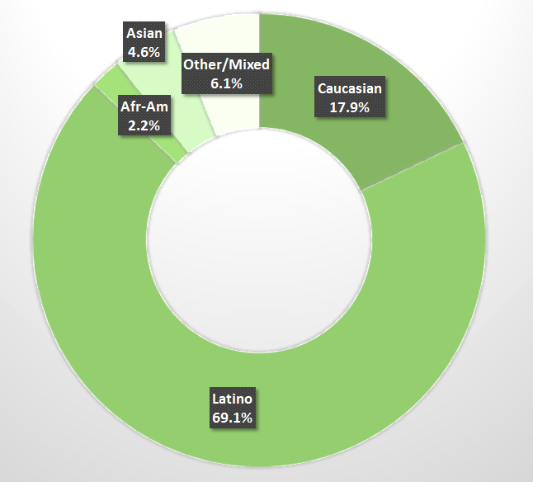

County vs. Contract (n = 805): County 17.6% vs. Contract 82.4%
Division (n = 805): CYBH 96.6%, 3.0% P&I, 0.4% Innovations

Mean YSS-F scale scores:

Figure 1. Mean Scores: YSS-F
(Scale is 1-"strongly disagree" to 5-"strongly agree")
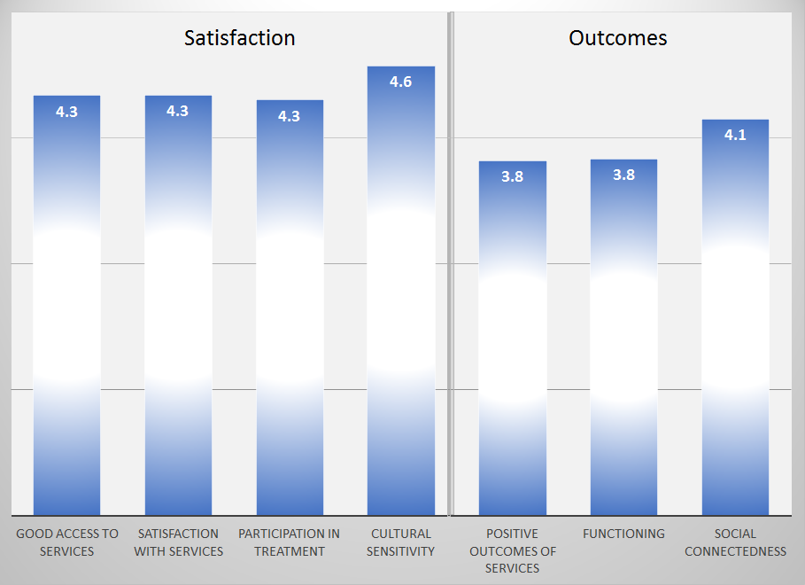

Factors affecting YSS-F scores:

Age and gender were not significantly related to any of the YSS-F scores. “Positive Outcomes of Services” was rated higher in County vs. contract clinics, 4.0 vs. 3.8.

Clients who had been enrolled longer in services tended to score higher on “Positive outcomes of services,” “Functioning,” and “Satisfaction with Services” (r = .10, .12, .13 respectively).

Figure 2. YSS-F scales by time in service
(Scale is 1-"strongly disagree" to 5-"strongly agree")
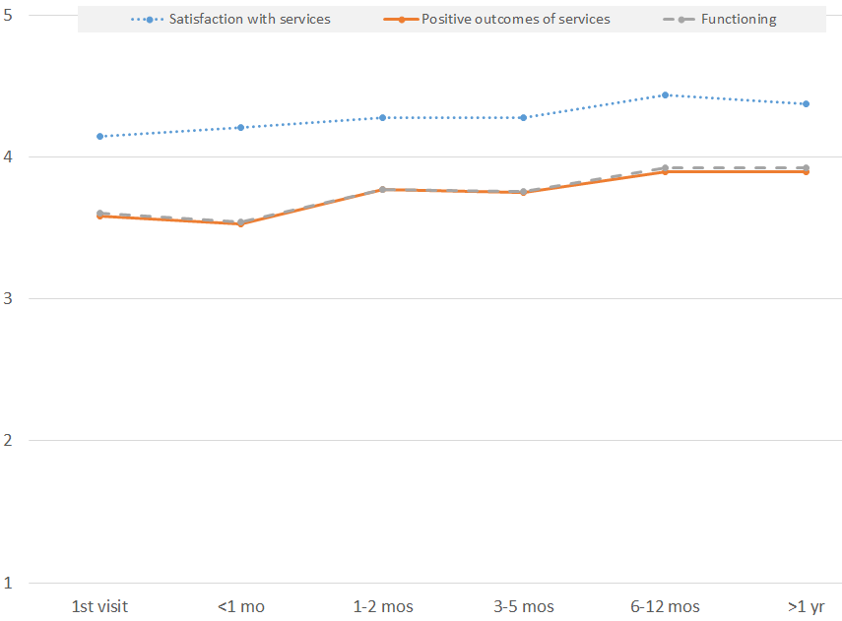

There was a significant ethnic difference on the Outcomes and Functioning scales, with Asian and Latino clients showing higher scores. Outcome and Function also differed significantly by form language, with participants completing non-English forms providing higher ratings.

Figure 3. YSS-F scales differing by ethnicity
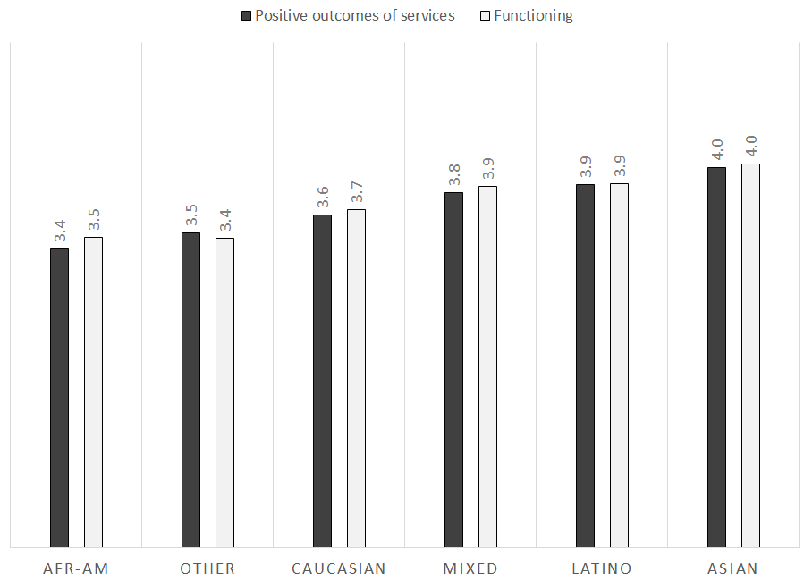

Figure 4. YSS-F scales by form language
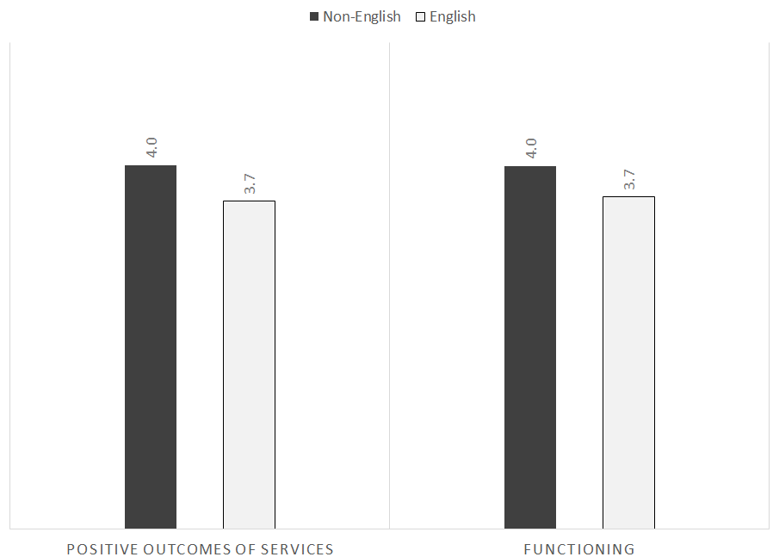
Start here.

Living Situation

Clients were asked, “Have you lived in any of the following places in the last 6 months? (Mark all that apply.)”

Figure 5. Percentage in living situation over past 6 months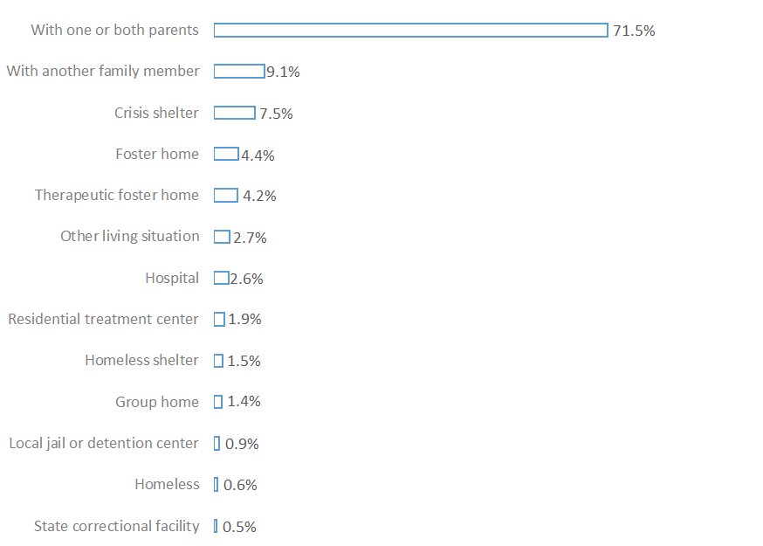

Doctor visits and medication

Figure 6. "In the last year, did you see a medical doctor (or nurse) for a health check-up or because you were sick?" (n = 734)
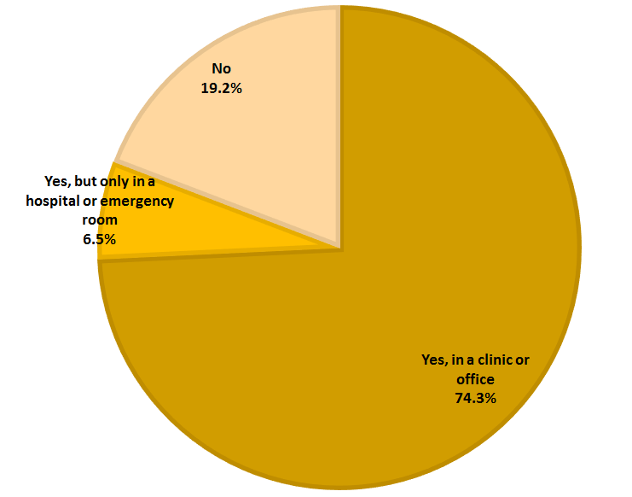
Seventy-four percent of clients were seen for a clinic or office visit in the prior year. This rate did not differ significantly by age, gender, ethnicity, or county vs. contract clinic.

By the parent/guardian report, 42.6% (310/727) of the clients are taking psychotropic medication. Medical providers discussed medication side-effects with 94.0% of the clients prescribed psychotropic medication.

Table 2. YSS-F mean scores by program (highlighted values significantly different from overall mean)

Program | Access | Satis- faction | Partici- pation | Cultural | Outcomes | Func- tioning | Social | N
ADAS Adolescent Unit, Aliso Viejo | 3.7 | 3.8 | 3.7 | 3.9 | 4.0 | 4.0 | 4.0 | 13
Brighter Futures | 3.6 | 3.9 | 3.8 | 3.8 | 3.3 | 3.1 | 3.9 | 4
Canyon Acres Seneca, Anaheim | 4.2 | 4.1 | 4.4 | 4.5 | 3.3 | 3.4 | 4.0 | 21
CEGU-OCFC | 4.5 | 4.0 | 4.0 | 5.0 | 3.8 | 4.0 | 3.5 | 1
CEGU, Probation | 4.0 | 3.7 | 4.7 | 4.3 | 3.0 | 3.0 | 3.5 | 1
Child Guidance Center | 4.3 | 4.4 | 4.3 | 4.6 | 3.9 | 3.9 | 4.1 | 103
Child Guidance Center, BP | 4.5 | 4.3 | 4.1 | 4.8 | 4.0 | 4.0 | 4.3 | 12
Collaborative Courts FSP | 4.3 | 4.5 | 4.2 | 4.5 | 4.2 | 4.2 | 4.3 | 62
CYBH CM | 4.3 | 4.4 | 4.5 | 4.7 | 3.8 | 3.8 | 4.1 | 22
CYBH Dana | 4.2 | 4.3 | 4.1 | 4.6 | 3.8 | 3.8 | 4.3 | 30
CYBH East | 4.4 | 4.2 | 4.3 | 4.5 | 3.9 | 3.9 | 4.3 | 61
CYBH MV Los Alisos | 4.0 | 3.8 | 3.3 | 4.5 | 3.0 | 3.3 | 3.8 | 1
CYBH South, LB-Wesley | 4.1 | 4.3 | 4.1 | 4.2 | 3.9 | 3.8 | 4.0 | 12
CYBH West | 4.4 | 4.4 | 4.3 | 4.6 | 3.9 | 3.9 | 4.2 | 47
CYBH, North | 4.3 | 4.3 | 4.3 | 4.7 | 3.9 | 3.9 | 4.2 | 41
Families First | 4.1 | 4.5 | 4.3 | 4.8 | 3.9 | 4.0 | 4.1 | 7
Korean Community Services | 4.4 | 4.3 | 4.0 | 4.7 | 3.7 | 3.7 | 4.1 | 12
Kinship Seneca Center | 4.1 | 4.4 | 4.3 | 4.6 | 3.9 | 3.9 | 4.3 | 26
OCAPICA | 3.4 | 4.7 | 4.5 | 4.6 | 4.0 | 4.0 | 4.6 | 5
OC CREW | 4.3 | 4.4 | 4.0 | 4.4 | 4.2 | 4.2 | 4.1 | 18
OC Postpartum Wellness | 5.0 | 5.0 | 4.5 | 4.4 | 4.7 | 4.7 | 4.3 | 2
Orangewood Children's Foundation FSP | 4.9 | 4.9 | 4.8 | 4.8 | 4.4 | 4.4 | 4.6 | 11
Providence Garden Grove | 4.3 | 4.2 | 4.0 | 4.4 | 3.8 | 3.8 | 4.1 | 34
Providence RENEW | 4.5 | 4.4 | 4.4 | 4.6 | 3.9 | 3.9 | 4.1 | 111
Providence, Anaheim | 4.3 | 4.4 | 4.3 | 4.5 | 4.2 | 4.1 | 4.1 | 4
Providence, Costa Mesa | 3.5 | 2.8 | 4.3 | 5.0 | 2.3 | 2.3 | 3.3 | 2
Providence, Santa Ana | 4.3 | 4.3 | 4.1 | 4.6 | 3.9 | 4.0 | 4.2 | 42
School Based Behavioral Health Intervention and Support- UCI CDC | 4.2 | 4.5 | 4.3 | 4.8 | 4.1 | 4.1 | 4.3 | 15
South Coast Children's Society | 4.8 | 4.5 | 4.1 | 4.5 | 4.0 | 4.1 | 4.3 | 15
Vietnamese Community of OC, OCAPICA FSP | 4.6 | 4.3 | 4.2 | 4.5 | 3.8 | 3.9 | 4.1 | 8
WYS North (Anaheim) | 4.3 | 4.3 | 4.2 | 4.5 | 3.7 | 3.7 | 4.1 | 223
WYS, Mission Viejo | 4.3 | 4.4 | 4.4 | 4.7 | 3.9 | 4.0 | 4.3 | 56
WYS, West | 4.1 | 4.1 | 4.1 | 4.4 | 3.7 | 3.7 | 4.0 | 195
Youthful Offender Wraparound | 4.6 | 4.5 | 4.5 | 4.6 | 4.2 | 4.2 | 4.3 | 24
Total | 4.3 | 4.3 | 4.2 | 4.5 | 3.8 | 3.9 | 4.1

