Consumer Perception Survey
April 2014 Administration
Children and Youth

The Youth Satisfaction Survey (YSS-F) was offered to the parents and guardians of all clients attending mental health services at a County or contract CYS clinic during April 2014. YSS-F records with a CYS, PEI or ADAS program indicated were retained for this analysis.

YSS-F Results

Sample description:

N: 823
Gender (n = 770): F 324 (44.7%), M 426 (55.3%)
Age: [Age and birthdates were unavailable due to scanner error]
Form Language (n = 626): English, 62.3% Spanish, 33.9% Vietnamese, 3.6% Chinese, 0.1%
Race/Ethnicity (n = 769):

County vs. Contract (n = 626): County 19.2% vs. Contract 80.8%
Division (n = 626): CYS 100%

Mean YSS-F scale scores:

Figure 1. Mean Scores: YSS-F
(Error bars show SD; scale is 1-"strongly disagree" to 5-"strongly agree")
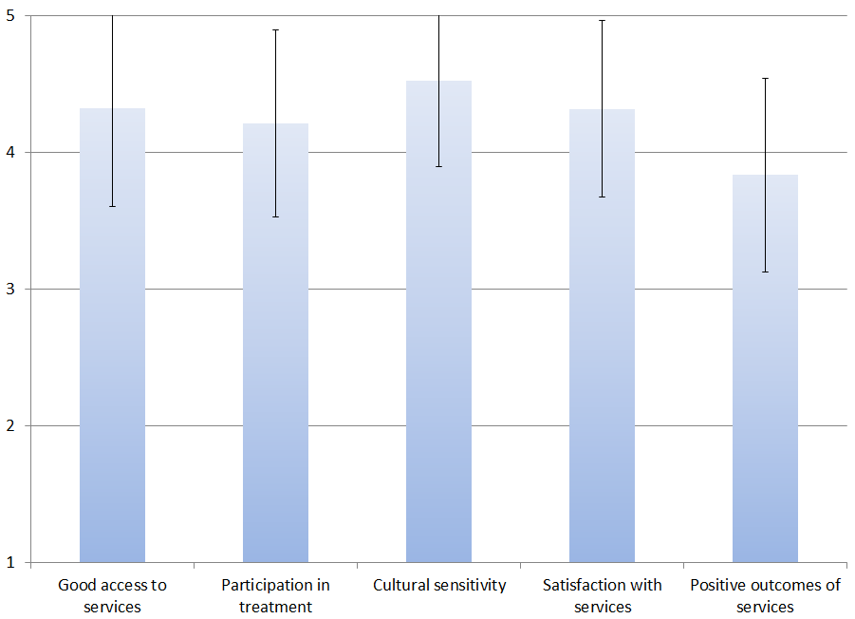

Factors affecting YSS-F scores:

Age, gender, county vs. contract, and ethnicity were not significantly related to any of the YSS-F scores.

Clients who had been enrolled longer in services tended to score higher on “Positive outcomes of services,” r = .16, p < .001.

Figure 2. YSS-F “Positive outcomes of services” by time in service
(Scale is 1-"strongly disagree" to 5-"strongly agree")
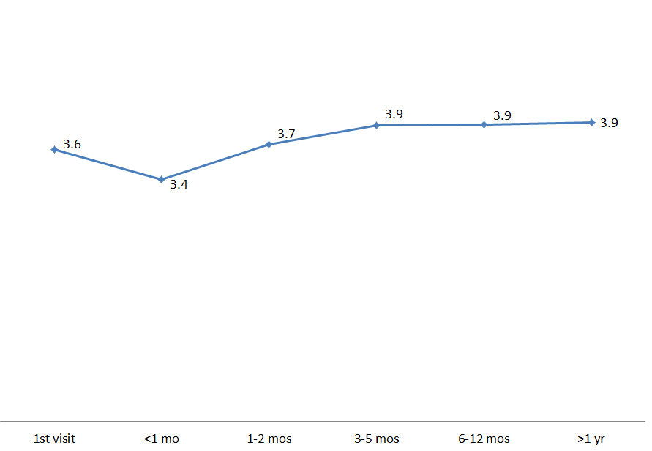

Living Situation

Clients were asked, “Have you lived in any of the following places in the last 6 months? (Mark all that apply.)”

Figure 3. Percentage in living situation over past 6 months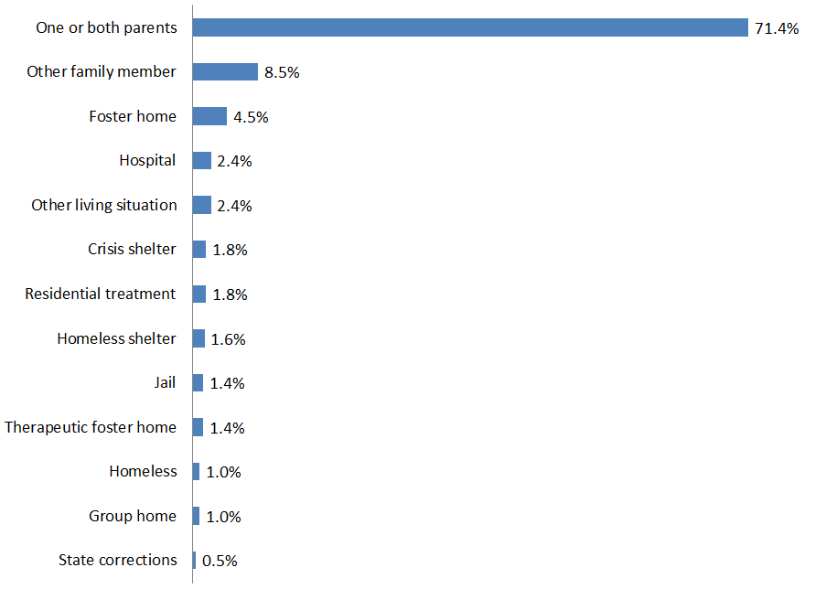

Doctor visits and medication

Figure 5. "In the last year, did you see a medical doctor (or nurse) for a health check-up or because you were sick?"
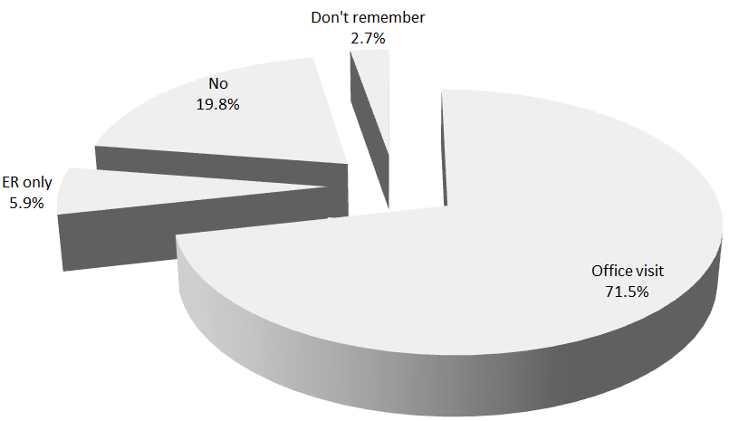
Seventy-two percent of clients were seen for a clinic or office visit in the prior year. This rate did not differ significantly by gender, ethnicity, or county vs. contract clinic.

Seventy-three percent of the clients (204/278) reported that they are taking psychotropic medication. Of the clients taking medication, 95.9% (189/197) reported that their medical provider had discussed side-effects with them.

Table 2. YSS-F mean scores by program (highlighted values significantly different from overall mean)

Program | Good access to services | Participation in treatment | Cultural sensitivity | Satisfaction with services | Positive outcomes of services | N
Child Guidance Center | 4.3 | 4.2 | 4.5 | 4.3 | 3.8 | 109
Child Guidance Center, BP | 4.1 | 3.9 | 4.4 | 4.2 | 3.8 | 24
Collaborative Courts FSP | 4.5 | 4.3 | 4.8 | 4.6 | 4.3 | 14
CYS CM | 4.5 | 4.2 | 4.7 | 4.6 | 4.3 | 12
CYS Dana | 4.7 | 3.7 | 4.5 | 4.1 | 3.8 | 11
CYS East | 4.3 | 4.2 | 4.4 | 4.3 | 3.8 | 40
CYS MV Los Alisos | 4.5 | 4.7 | 4.8 | 4.8 | 3.9 | 5
CYS South, LB-Wesley | 4.7 | 4.4 | 4.9 | 4.5 | 3.9 | 6
CYS West | 4.4 | 4.4 | 4.6 | 4.5 | 4.1 | 24
CYS, North | 4.0 | 4.3 | 4.5 | 4.5 | 3.7 | 20
Korean Community Services | 4.3 | 4.3 | 4.2 | 4.1 | 3.5 | 6
Providence Garden Grove | 4.4 | 3.9 | 4.7 | 4.5 | 4.0 | 9
Providence, Anaheim | 4.3 | 4.2 | 4.5 | 4.2 | 3.8 | 22
Providence, Costa Mesa | 4.4 | 4.2 | 4.5 | 4.4 | 4.0 | 36
Providence, Santa Ana | 4.6 | 4.2 | 4.7 | 4.5 | 4.0 | 19
WYS East (Anaheim) | 4.3 | 4.1 | 4.4 | 4.2 | 3.7 | 93
WYS North (Anaheim) | 4.3 | 4.3 | 4.6 | 4.2 | 3.7 | 88
WYS, Mission Viejo | 4.4 | 4.2 | 4.6 | 4.3 | 3.8 | 61
WYS, West | 4.3 | 4.4 | 4.7 | 4.4 | 4.0 | 17
Youthful Offender Wraparound | 4.5 | 5.0 | 5.0 | 5.0 | 4.8 | 1
Total | 4.3 | 4.2 | 4.5 | 4.3 | 3.8 | 617

