Percentage Assessment of Total Body Surface Area Burned:

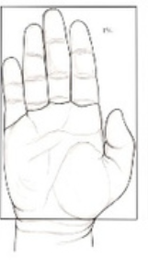

Patient’s entire palmar surface is approximately 1%

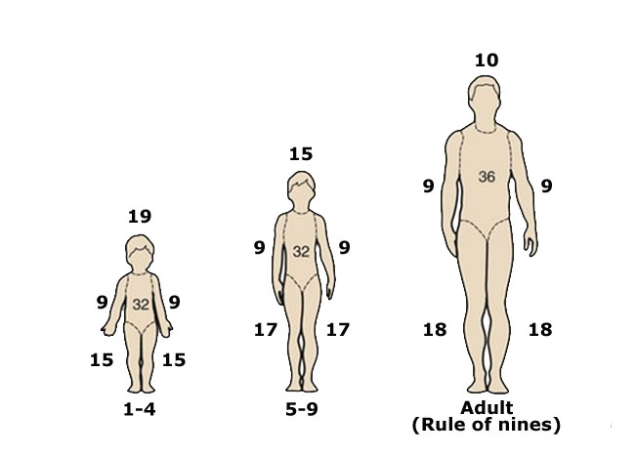

_________________________________________________________________________________________________________________

The goal of this assessment is to determine if transport to a burn center is necessary. If the total body surface area (TBSA) burned is 10% or more, the patient should go to a burn center. Estimate the total body surface area burned using the chart or palm, then add percentages to get total. Do not count first degree burns.

For example:

Adult: Burns to back of trunk and back of one leg = 36% / 2 + 18% / 2 = 18% + 9% = 27% TBSA

8 y.o. Child: Burns to back of trunk and back of a leg = 32% / 2 + 17% / 2 = 16% + 8% = 24% TBSA

For combined burns, second and third degree, combine body surface area determination to arrive at total.

In Orange County, the following should also be triaged to a burn center:

* Any third degree burn ● Second degree burns of face, genitalia, perineum, hand, and foot
* Suspected inhalation injury ● High voltage (> 500-1000 V) electrical injuries
* Chemical burns ● Pediatric (<10 years old or 30 kg)

**Calculation for percentage of total body surface area (TBSA) burned does not need to be exact. The goal is to determine if TBSA is < or > 10%.**