EOC Within A Date Range
Report Description:
This report shows all clients who have an open Episode of Care (EOC) during a specified date range at a specified Facility. The user can choose one Facility and a date range may go up to 93 days. The report will pull information from the last Registered FIN and sorts by Facility first and then Building. It is a companion to the EOC Last DOS over 30 Days report except it will include EOCs that were open during the specified date range and are now closed.

This report now captures both the CANS and PSC-35 psychometrics including; the Initial, Initial Provider, Initial Facility, Recent Date, Recent Status, Recent Provider, Recent Facility, and Next Due date.

Additionally, it captures the Care Team Plan Coordinator or the Treatment Team SUD Assigned Counselor and the MD/DO/NP, Client’s City, Zip Code and Referral Source.

Where to locate the report
To run this report, go to the Reports icon on the banner bar
In the search bar type in EOC Within a Date Range and select Run
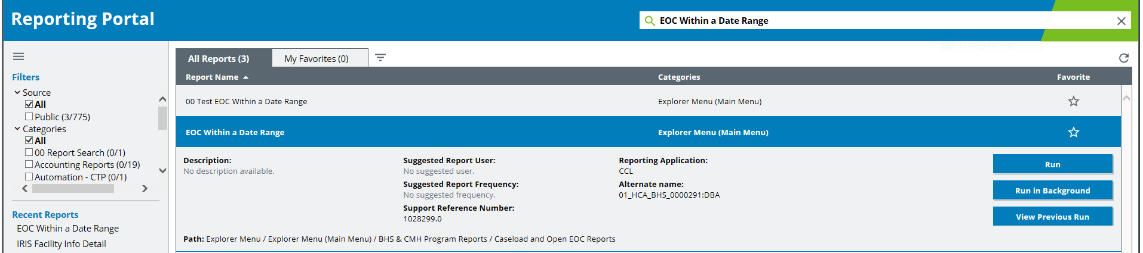

How to Run the Report
- Do nothing in the first field
- Select the Beginning Date Range and the Ending Date Range (report can be run for up to 93 days)
- Select the Division
- Select the Facility
- Select Execute
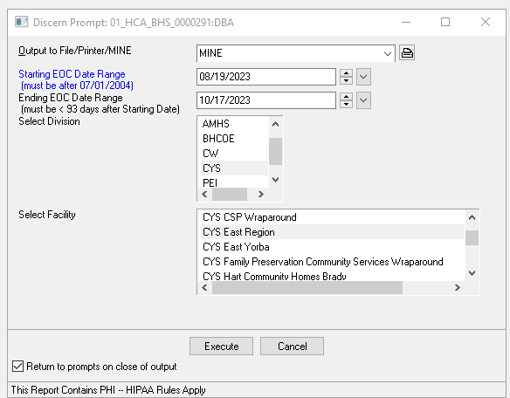
The Report Results:
The report will appear in a spreadsheet format shown below. The report is sorted in the order of FACILITY/ORG, BUILDING and CLIENT. It will display the encounter with the most recent Registration Date within an EOC. If the LAST_DOS field says ‘No DOS’, it means no services have been posted for this client within the EOC. The report will still display the last Registered FIN, (in the LAST_EOC_FIN column) although the service has not been billed.
***County only when the same client shows up multiple times, please run the EOC Last DOS Over 30 Days report to verify for accuracy and close any necessary EOCs that remain open.

Description of Column Headings:

FACILITY: Name of the facility where encounter was registered.

BUILDING: Building within the Facility where the encounter was registered.

CLIENT: Client Name – Each client should be listed on the report once. A client listed more than once has multiple Open EOCs at the chosen facility.

MRN: Medical Record Number, a unique identifier for the client.

DOB: Date of Birth.

Age_At_Encounter: Age at the time of service.

LAST_EOC_FIN: Last Financial Information Number for the encounter with the most current Registration Date within the EOC.

LAST_FIN_ENC_TYPE: Encounter type of the Last FIN within the EOC.

LAST_REG_DATE: Registration Date from the last FIN.

VALID_ENC: This reflects the validity status of the most recent FIN within this EOC that’s at this location. If the status is INVALID, no demographic or clinician assignment data will populate on the report Please see Special Notes for more explanation.

DOS_FIN: Last FIN for the encounter with the most recent DOS posted within the EOC. If no DOS within the EOC, the report will display No FIN.

LAST_DOS: Last DOS (Last Date Of Service) provided for the client. If no services were provided within the EOC, the report will display No DOS, meaning no services have been posted.

DAYS_SINCE_LAST_SVC: The number of days since the client had a DOS within this EOC. If no services were provided within the EOC, the report will display No DOS, meaning no services. have been posted.

DATA_FIN: This is the FIN that is used to get the Health Plan, Primary Clinician/Care Coord/Case Mgr data or information. If the Last FIN is an Access Log, Pre-Reg or INVALID FIN, the report will find the next dated valid FIN that contains this data.

Plan_COORD or SUD_AC: (county only) Name of Plan Coordinator (PC) identified on the Care Team (should not result more than one name).

ASSIGNED_MD_DO_NP: (county only) Name of MD, DO or NP identified on the Care Team (should not result more than one name).

LAST_ASSIGNED_CC_CM: (contract only) Name of the person listed on the DATA_FIN as “Care Coord/Case Mgr” in the Registration Conversation on the Encounter Tab. See DATA_FIN description for more information.

LAST_ASSIGNED_CLINICIAN: (contract only) Name of the person listed on the DATA_FIN as “Clinician” in the Registration Conversation on the Encounter Tab. See DATA_FIN description for more information.

HP1: Primary Health Plan listed from the DATA_FIN.

HP2: Secondary Health Plan listed from the DATA_FIN.

HP3: Third Health Plan listed from the DATA_FIN.

PROG SPCLTY: Program Specialty at the location where service is provided.

HF_SED: Enrolled in Healthy Families.

VET: Veteran Status listed in the DATA_FIN.

US_MILITARY: Identified when registering the FIN.

EOC_START_DATE: Episode of Care Start Date. If this field is blank, it means there is no EOC Start Date on the EOC Start Date Tab in the Registration Conversation.

EOC_END_DATE: Episode of Care End Date. If this field is blank, the EOC has not been closed.

DAYS_OPEN: Number of days EOC has been open.

EOC_LOS: Number of days between EOC start date and EOC end date.

DISCHARGE_ DATE: The date the client discharged.

DISCHARGE_REASON: Why the client discharged.

CITY: City identified from the Home Address under the Client Demographics tab in Reg.

ZIP_CODE: Zip Code identified from the Home Address under the Client Demographics tab in Reg.

REFERRAL_SOURCE: Referral Source under the Encounter tab in Reg.

INITIAL_CANS_DATE: Most recently completed Date for the Initial CANS. If the field is blank, there is no CANS.

INITIAL_CANS_PROVIDER: Assessor for the most recently completed Initial CANS. If the field is blank, there is no CANS.

INITIAL_CANS_FACILITY: Name of Facility for the most recently completed Initial CANS. If the field is blank, there is no CANS.

RECENT_CANS_DATE: Date for the most recently completed CANS. If the field is blank there is no CANS, or the most recent is the Initial CANS.

RECENT_CANS_STATUS: CANS status either Reassessment, Discharge, Administrative Close or Urgent. If the field is blank there is no CANS, or the most recent is the Initial CANS.

RECENT_CANS_PROVIDER: Assessor for the most recently completed CANS. If the field is blank there is no CANS, or the most recent is the Initial CANS.

RECENT_CANS_FACILITY: Name of Facility for the most recently completed CANS. If the field is blank there is no CANS, or the most recent is the Initial CANS.

CANS_NEXT_DUE: 180 days from the most recent Reassessment, Urgent or Initial CANS. If the field is blank there is no CANS, or the last CANS was either a Discharge or Administrative Close.

INITIAL_PSC-35_DATE: Most recently completed Initial PSC-35. If the field is blank, there is no PSC-35.

INITIAL_PSC-35_PROVIDER: Assessor for the most recently completed Initial PSC-35. If the field is blank, there is no PSC-35.

INITIAL_PSC_35_FACILITY: Name of Facility for the most recently completed PSC-35. If the field is blank, there is no PSC-35.

RECENT_PSC-35_DATE: Date for the most recently completed PSC-35. If the field is blank there is no PSC-35, or the most recent is the Initial PSC-35.

RECENT_PSC-35_STATUS: PSC-35 status either Reassessment, Discharge, Administrative Close or Urgent. If the field is blank there is no PSC-35, or the most recent is the Initial PSC-35.

RECENT_PSC_35_PROVIDER: Name of Provider for the most recently completed PSC-35. If the field is blank there is no PSC-35, or the most recent is the Initial PSC-35.

RECENT_PSC-35_FACILITY: Name of Facility for the most recently completed PSC-35. If the field is blank there is no PSC-35, or the most recent is the Initial PSC-35.

PSC-35_NEXT_DUE: 180 days from the most recent Reassessment, Urgent or Initial PSC-35. If the field is blank there is no PSC-35, or the last PSC-35 was either a Discharge or Administrative Close.

COHORT1: Result Cohort 1 from BHS Special Cohort conversation- AB 109, Intensive Services, Katie A. (PWB) or Restricted Billing. If the field is blank, there is no Cohort 1.

START_DATE1: Result Start Date for Cohort 1. If the field is blank there is no Cohort 1.

END_DATE1: Result End Date for Cohort 1. If the field is blank there is no Cohort 1, or no end date has been inputted.

COHORT2: Result Cohort 2 from BHS Special Cohort conversation – AB 109, Intensive Services, Katie A. (PWB) or Restricted Billing. If the field is blank, there is no Cohort 2.

START_DATE2: Result Start Date for Cohort 2. If the field is blank there is no Cohort 2.

END_DATE2: Result End Date for Cohort 2. If the field is blank there is no Cohort 2, or no end date has been inputted.

COHORT3: Result Cohort 3 from BHS Special Cohort conversation – AB 109, Intensive Services, Katie A. (PWB) or Restricted Billing. If the field is blank, there is no Cohort 3.

START_DATE3: Result Start Date for Cohort 3. If the field is blank there is no Cohort 3.

END_DATE3: Result End Date for Cohort 3. If the field is blank there is no Cohort 3, or no end date has been inputted.

COHORT4: Result Cohort 4 from BHS Special Cohort conversation – AB 109, Intensive Services, Katie A. (PWB), Restricted Billing. If the field is blank, there is no Cohort 4.

START_DATE4: Result Start Date for Cohort 4. If the field is blank there is no Cohort 4.

END_DATE4: Result End Date for Cohort 4. If the field is blank there is no Cohort 4, or the end date has not been inputted.

DECEASED_DATE: Date client deceased.

EOC_TYPE: Name of the Episode of Care.

EOC_ERROR _DESCRIPTION: This shows a description of errors for this EOC as seen below:
Error Messages shown in the EOC_ERROR_DESCRIPTION Column for Open EOC reports:
- EOC Start Date missing from ALL encounters.
At least one encounter missing EOC Start Date; other encounters with at least two actual EOC Start Dates.
At least one encounter with a missing EOC Start Date - and ALL other encounters have the same EOC Start Date.
At least two encounters with different EOC Start Dates.

ZEPISODE_ID: IT use only.

Special Notes: This report is a companion report to the EOC Last DOS Over 30 Days report. Use the EOC Last DOS Over 30 Days report to find all Open EOC’s that have had no services within a specified number of days. The LAST_DOS reflects only the Main charge details, not different day documentation. When the report displays ‘INVALID’ in the VALID_ENC field column, please review the encounter in the chart to verify if the encounter should truly be an INVALID encounter. When the report displays ChkEOC (Check EOC) in the VALID_ENC field column, it means that there is still a charge associated to this INVALID encounter. Please check this FIN to verify if the encounter should be INVALID. The report can be saved into a shared folder as a csv.doc; then opened as an excel.doc to filter and sort as desired. Due to HIPAA regulations, the report should NOT be saved to your desktop or T drive.

